**Lab23– Understanding Availability Set and Load balancer – Azure**

**Availability set**

An Availability Set is a logical grouping capability that you can use in Azure to ensure that the VM resources you place within it are isolated from each other when they are deployed within an Azure datacenter. Azure ensures that the VMs you place within an Availability Set run across multiple physical servers, compute racks, storage units, and network switches. If a hardware or Azure software failure occurs, only a subset of your VMs are impacted, and your overall application stays up and continues to be available to your customers. Availability Sets are an essential capability when you want to build reliable cloud solutions.

Let’s consider a typical VM-based solution where you might have four front-end web servers and 2 back-end VMs. With Azure, you’d want to define two availability sets before you deploy your VMs: one availability set for the web tier and one availability set for the back tier. When you create a new VM you can then specify the availability set as a parameter to the az vm create command, and Azure automatically ensures that the VMs you create within the available set are isolated across multiple physical hardware resources. If the physical hardware that one of your Web Server or back-end VMs is running on has a problem, you know that the other instances of your Web Server and back-end VMs remain running because they are on different hardware.

Use Availability Sets when you want to deploy reliable VM-based solutions in Azure.

**Load Balancer**

With Azure Load Balancer, you can scale your applications and create high availability for your services. Load Balancer supports inbound and outbound scenarios, provides low latency and high throughput, and scales up to millions of flows for all TCP and UDP applications.

Load Balancer distributes new inbound flows that arrive on the Load Balancer's frontend to backend pool instances, according to rules and health probes.

Additionally, a public Load Balancer can provide outbound connections for virtual machines (VMs) inside your virtual network by translating their private IP addresses to public IP addresses.

Azure Load Balancer is available in two SKUs: Basic and Standard. There are differences in scale, features, and pricing. Any scenario that's possible with Basic Load Balancer can also be created with Standard Load Balancer, although the approaches might differ slightly. As you learn about Load Balancer, it is important to familiarize yourself with the fundamentals and SKU-specific differences.

## Why use Load Balancer?

You can use Azure Load Balancer to:

* Load-balance incoming internet traffic to your VMs. This configuration is known as a [Public Load Balancer](https://docs.microsoft.com/en-us/azure/load-balancer/load-balancer-overview#publicloadbalancer).
* Load-balance traffic across VMs inside a virtual network. You can also reach a Load Balancer front end from an on-premises network in a hybrid scenario. Both scenarios use a configuration that is known as an [Internal Load Balancer](https://docs.microsoft.com/en-us/azure/load-balancer/load-balancer-overview#internalloadbalancer).
* Port forward traffic to a specific port on specific VMs with inbound network address translation (NAT) rules.
* Provide [outbound connectivity](https://docs.microsoft.com/en-us/azure/load-balancer/load-balancer-outbound-connections) for VMs inside your virtual network by using a public Load Balancer.

**Note**

Azure provides a suite of fully managed load-balancing solutions for your scenarios. If you are looking for Transport Layer Security (TLS) protocol termination ("SSL offload") or per-HTTP/HTTPS request, application-layer processing, review [**Application Gateway**](https://docs.microsoft.com/en-us/azure/application-gateway/application-gateway-introduction). If you are looking for global DNS load balancing, review [**Traffic Manager**](https://docs.microsoft.com/en-us/azure/traffic-manager/traffic-manager-overview). Your end-to-end scenarios might benefit from combining these solutions as needed.

**Topology:**

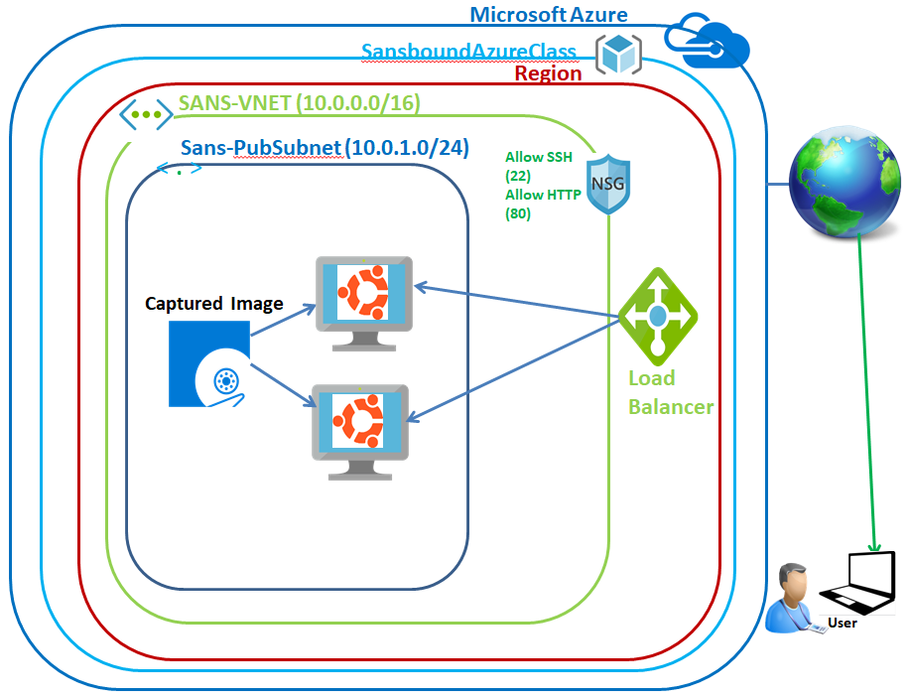

In Azure portal, click **“Resource groups”**.

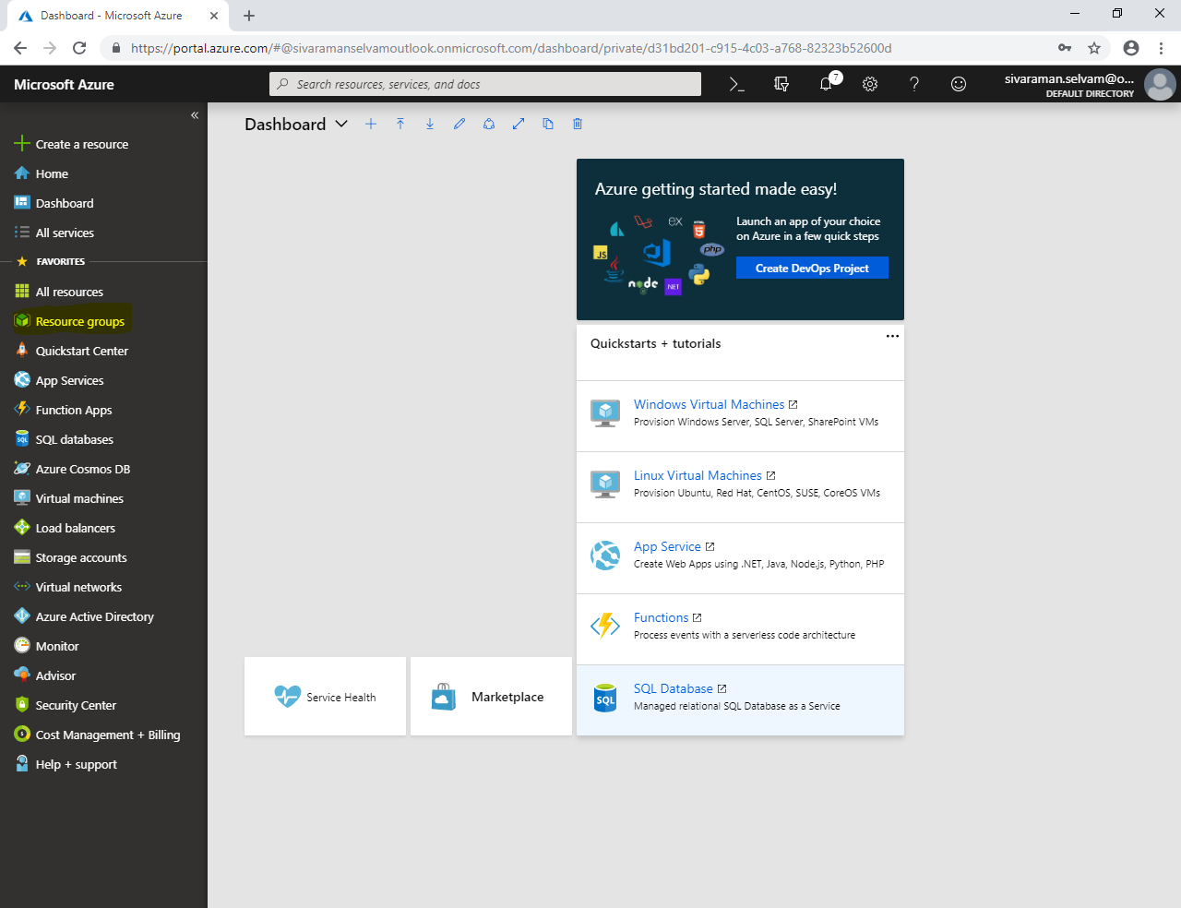

Click **“Add”**.

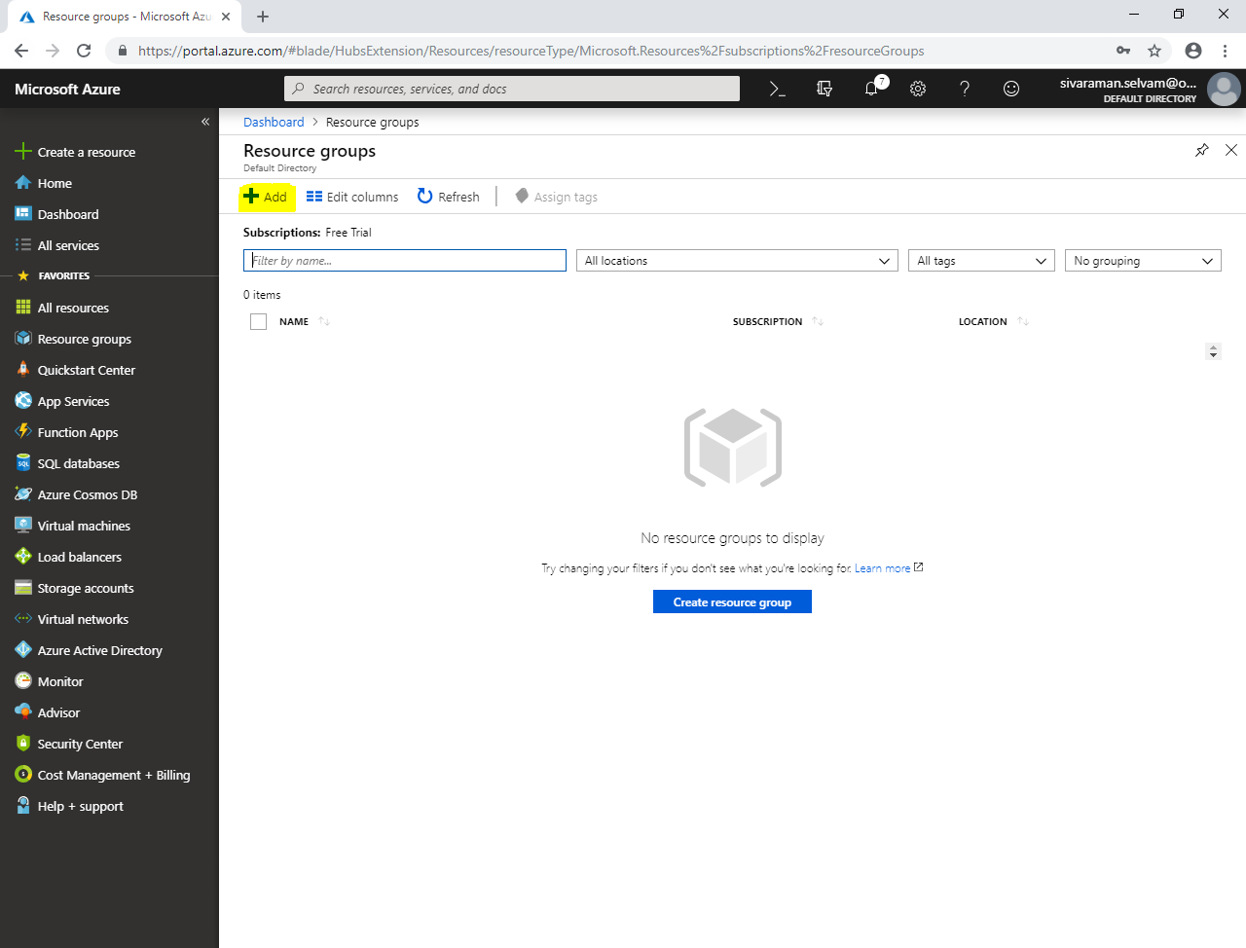

While create **“Resource group”**,

Type **“Resource group name”** as **“SansboundAzureClass”**.

Select **“Resource group location”** as **“CentralUS”**.

Click **“Create”**.

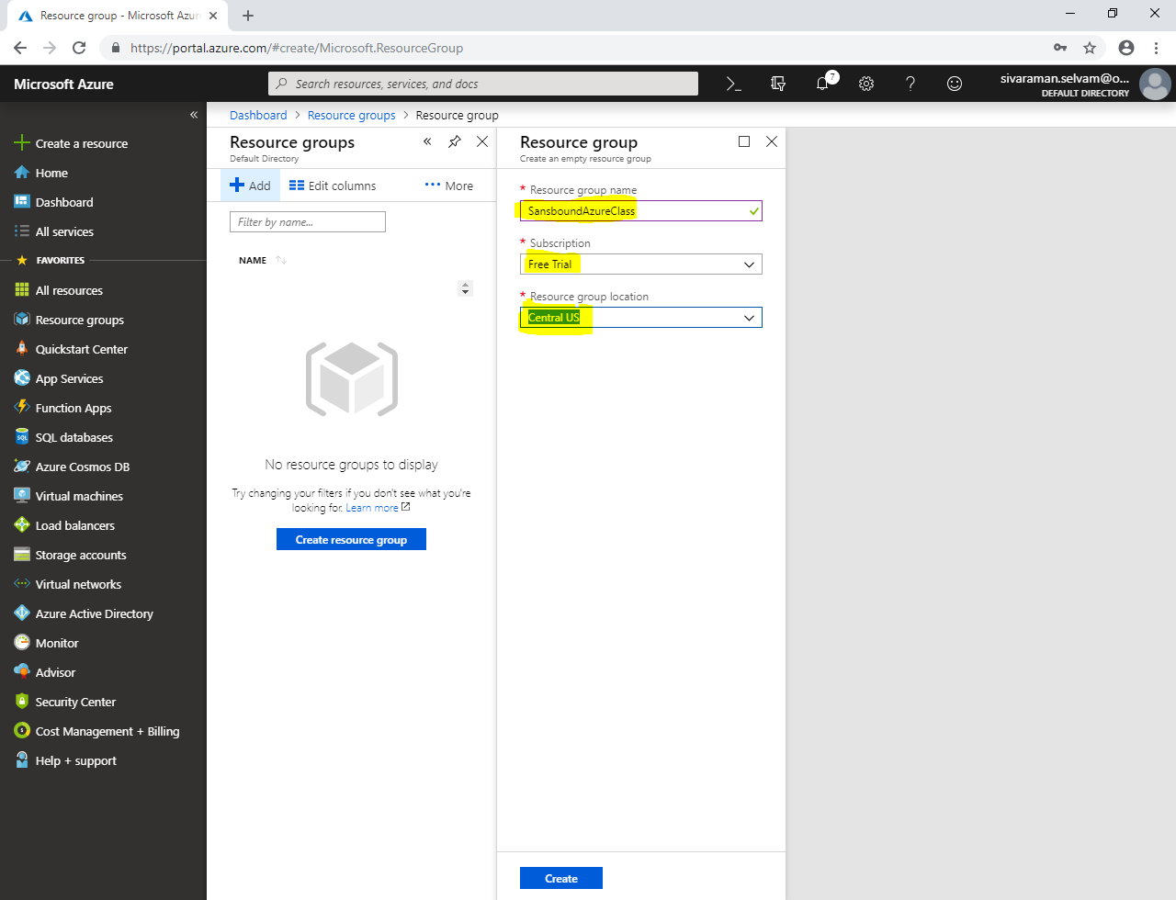

Click **“All services”**,

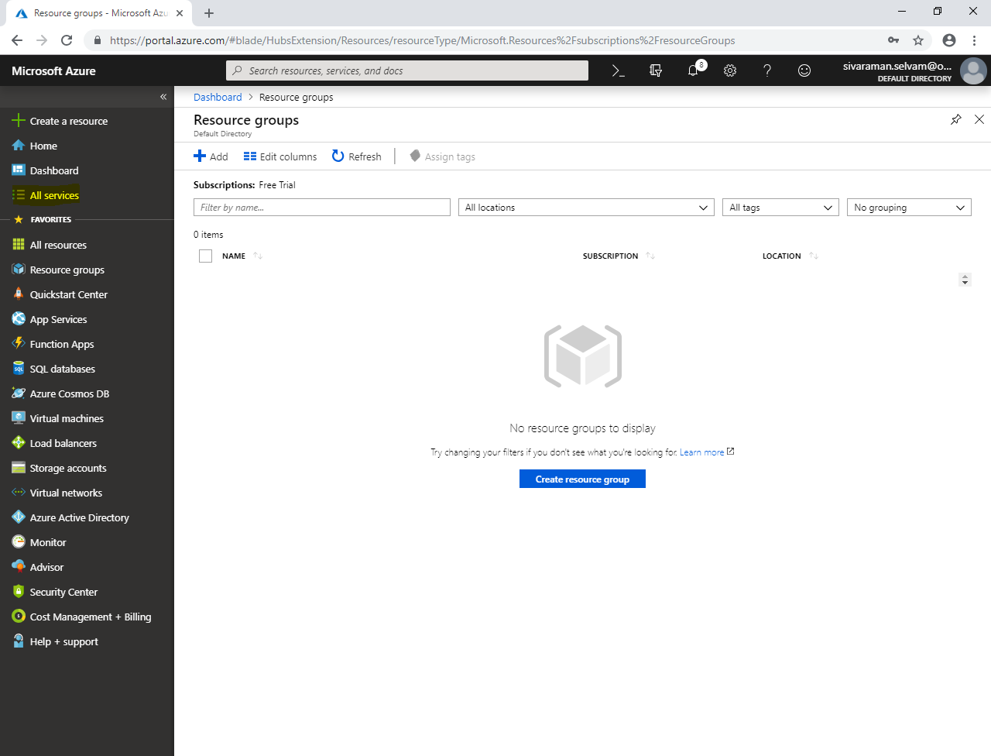

In **“All services”**,

Click **“Availability sets”**.

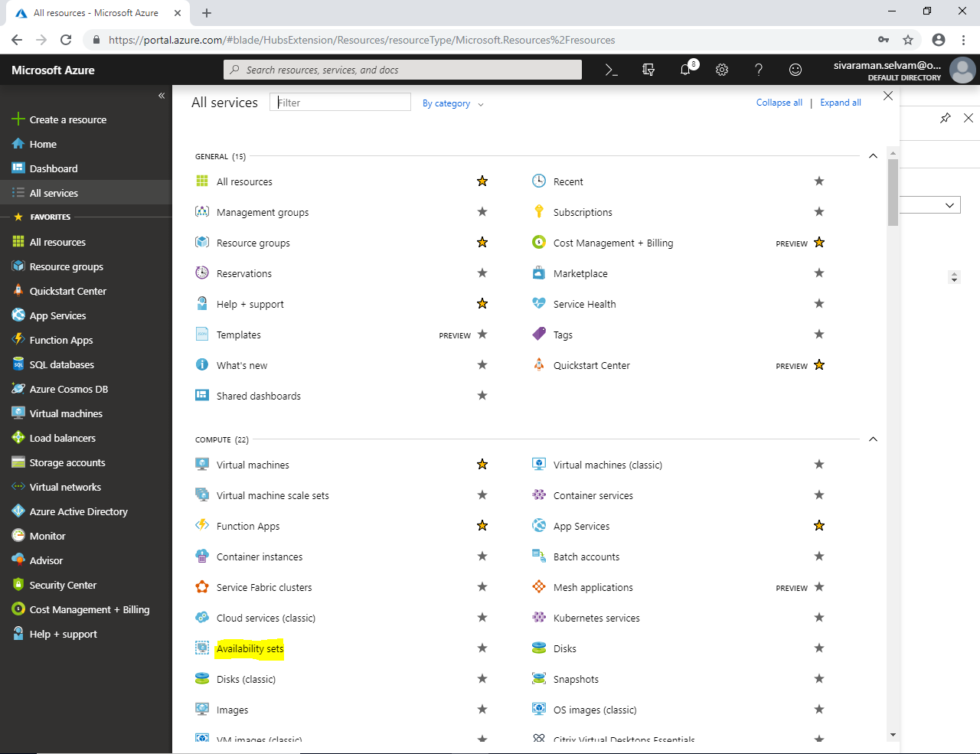

In **“Availability sets”**,

Click **“Add”**.

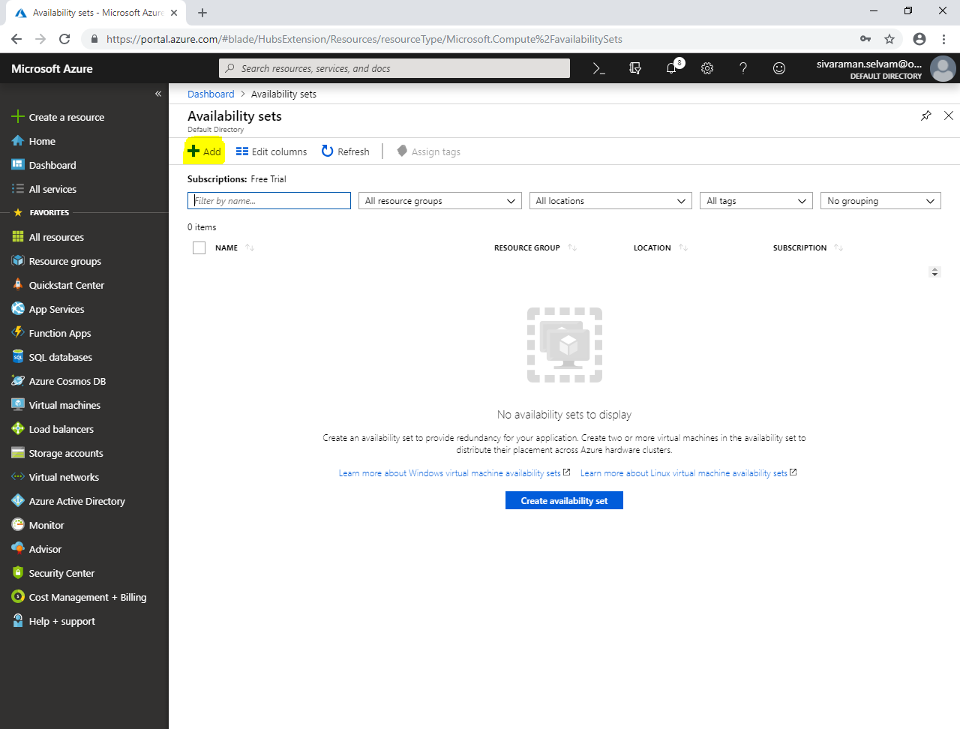

While create availability set,

Type **“Name”** as **“Sans-Cluster”**.

Select **“Subscription”** as **“Free Trial”**.

Select **“Resource group”** as **“SansboundAzureClass”**.

Select **“Location”** as **“Central US”**.

Default fault domain as **“2”** for (Free Trial account).

Update domains : Reserved : **5 No’s**

Ensure **“Use Managed disks”** as **“Yes”.**

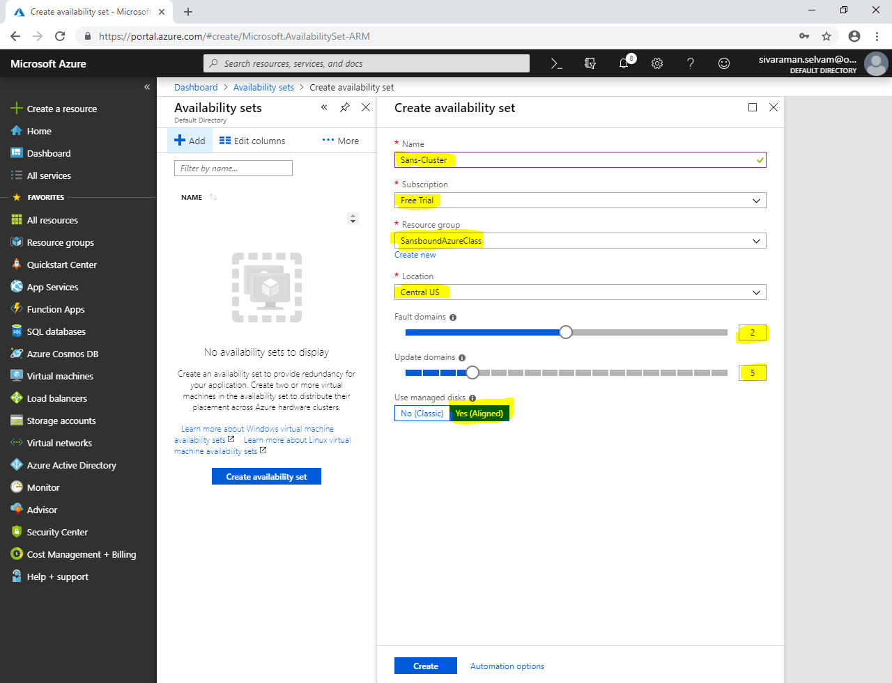

In **“Availability sets”**,

Click **“Refresh”** to view Availability sets.

You have required to click **“Virtual networks”.**

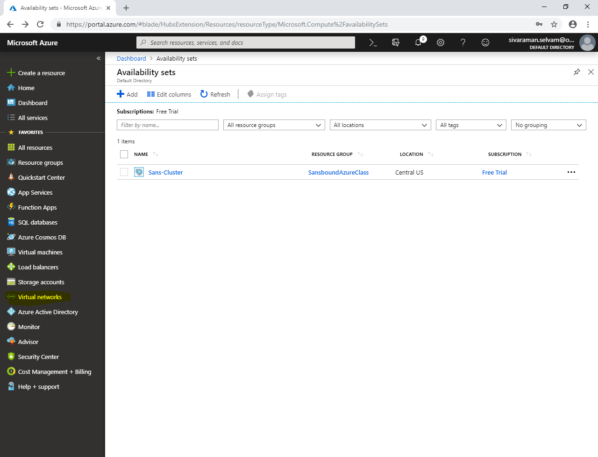

Click **“Add”**.

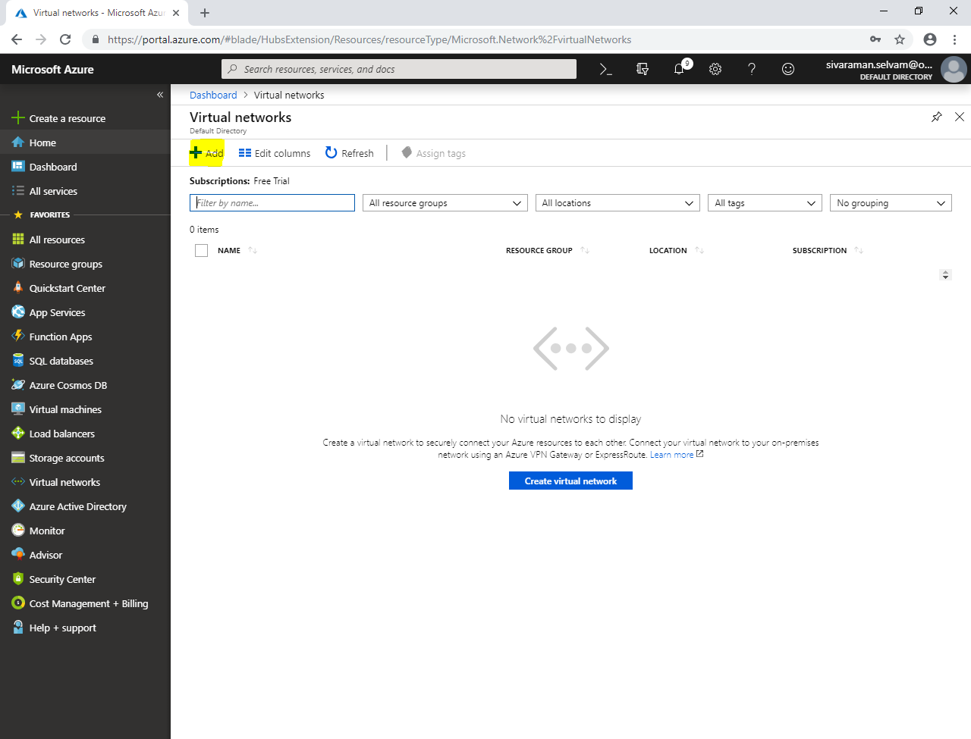

While create network,

Type **“Name”** as **“SANS-VNET”**.

Type **“Address range”** as **10.0.0.0/16**.

Select **“Subscription”** as **“Free Trial”**.

Select **“Resource group”** as **“SansboundAzureClass”**.

Select **“Location”** as **“Central US”**.

Type **“Subnet”** name as **“SANS-PubSubnet”**.

Select **“Address range”** as **10.0.1.0/24**.

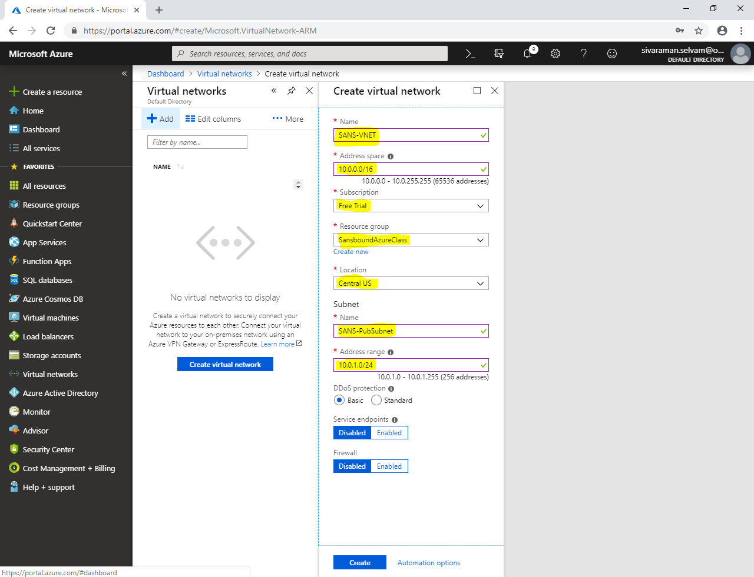

Click **“Create”**,

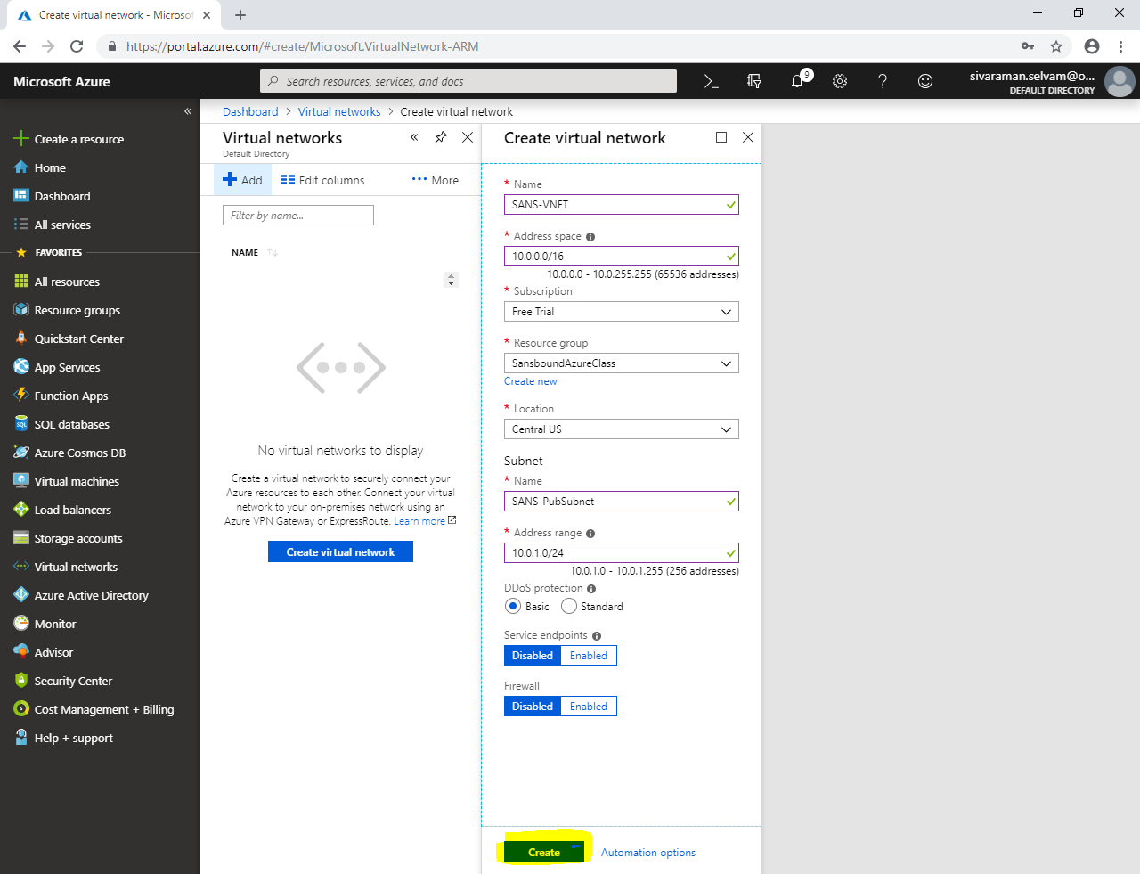

Click **“Dashboard”**.

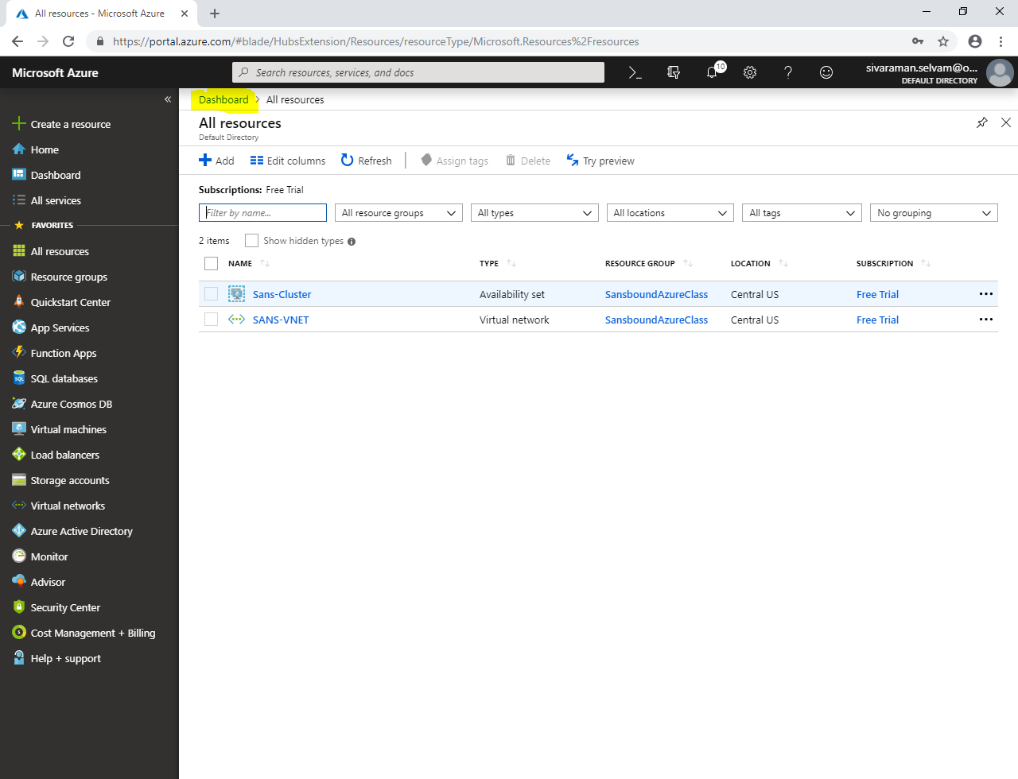

Click **“All services”** in left side panel.

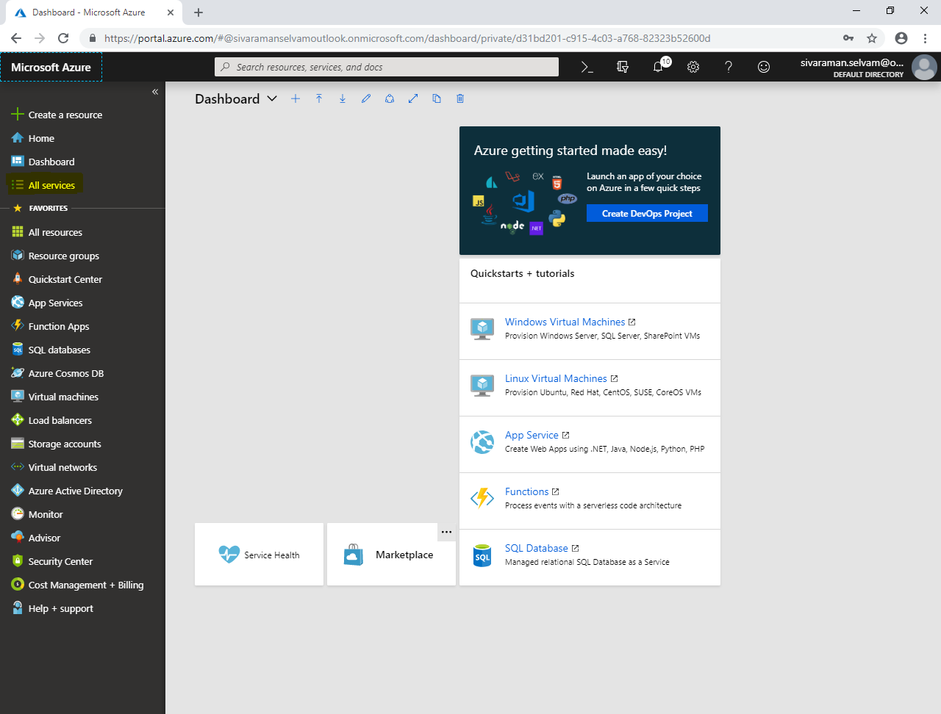

In **“All services”**,

Click **“Network security group”**.

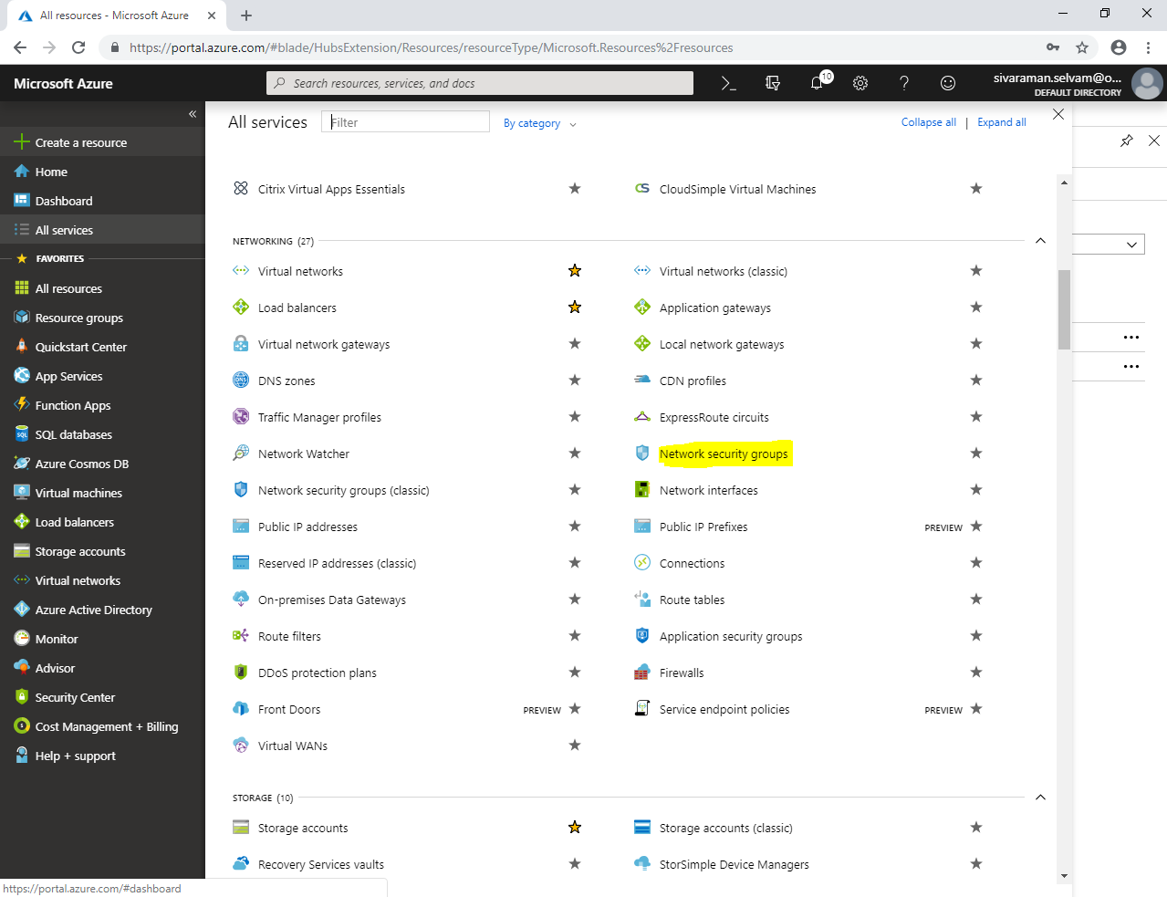

In **“Network security groups”**,

Click **“Add”**.

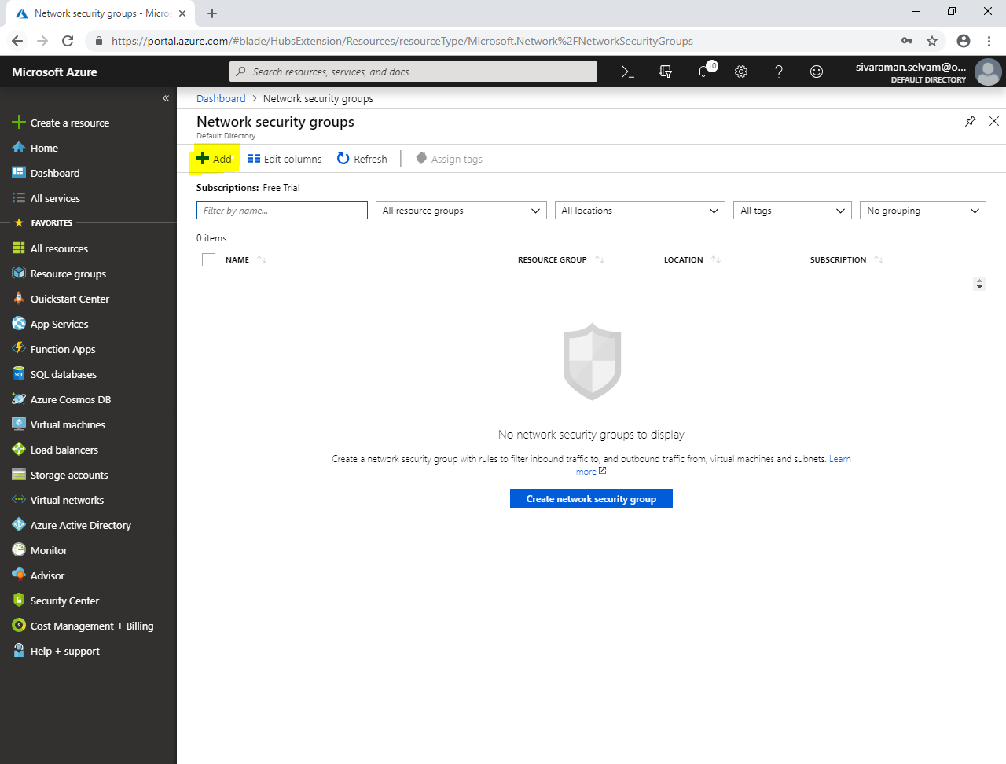

While create network security group,

Type **“Name”** as **“Front-EndNSG”**.

Select **“Subscription”** as **“Free Trial”**.

Select **“Resource group”** as **“SansboundAzureClass”**.

Select **“Location”** as **“Central US”**.

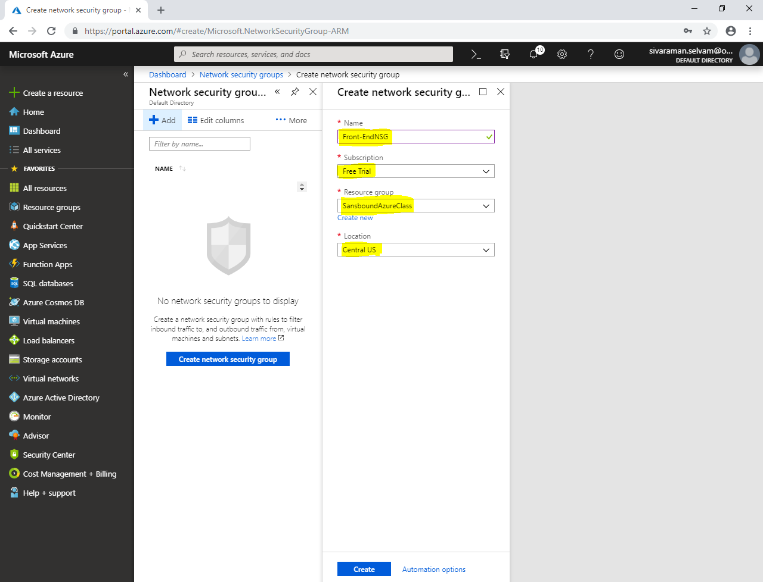

Click **“Create”**.

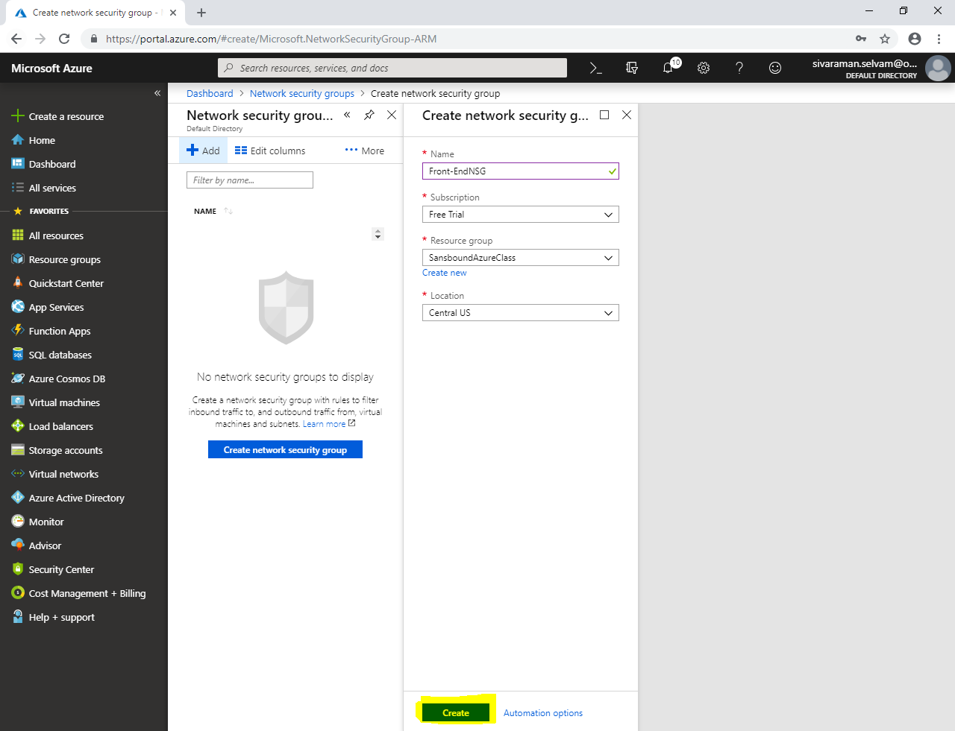

Click **“Refresh”**.

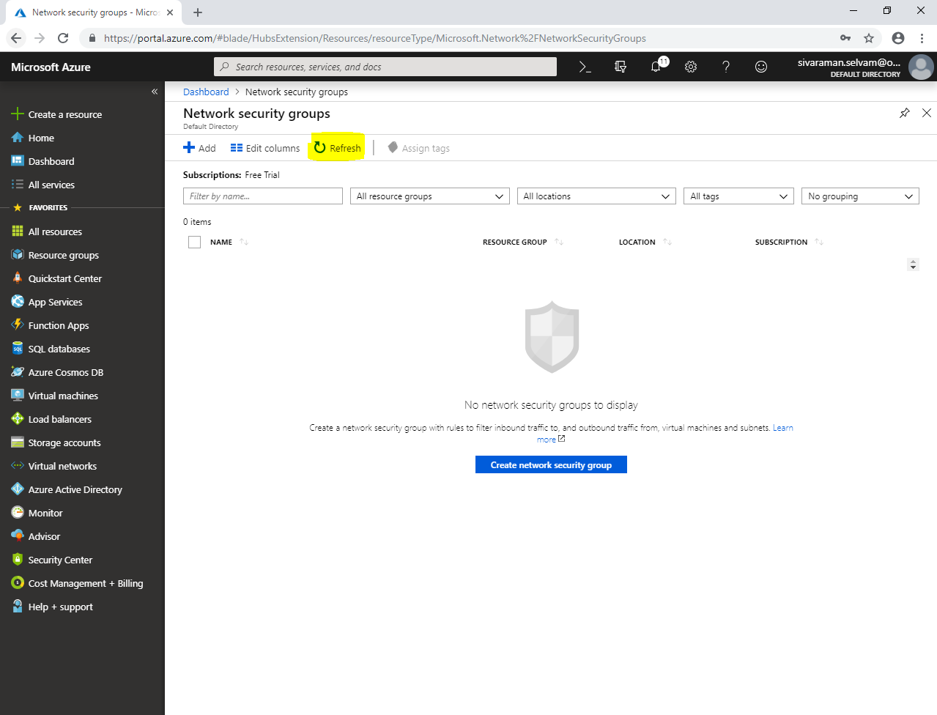

In **“Network security groups”,**

Click **“Front-EndNSG”.**

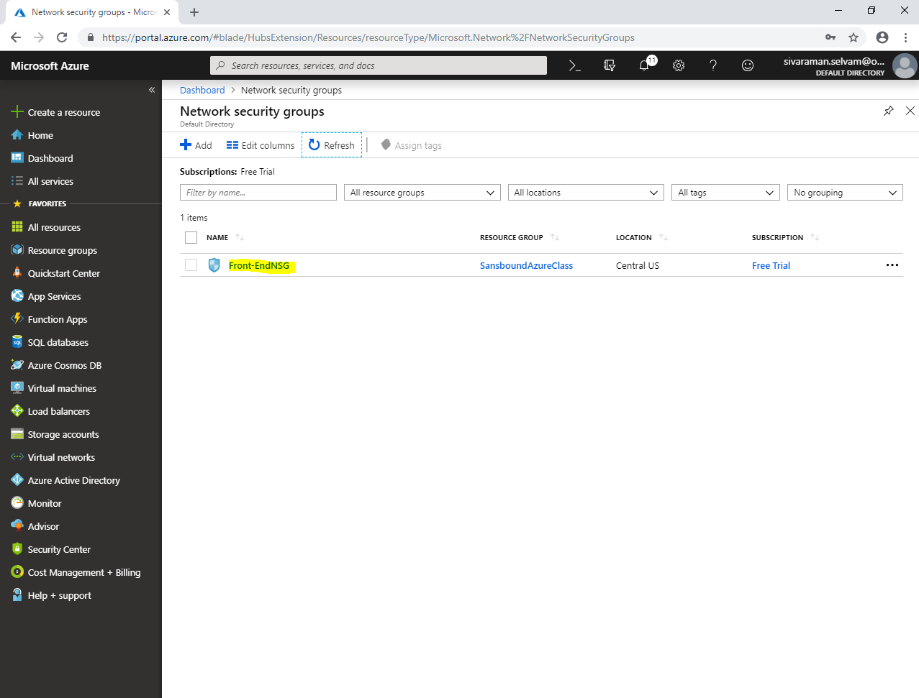

**In “Front-EndNSG”,**

Click **“Inbound security rules”**.

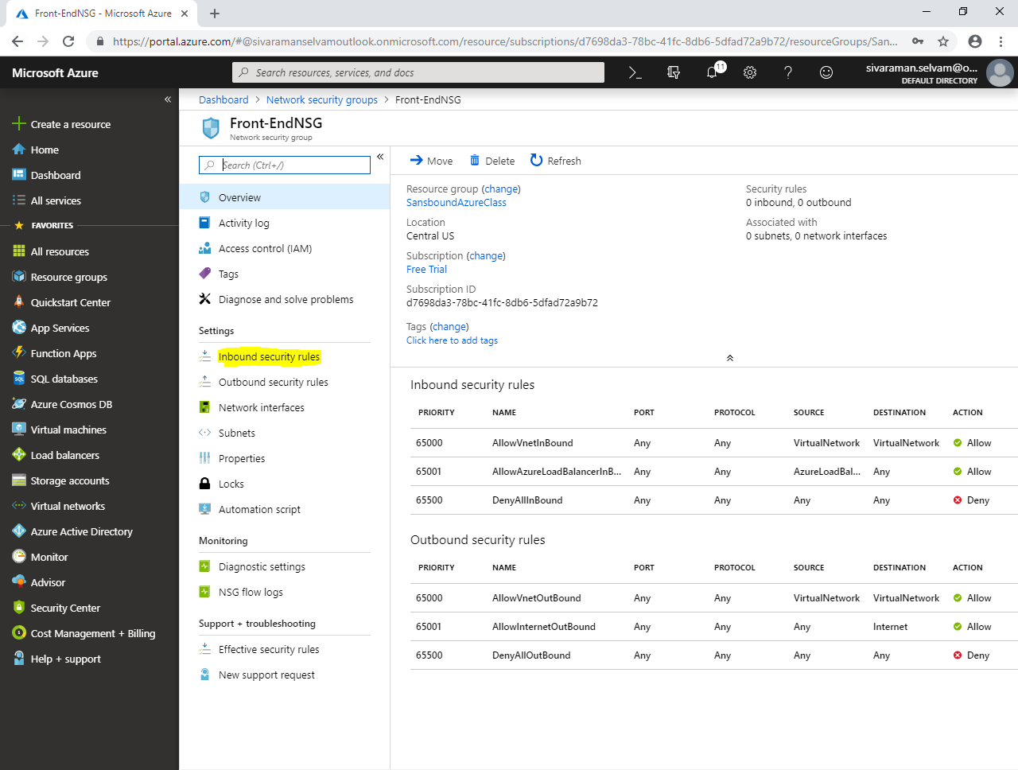

In **“Inbound security rules”,**

Click **“Add”.**

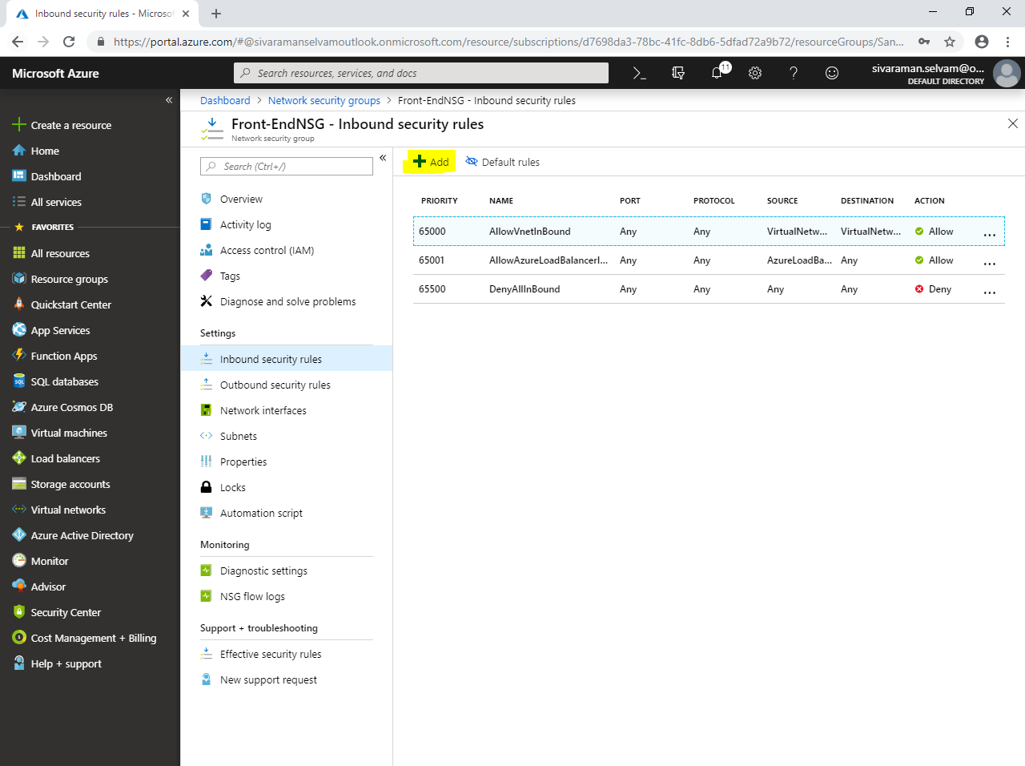

While **“Add inbound security rule”**,

Select **“Source”** as **“Any”**.

Select **“Source port ranges”** as **“*”**.

Select **“Destination”** as **“Any”**.

Select **“Destination port ranges”** as **“80”**.

Click **“Protocol”** as **“TCP”**.

Ensure **“Priority”** as **“100”**

Type **“Name”** as **“AllowHTTP”**.

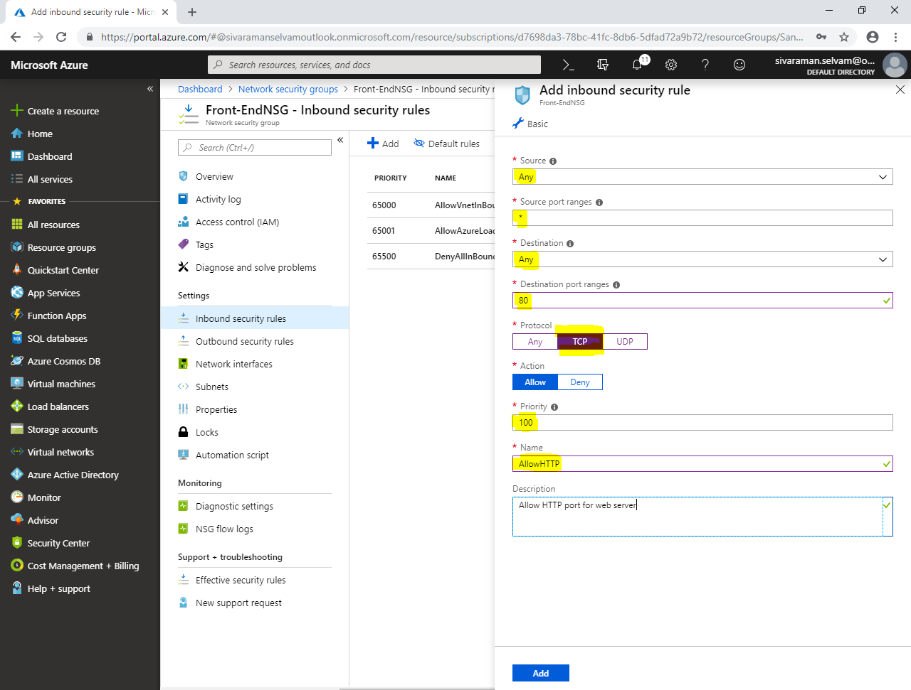

**Click “Add”.**

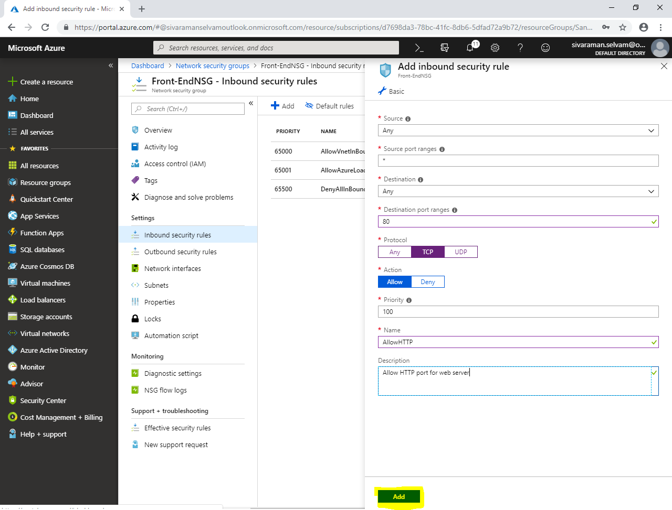

Now you are able to see that inbound security rules has been created for **“100”**.

Click **“Add”**.

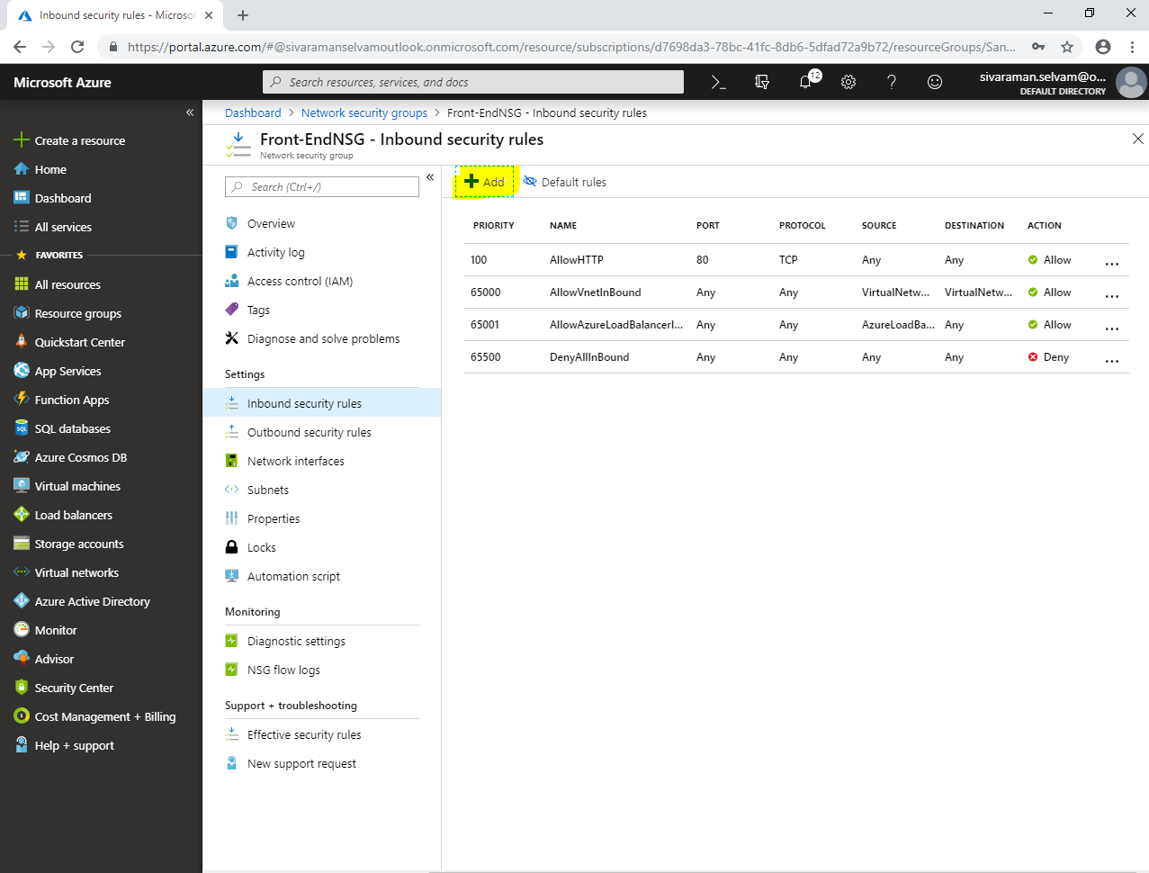

While **“Add inbound security rule”**,

Select **“Source”** as **“Any”**.

Select **“Source port ranges”** as **“*”**.

Select **“Destination”** as **“Any”**.

Select **“Destination port ranges”** as **“22”**.

Click **“Protocol”** as **“TCP”**.

Ensure **“Priority”** as **“110”**

Type **“Name”** as **“AllowSSH”**.

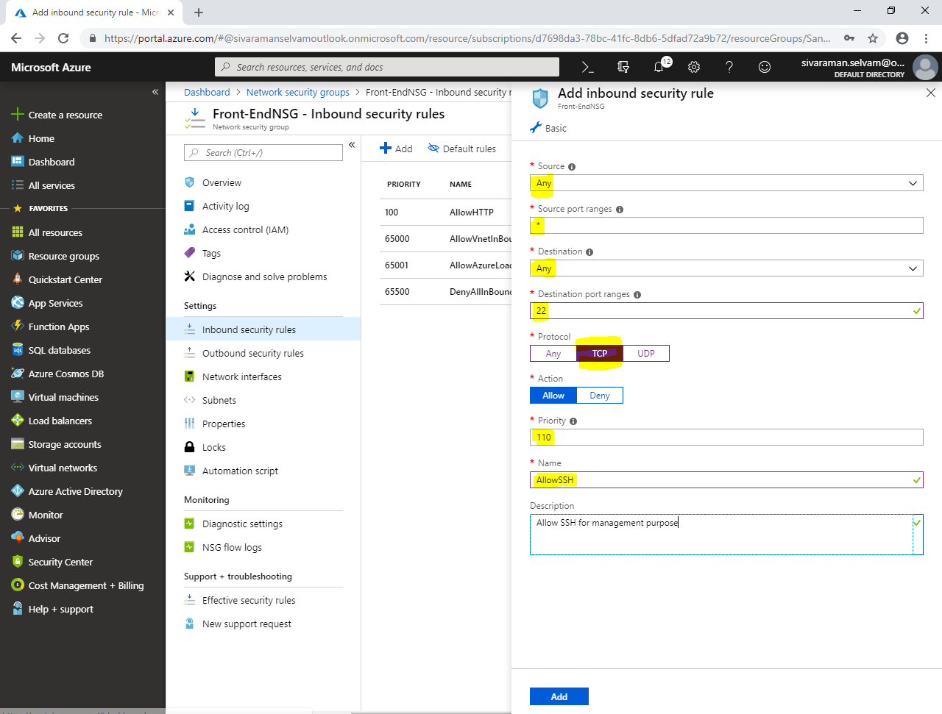

Click **“Add”.**

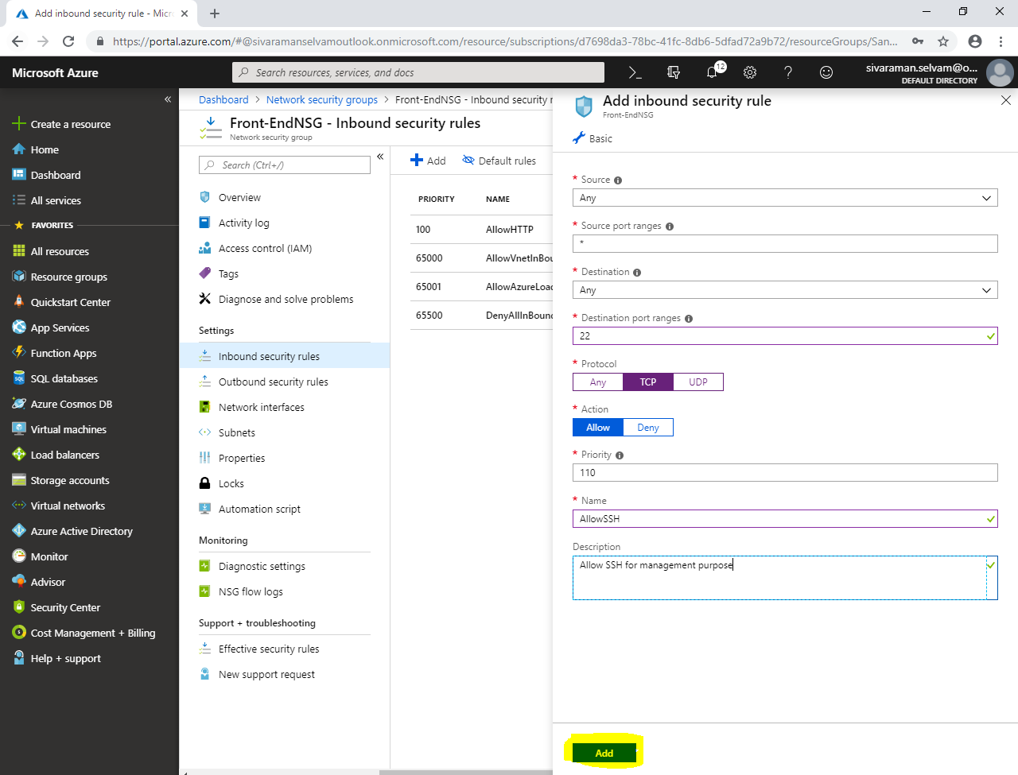

In **“Front-EndNSG”**,

Click **“Subnets”**.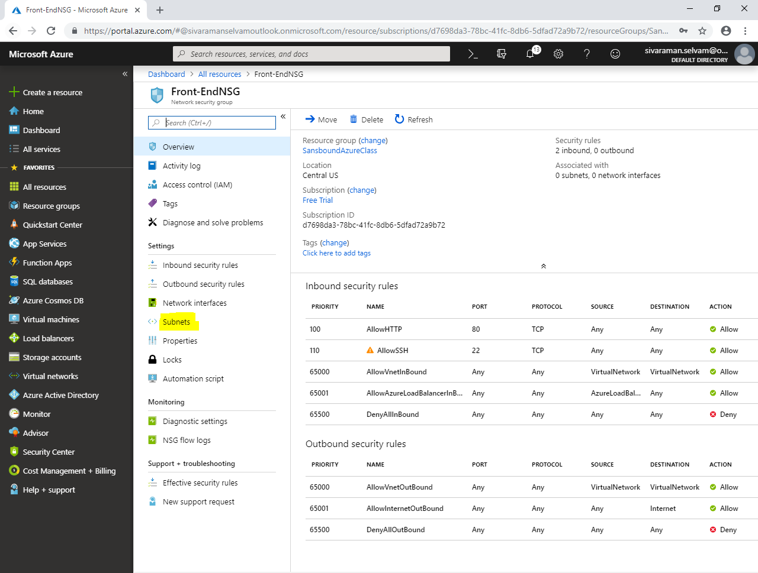

In **“Subnets”,**

Click **“Associate”** to associate the subnet to **“Front-EndNSG”** network security group.

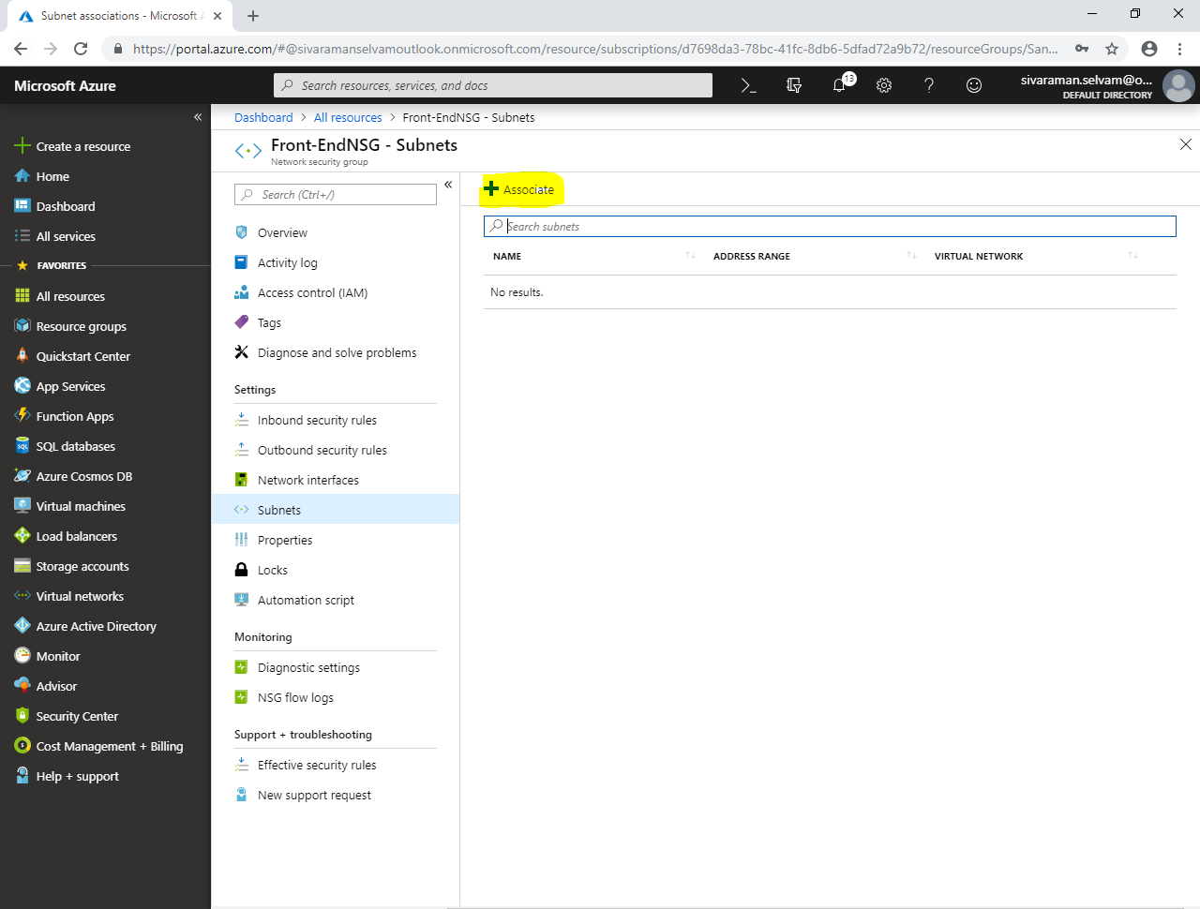

While **“Associate subnet”,**

Click **“Choose a virtual network”,**

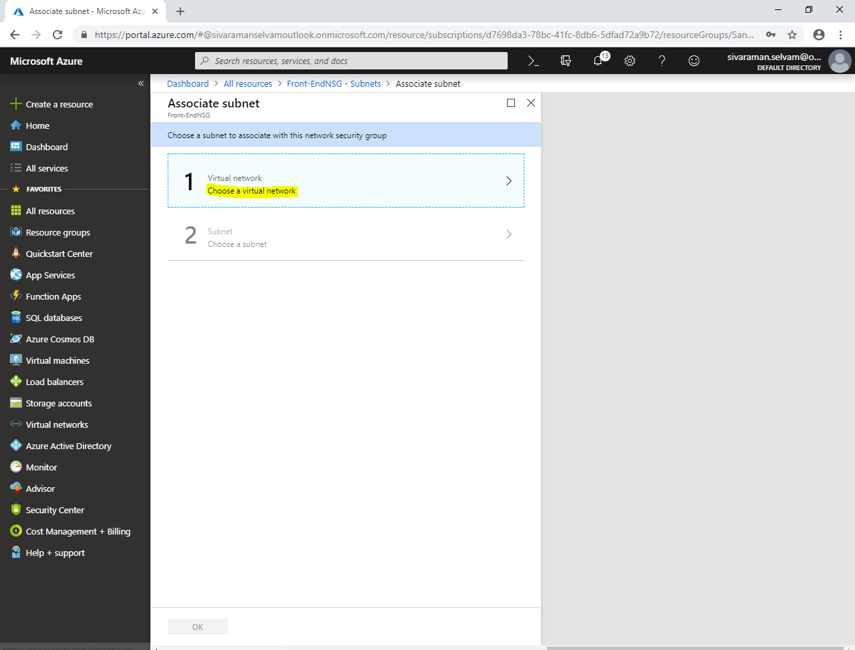

**Click “SANS-VNET”** to select the virtual network.

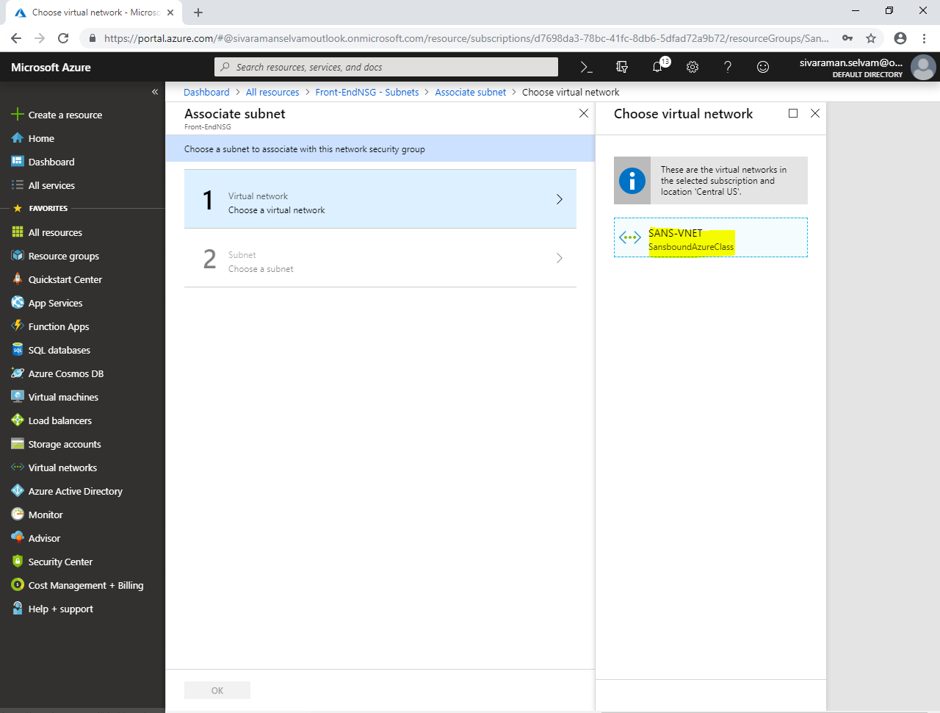

To **“Choose a subnet”** click **“SANS-PubSubnet”.**

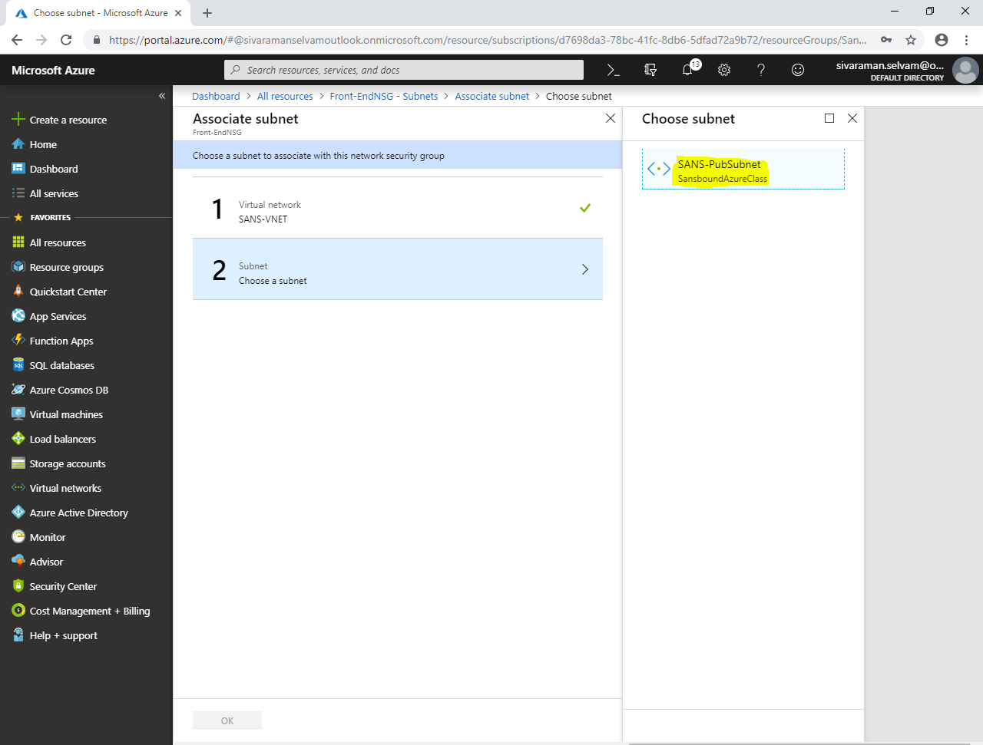

**Click “Ok”.**

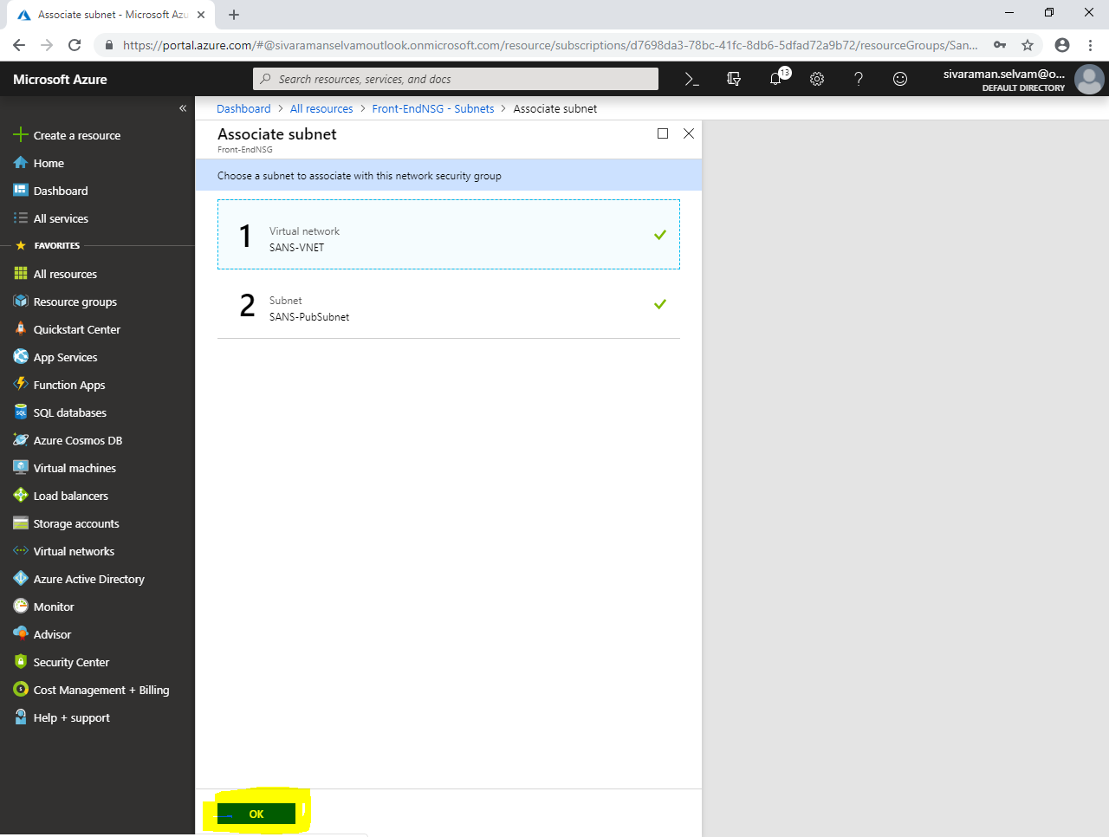

**Click “Virtual machines”,**

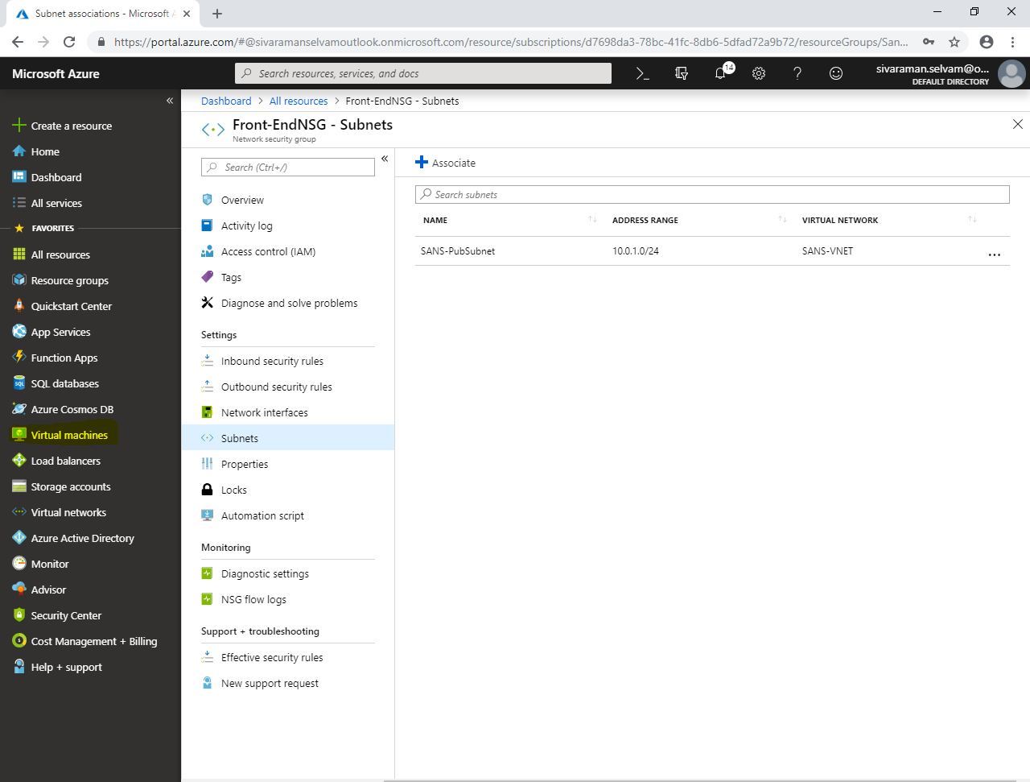

**While create virtual machine,**

Select **“Subscription”** as **“Free Trial”.**

Select **“Resource group”** as **“SansboundAzureClass”.**

Type **“Virtual machine name”** as **“Linux”.**

Select **“Region”** as **“Central US”.**

Select **“Image”** as **“Ubuntu Server 18.04”.**

Change **“VM size”** as **“Standard B1s”.**

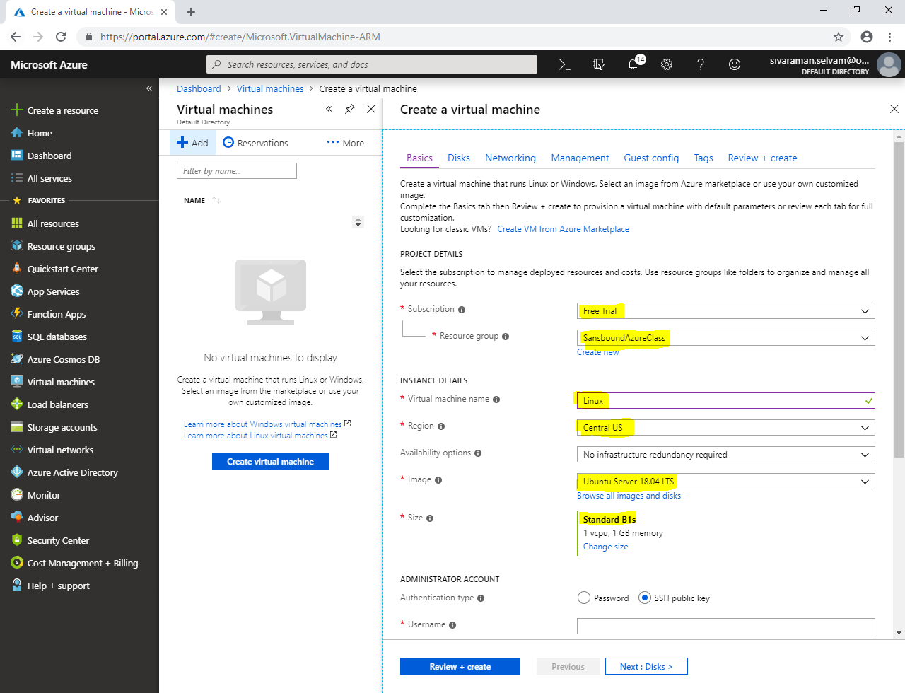

**In “Administrator Account”,**

**Set “Authentication type” as “Password”.**

**Type “Username” as “sansbound” and type password for the virtual machine.**

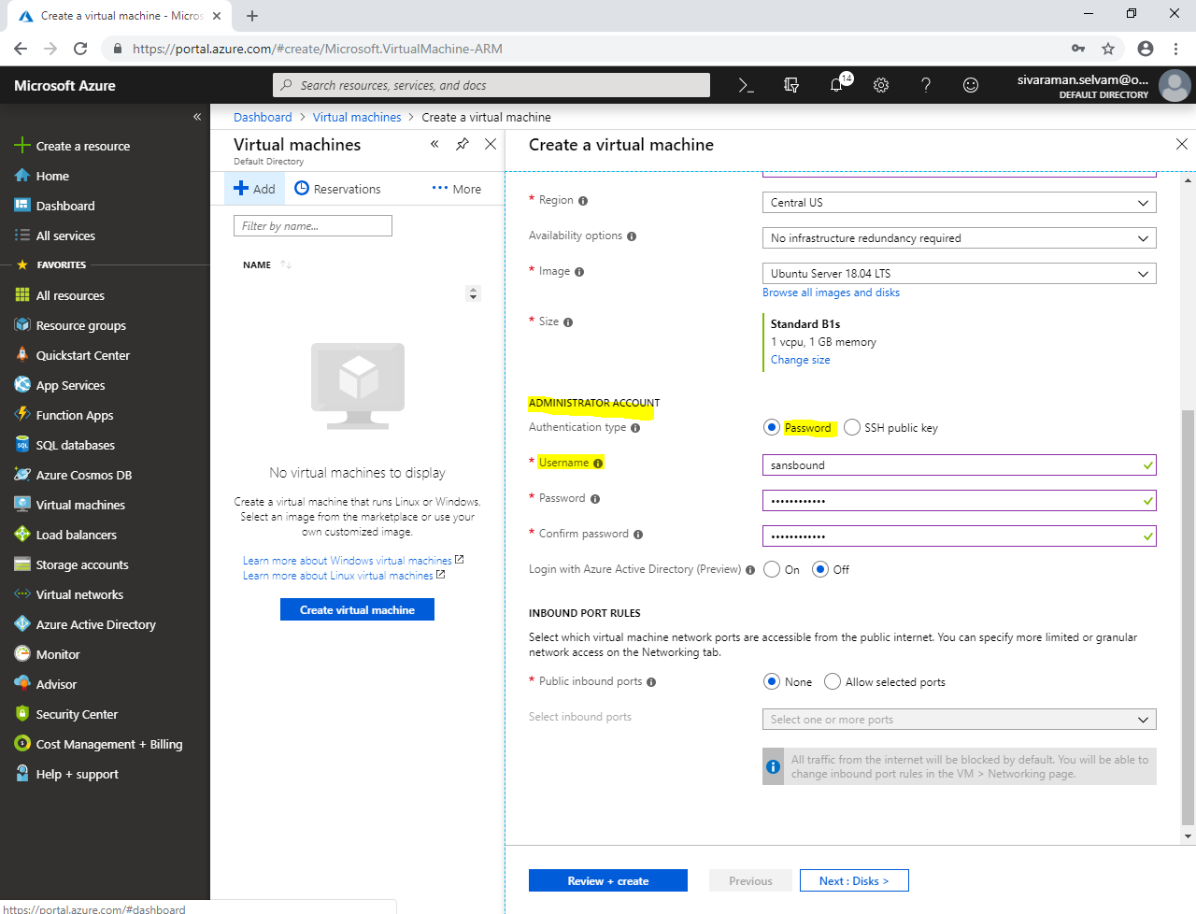

Click **“Next : Disks”.**

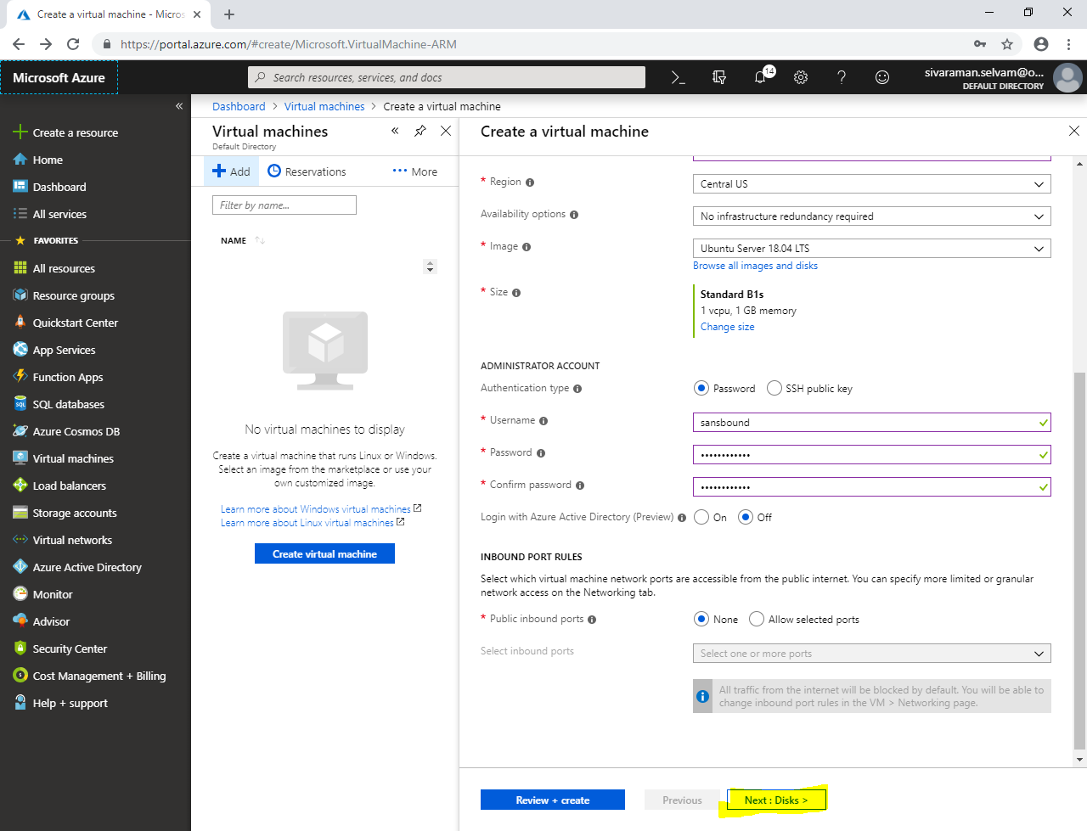

In **“Disks”,**

Expand **“Advanced”,**

Ensure **“Use managed disks” as “Yes”.**

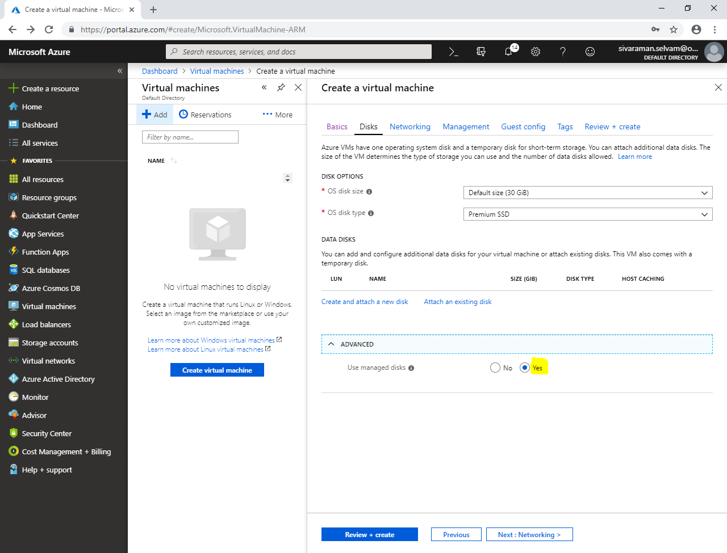

**Click “Next : Networking >”.**

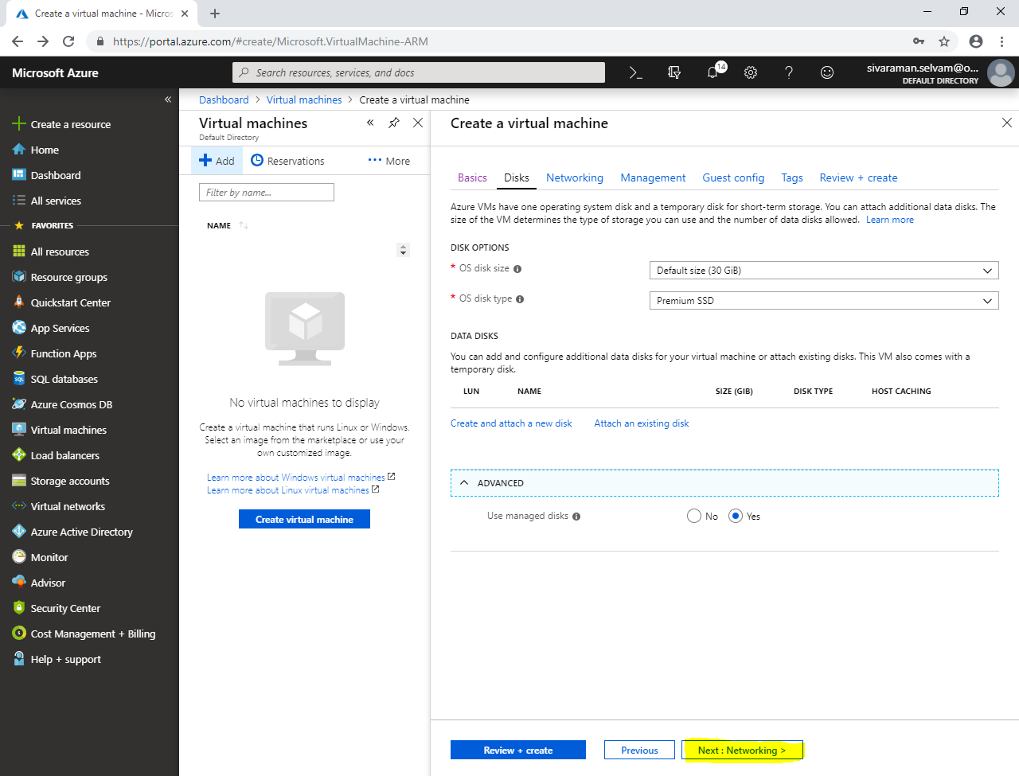

**In “Networking”,**

**Ensure “Virtual network” as “SANS-VNET”.**

**Ensure “Subnet” as “SANS-PubSubnet”.**

**Ensure Public IP is selected.**

**Ensure “NIC network security group” as “None”.**

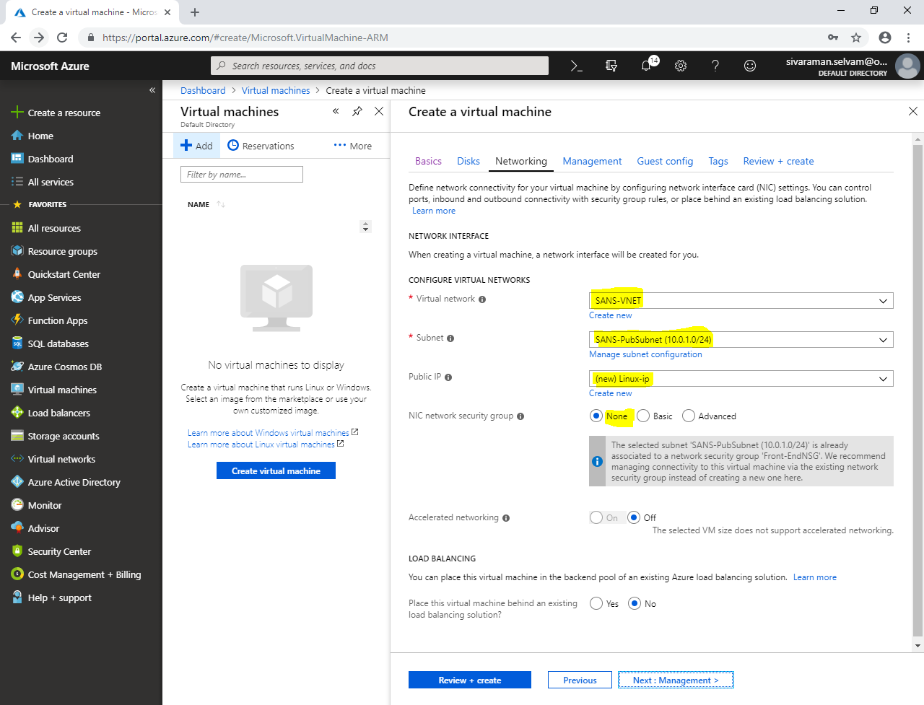

**Click “Next : Management”.**

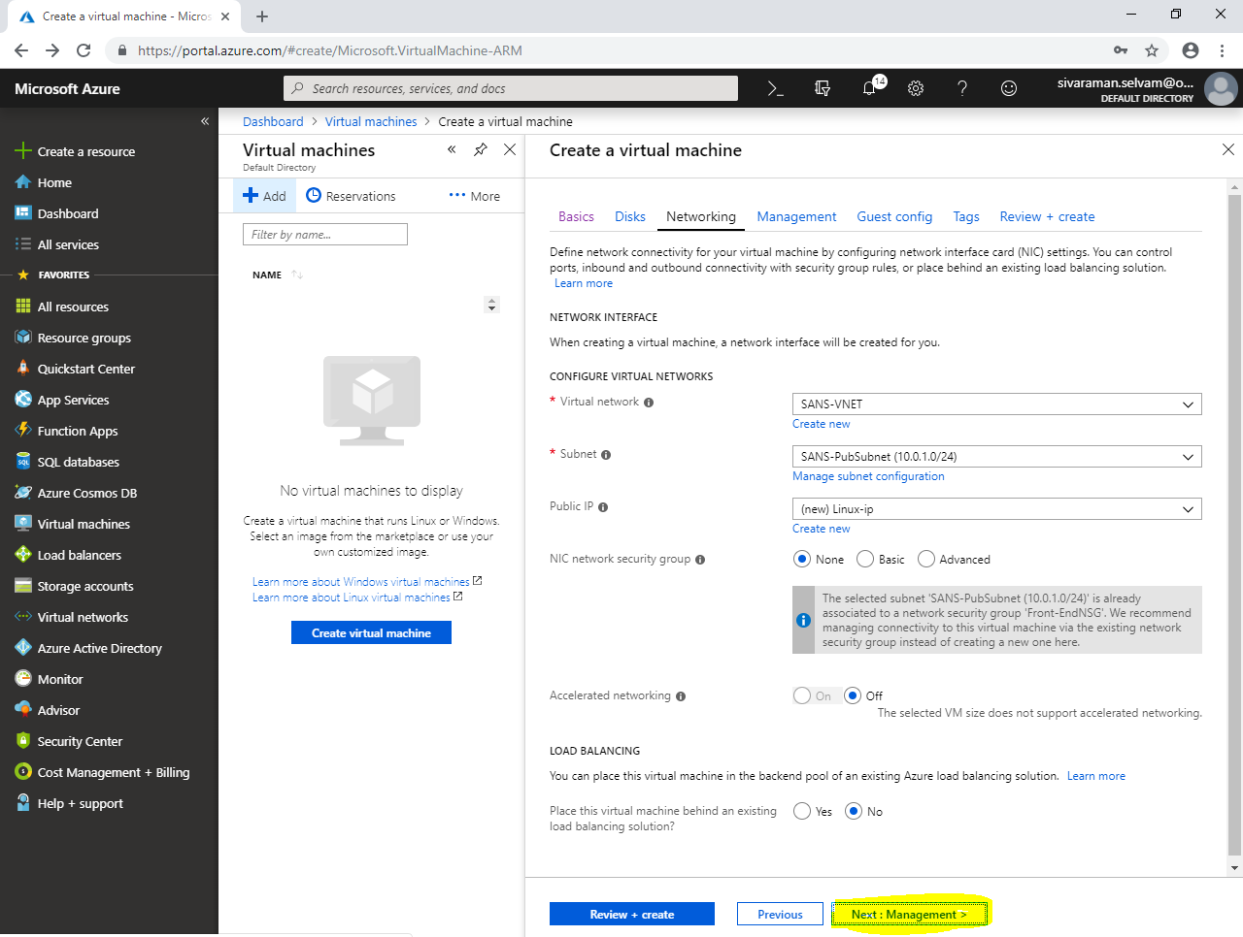

In **“Management”,**

Click **“Next : Guest config”.**

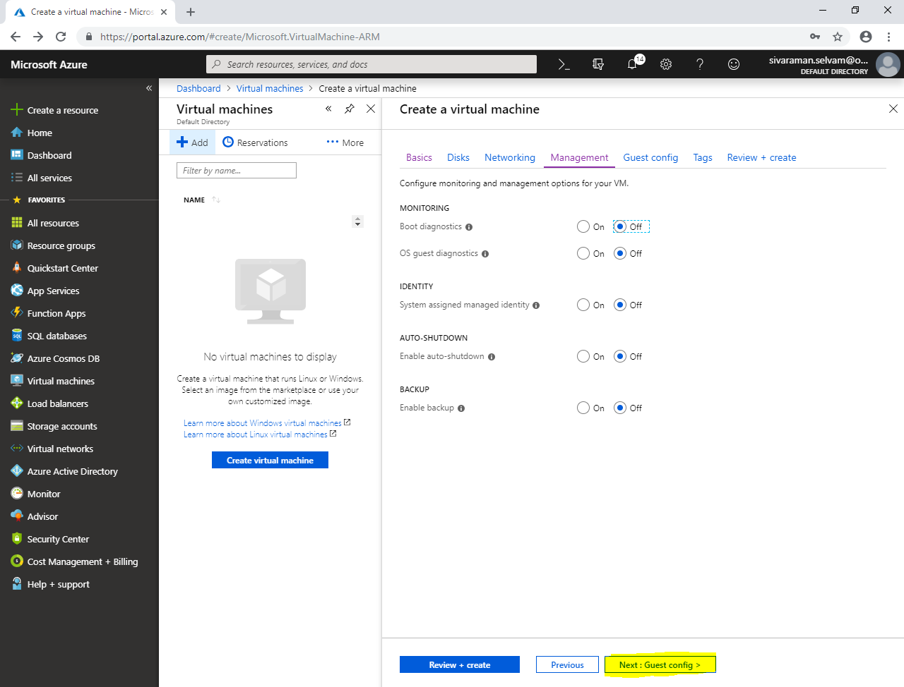

**In “Guest config”,**

Click **“Next : Tags >”.**

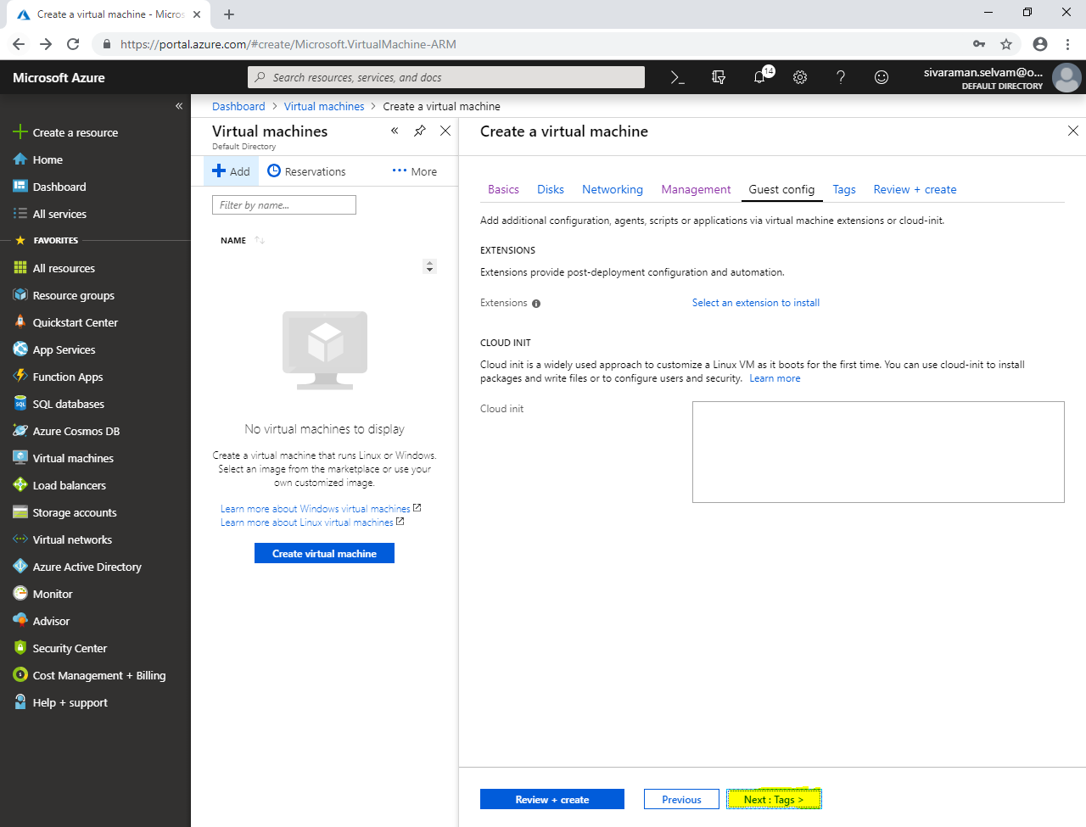

In **“Tags”,**

Click **“Next : Review + create”.**

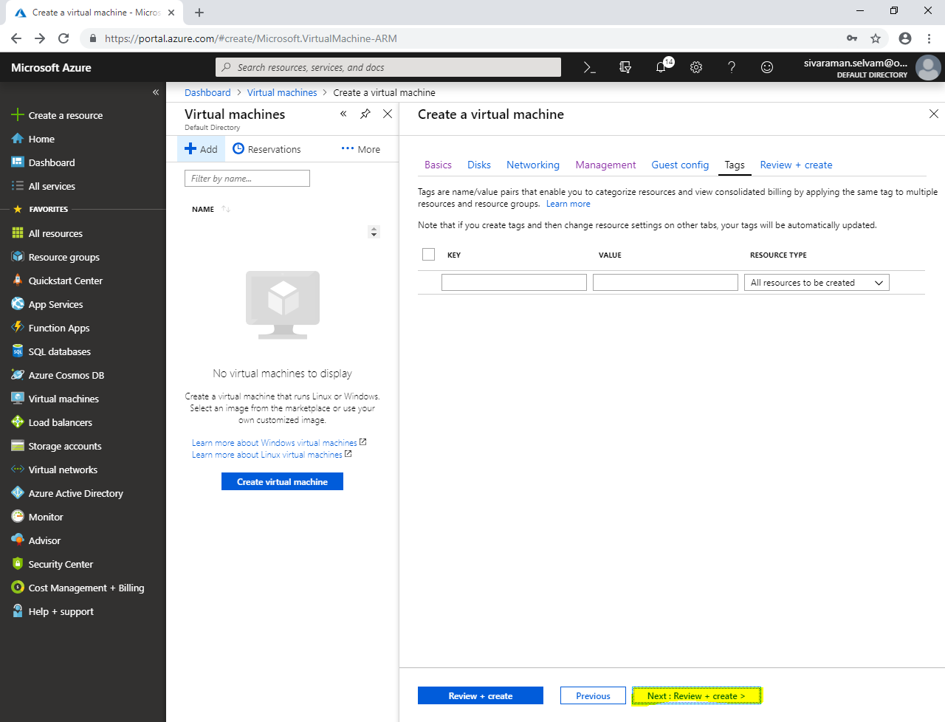

**Click “Create”.**

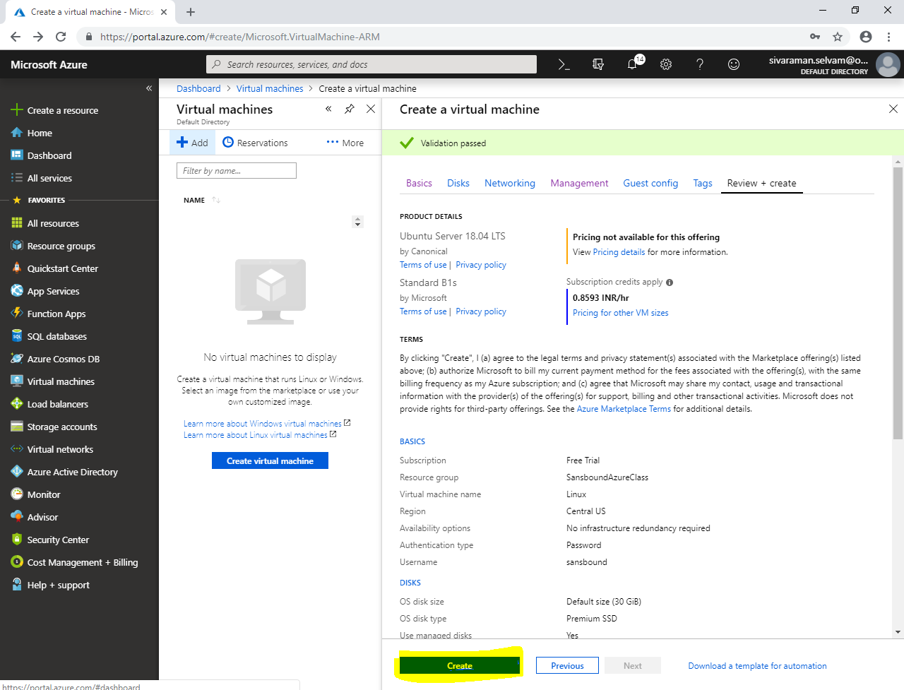

Click **“Go to resource”.**

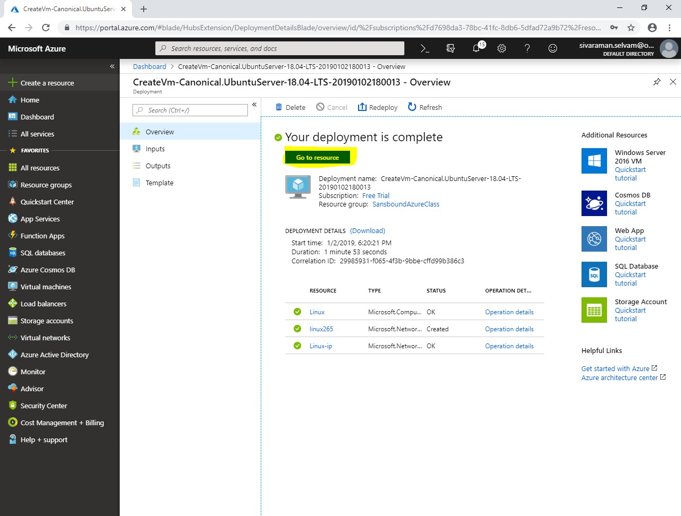

Kindly note the public IP address of Linux / Ubuntu.

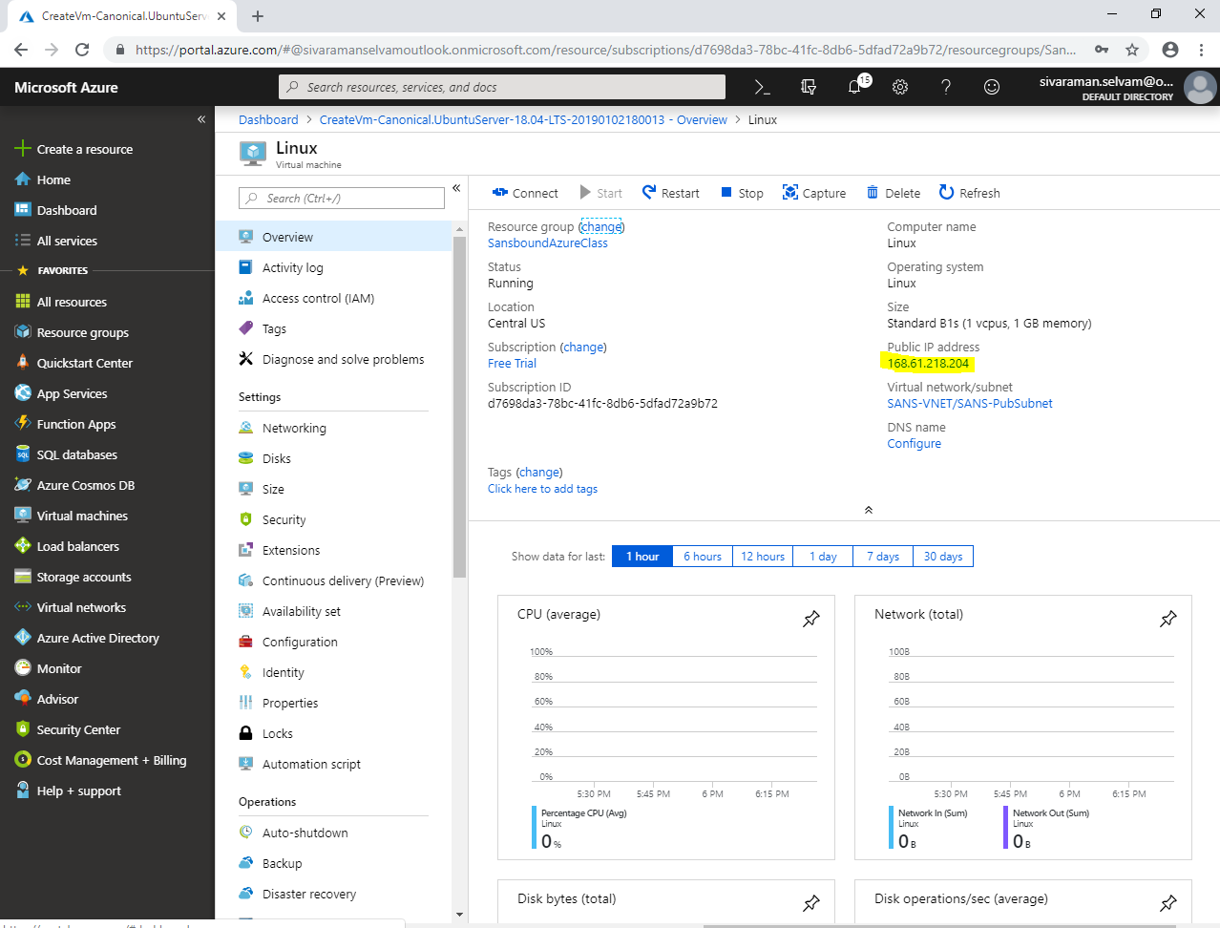

From your local machine, launch **“putty.exe”** to connect the Ubuntu.

Type Pubic IP address of Ubuntu in putty and click **“Open”** to connet.

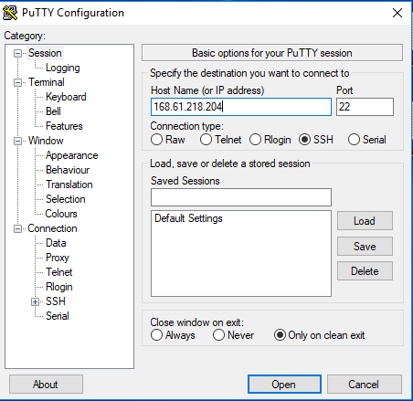

Type username as **“sansbound”** and press **“Enter”**.

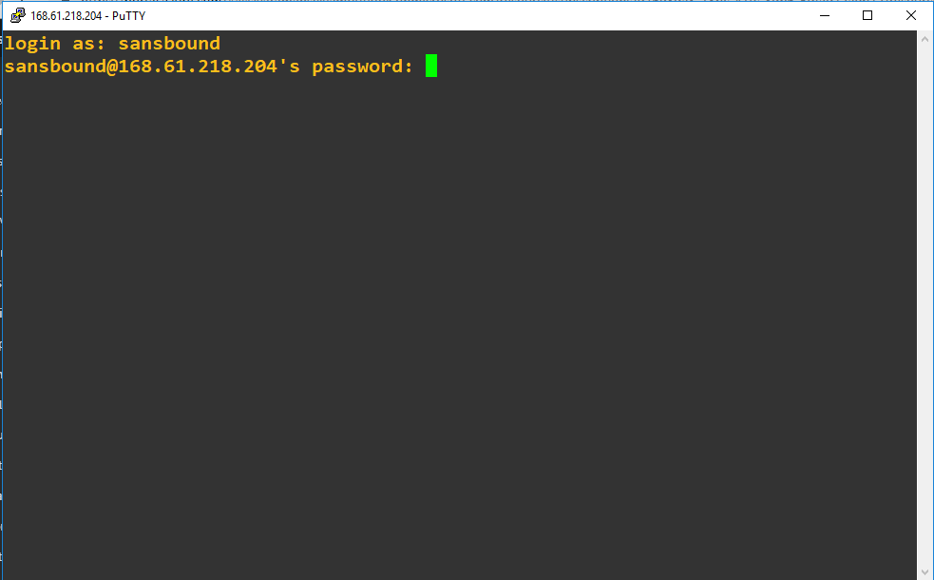

Type **“Password”** of Ubuntu and press **“Enter”**.



You have successfully logged into Ubuntu server.

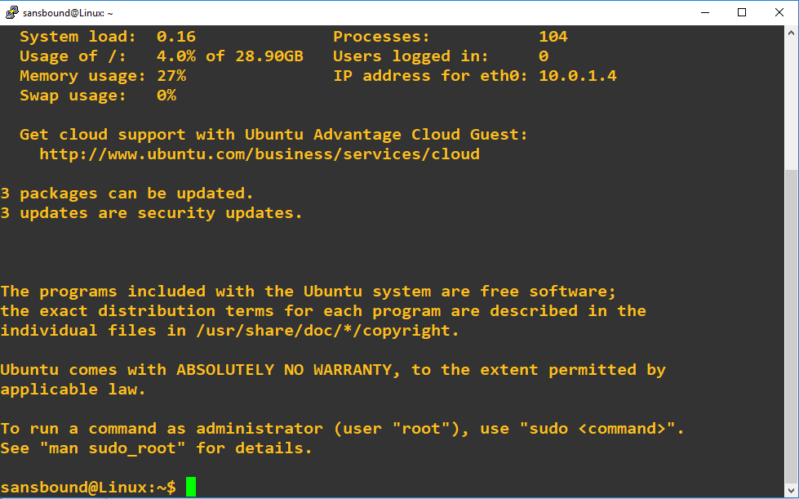

Type **“sudo –i”** and press **“Enter”** to login Ubuntu as a root account.

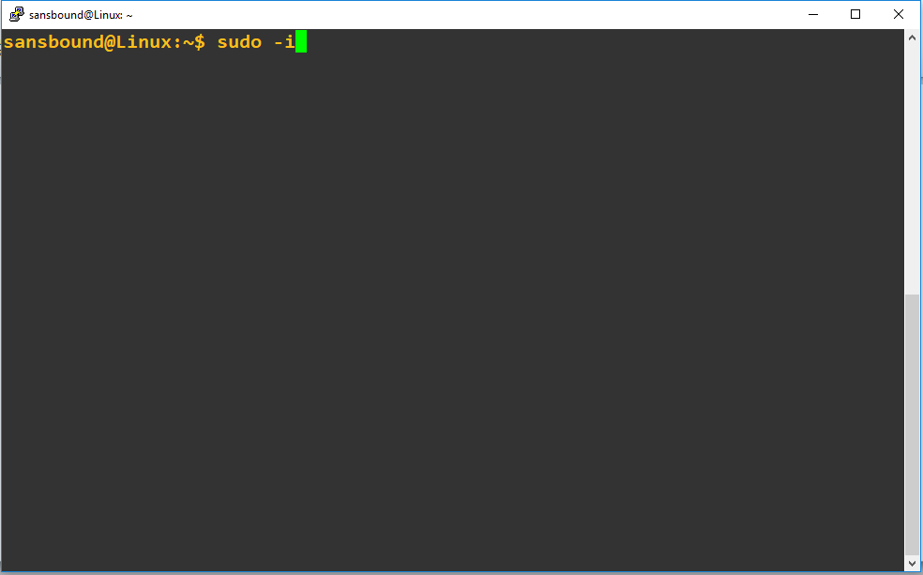

Type **“apt-get update”** and press **“Enter”** to update the packages.

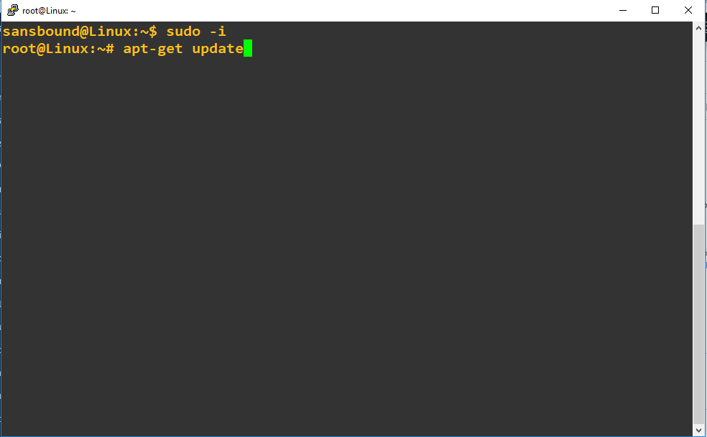

You have successfully updated Ubuntu packages from internet.

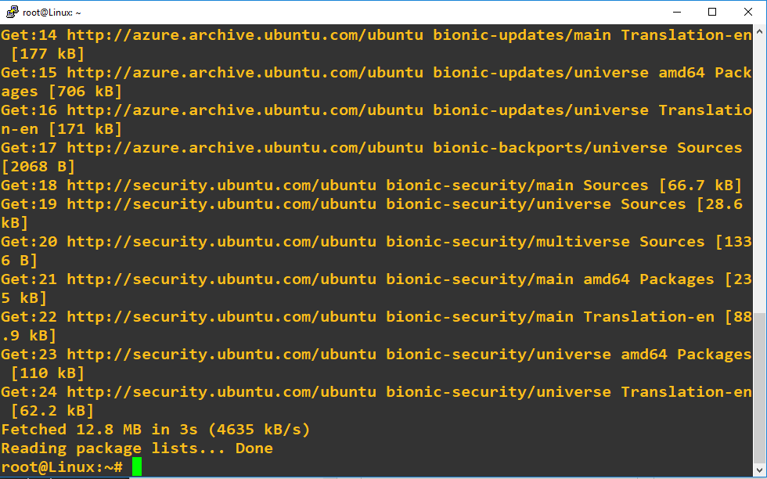

Type **“apt-get install apache2”** and press **“Enter”**.

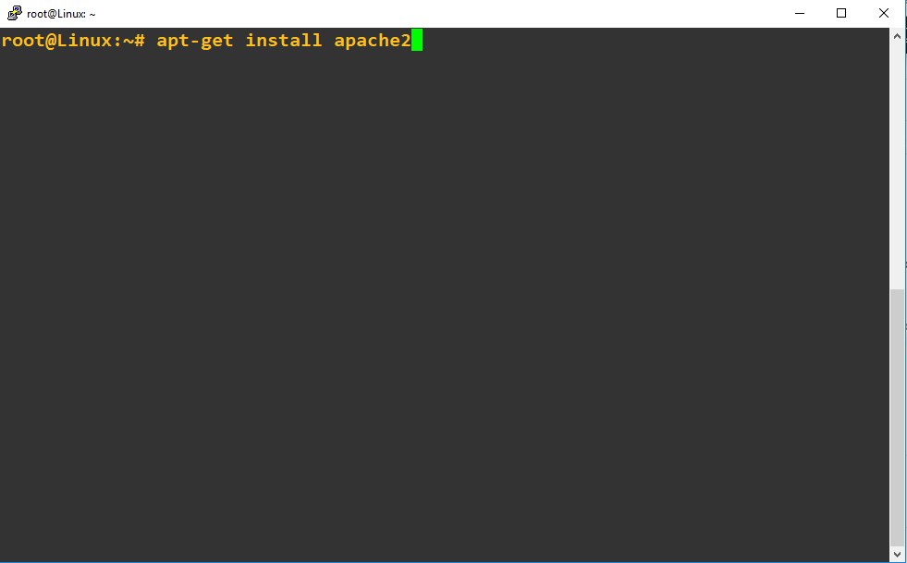

Type **“y”** and press **“Enter”**.

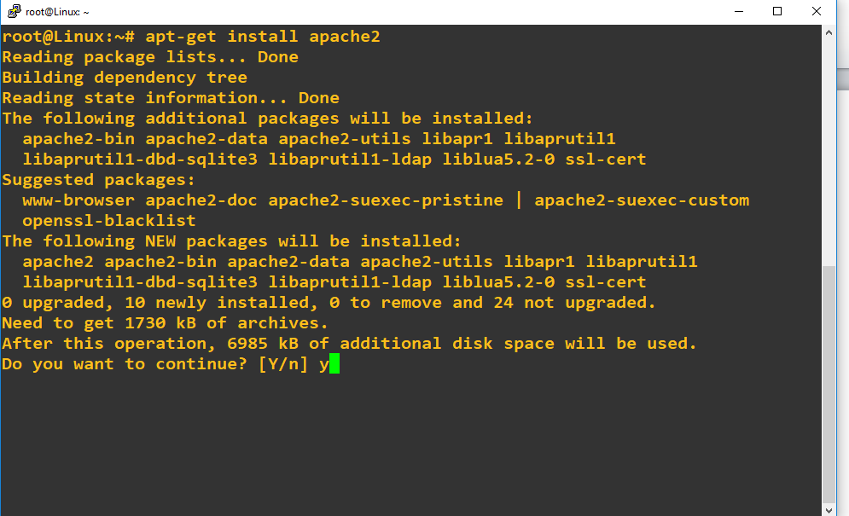

Type public IP address of Ubuntu in browser and press **“Enter”.**

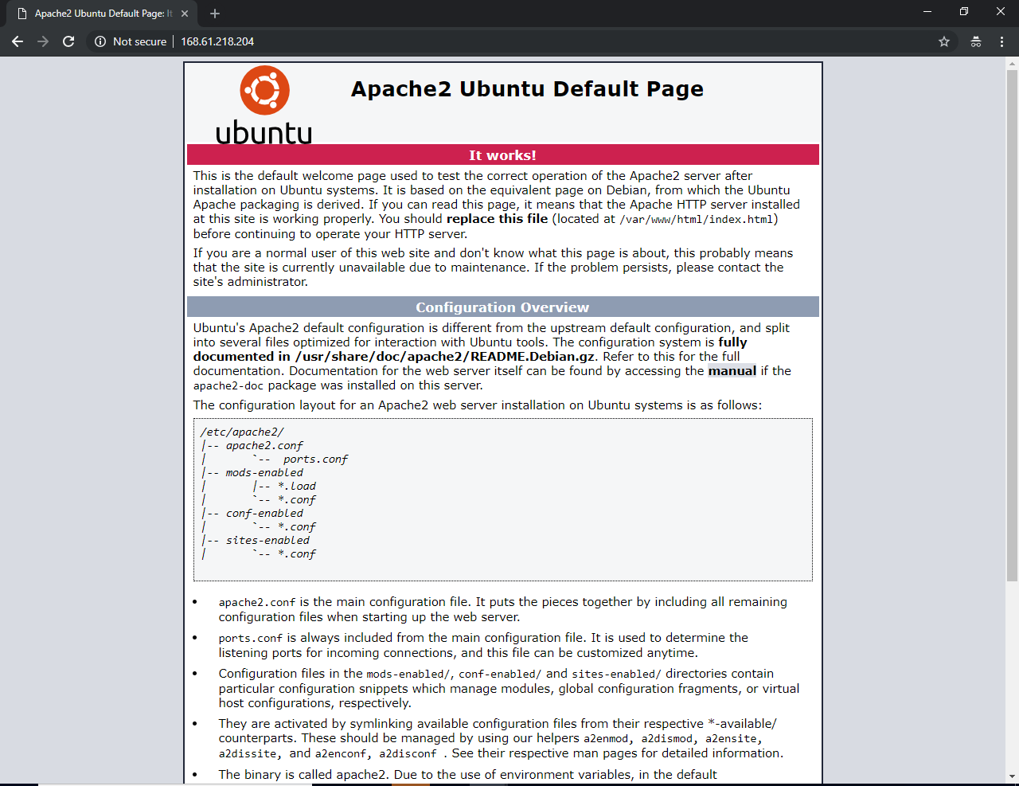

In Ubuntu virtual machine,

Click **“Capture”** to capture the virtual machine as image.

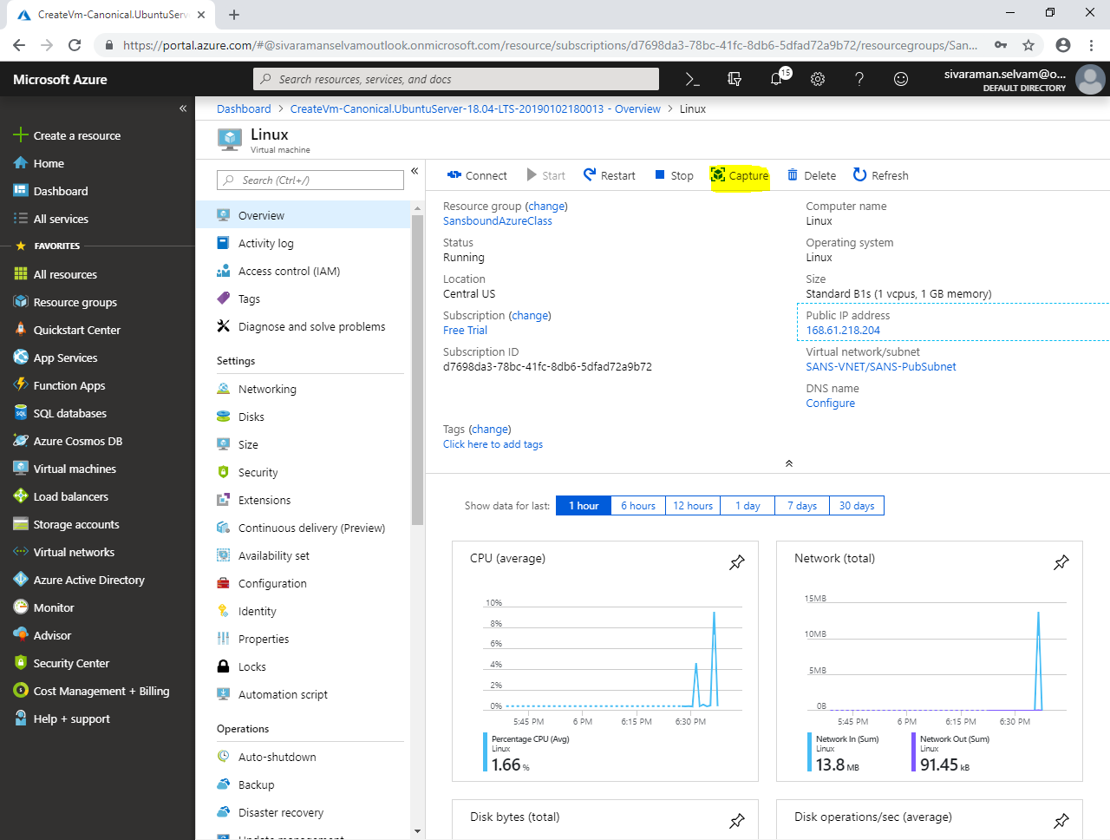

While **“create image”**,

Type **“Name”** as **“Sans-Webserver”**.

Select **“Resource group”** as **“SansboundAzureClass”**.

Need to check **“Automatically delete tis virtual machine after creating the image”**.

In **“Zone resilency”** click **“On”**.

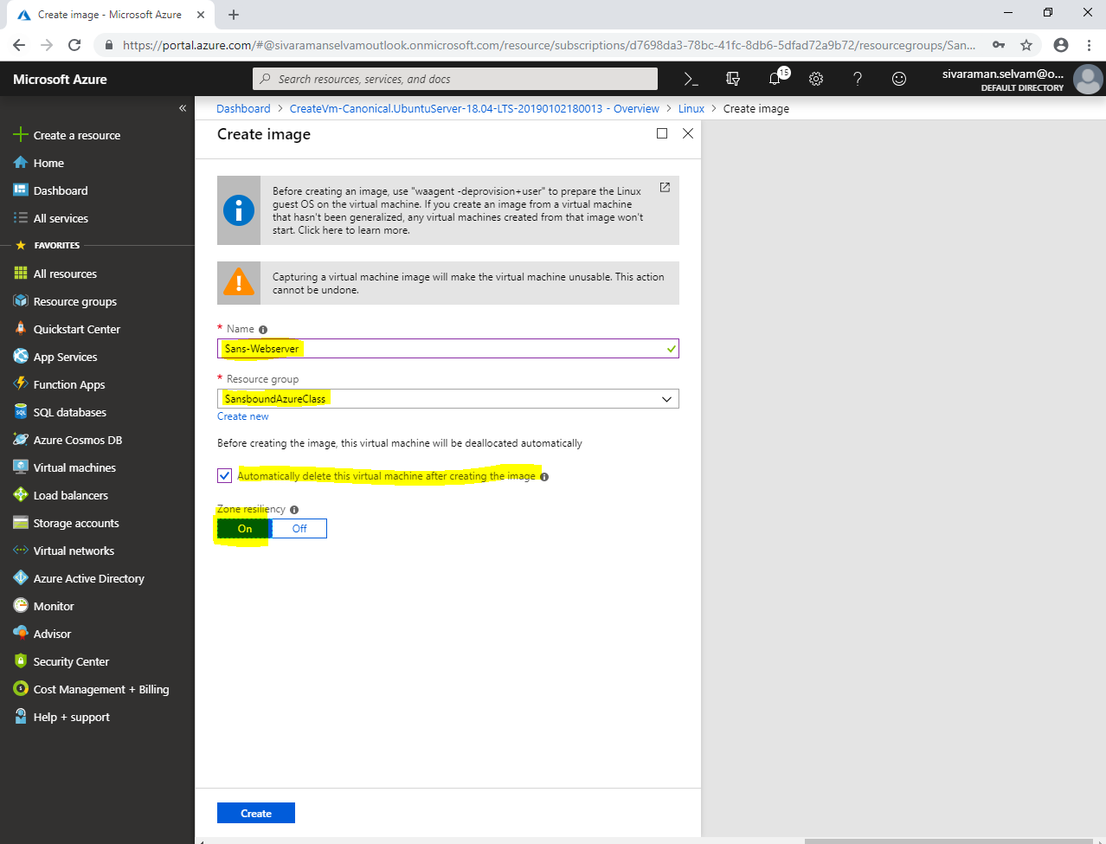

Click **“Create”**.

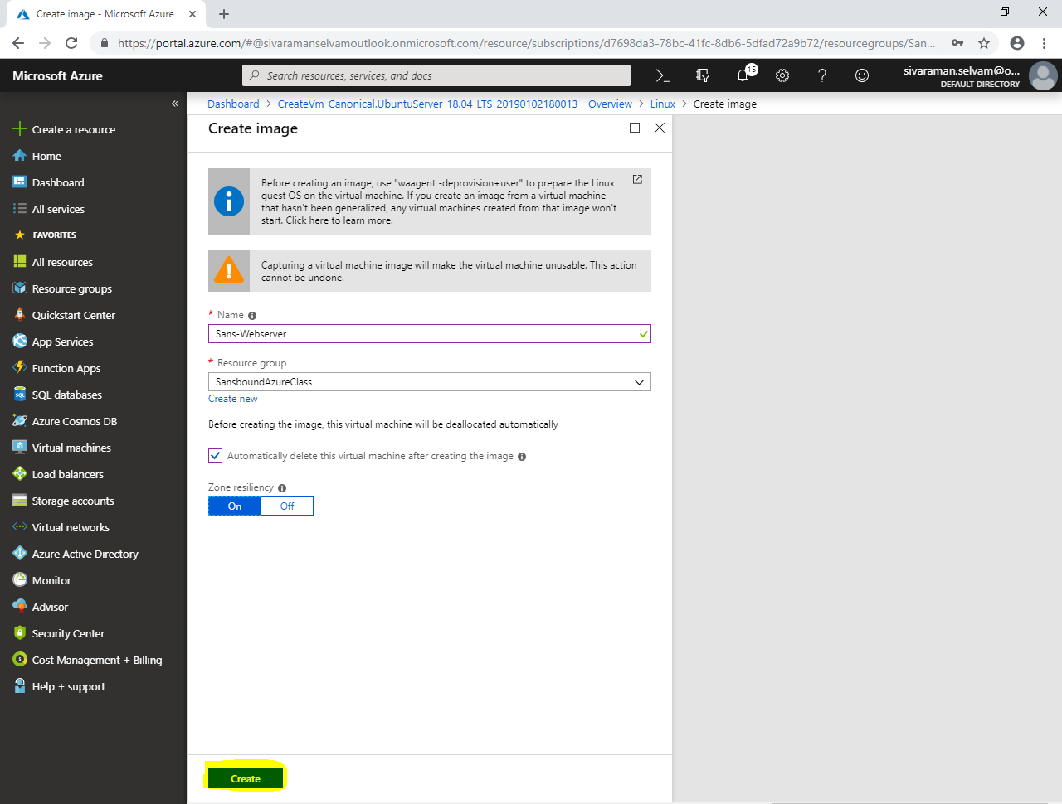

Click **“Virtual machines”** in left side panel.

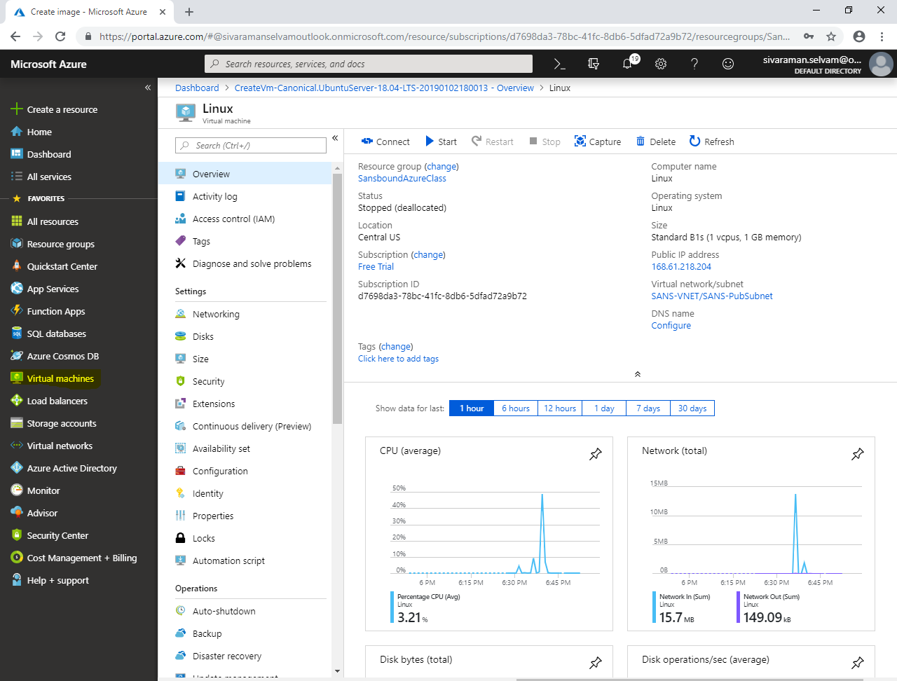

In **“Virtual machines”**,

Click **“Add”**.

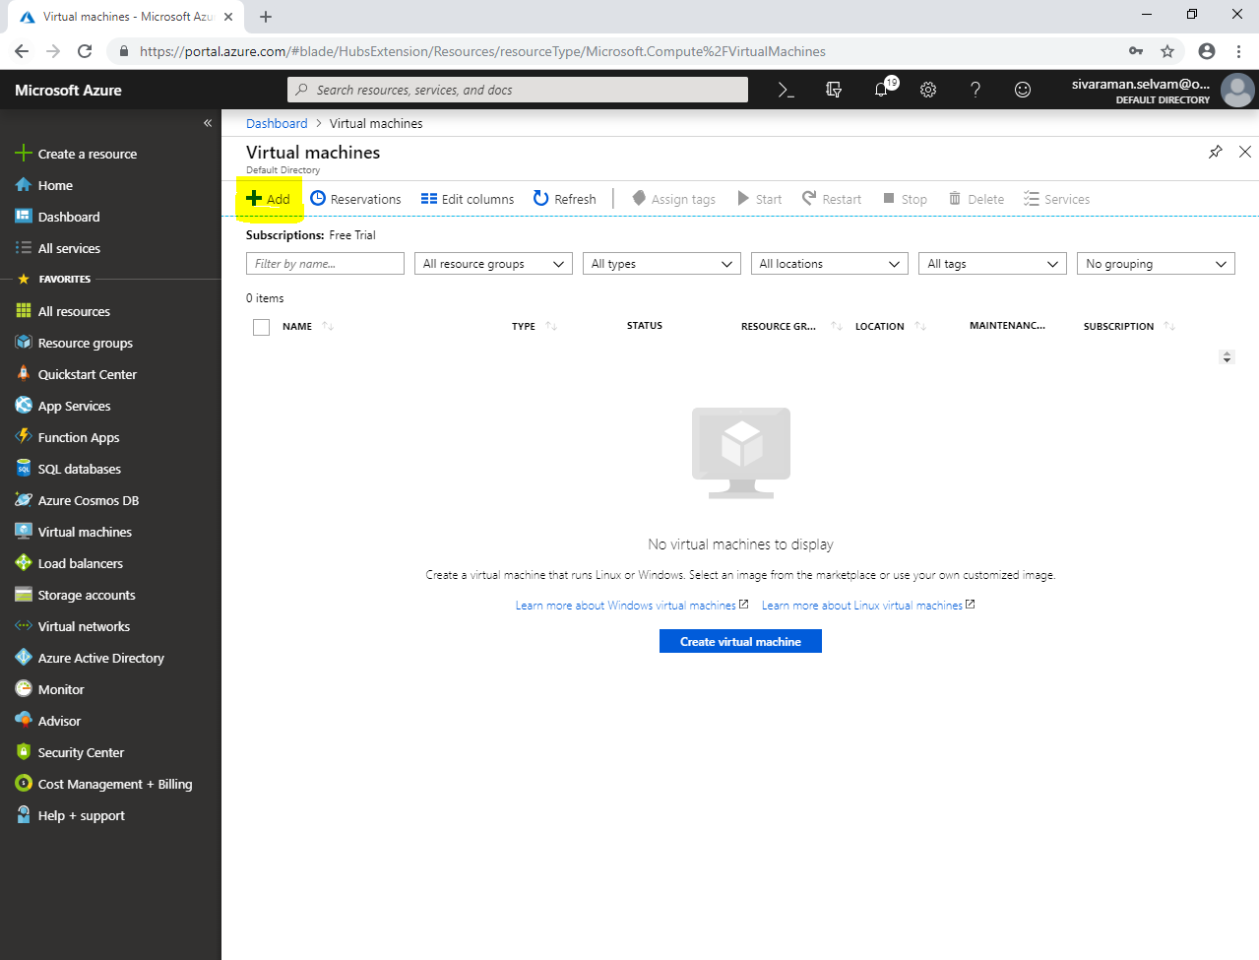

Type **“Virtual machine name”** as **“webserver01”**.

Select **“Region”** as **“Central US”**.

Select **“Availability options”** as **“Availability Set”**.

Select **“Availability set”** as **“Sans-Cluster”**.

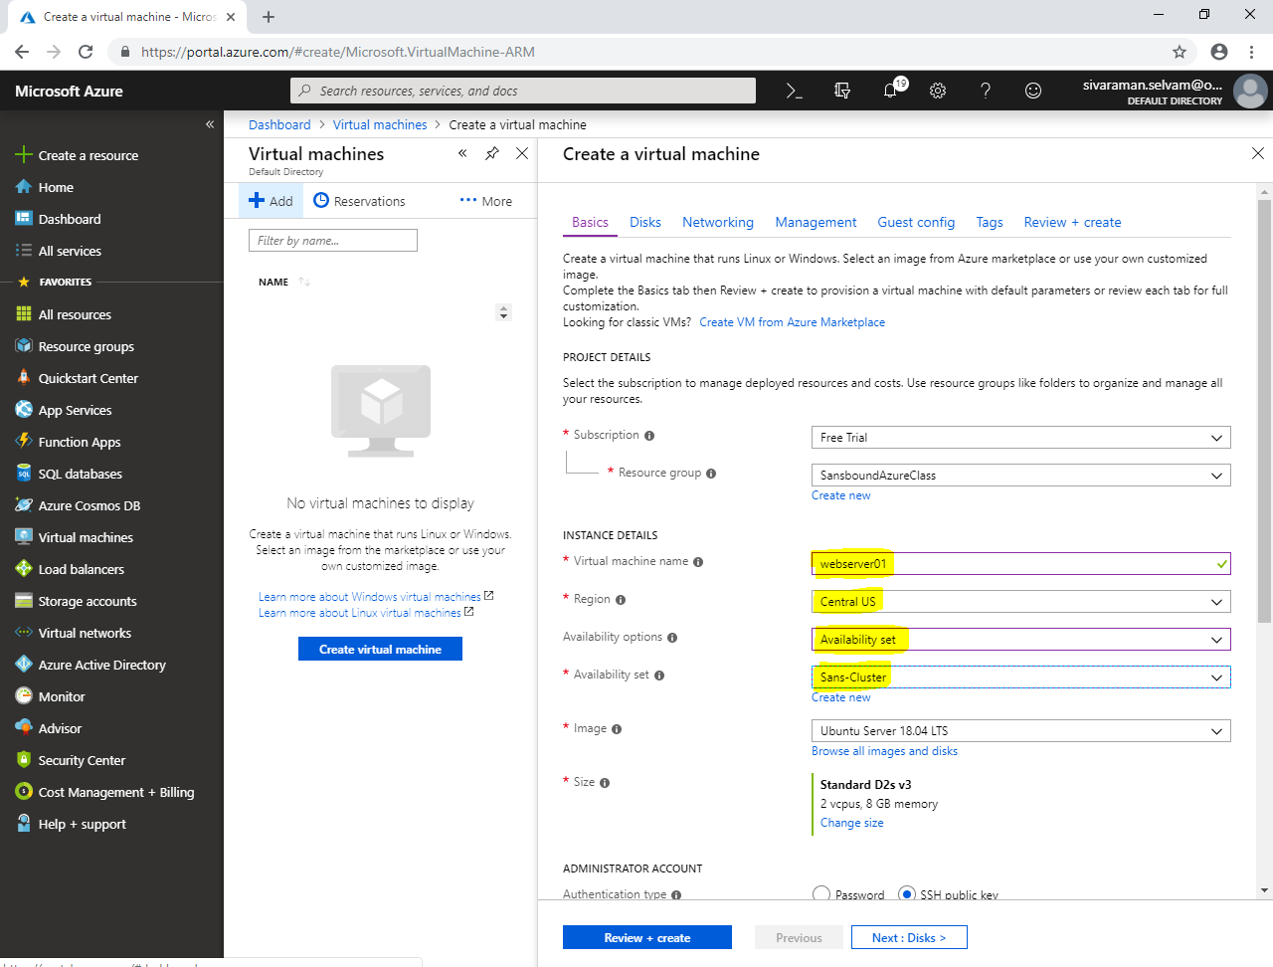

In **“Image”** click **“Browse all images and disks”**.

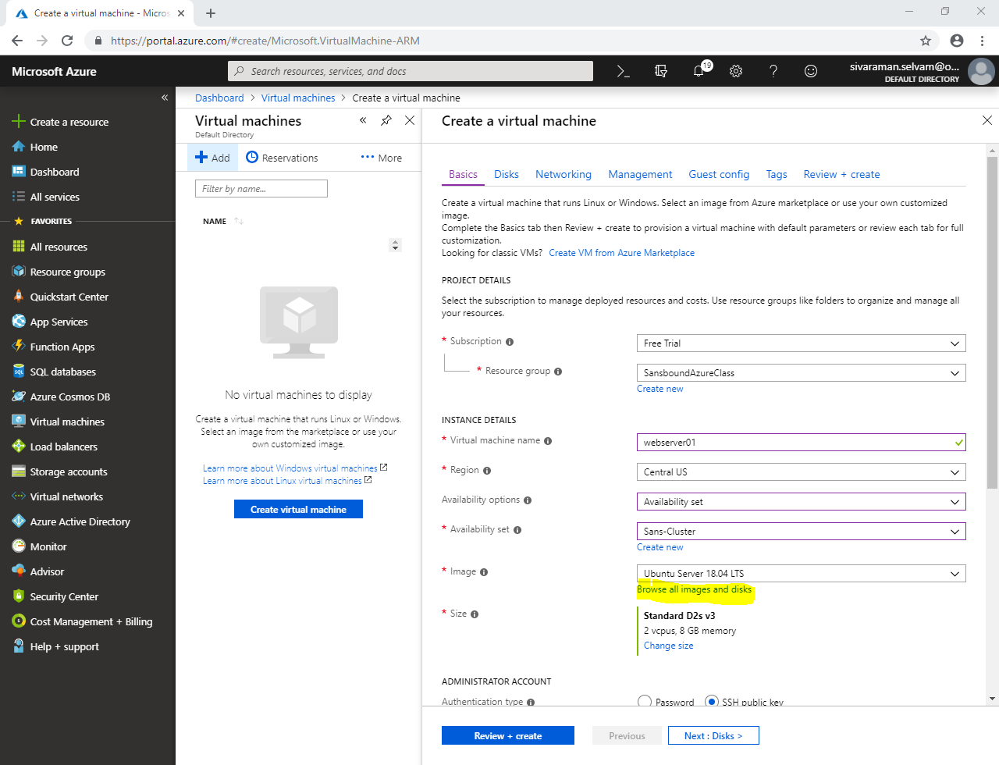

Click **“My Items”**.

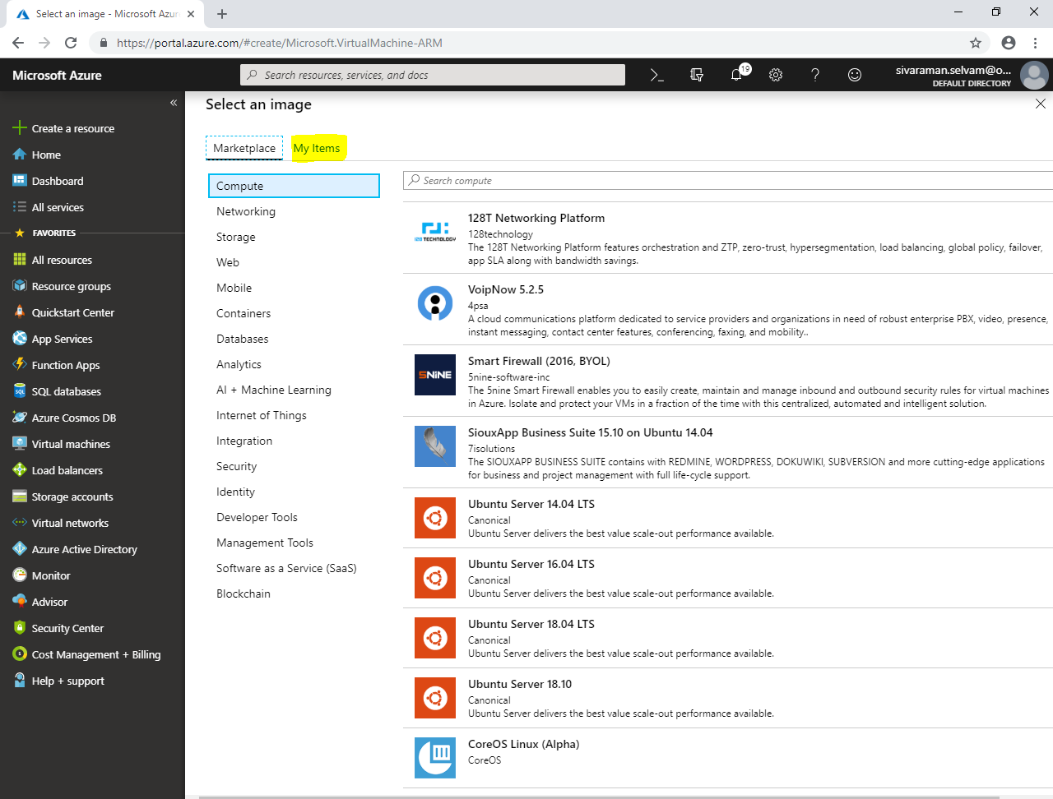

Click **“Sans-Webserver”** image.

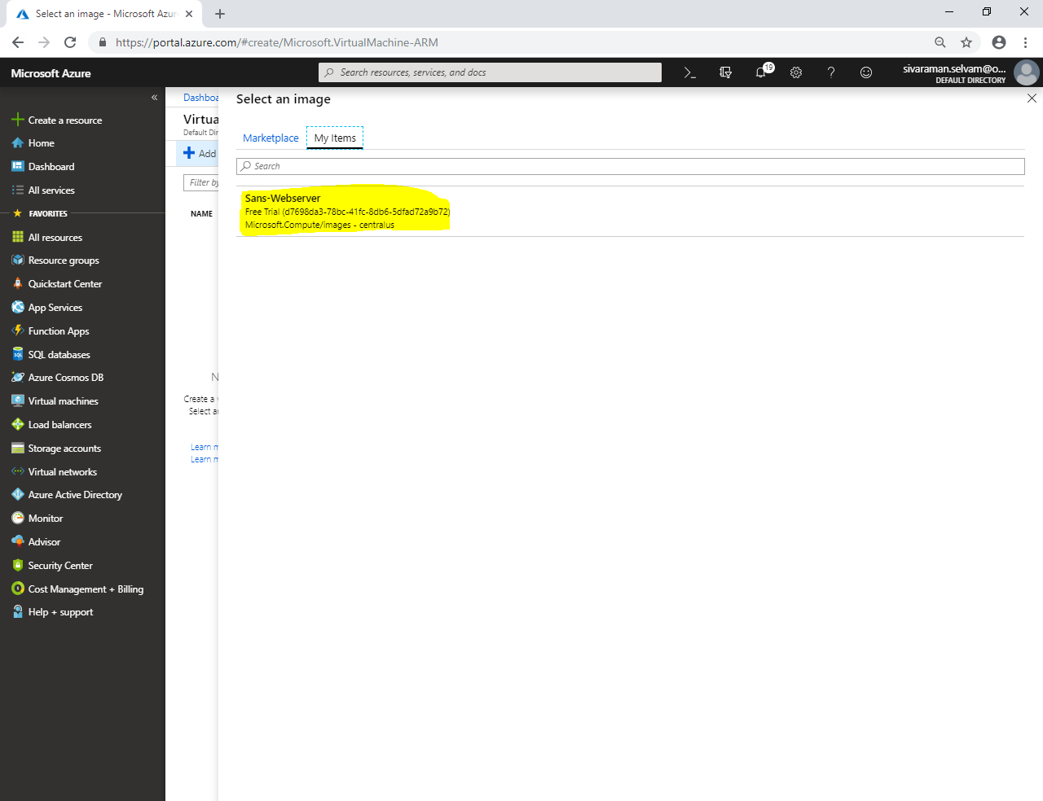

Ensure that you have selected **“Sans-Webserver”**.

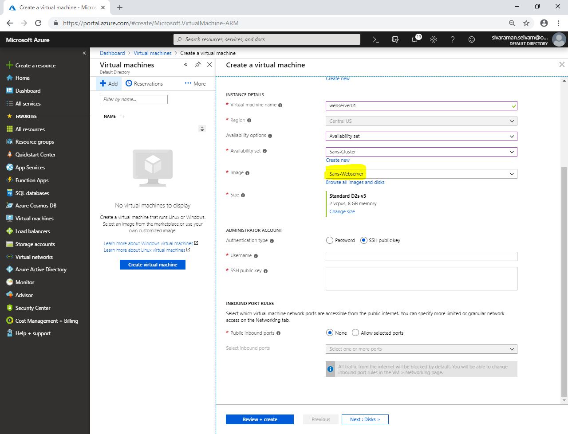

Change **“VM Size”** as **“Standard B1s”**.

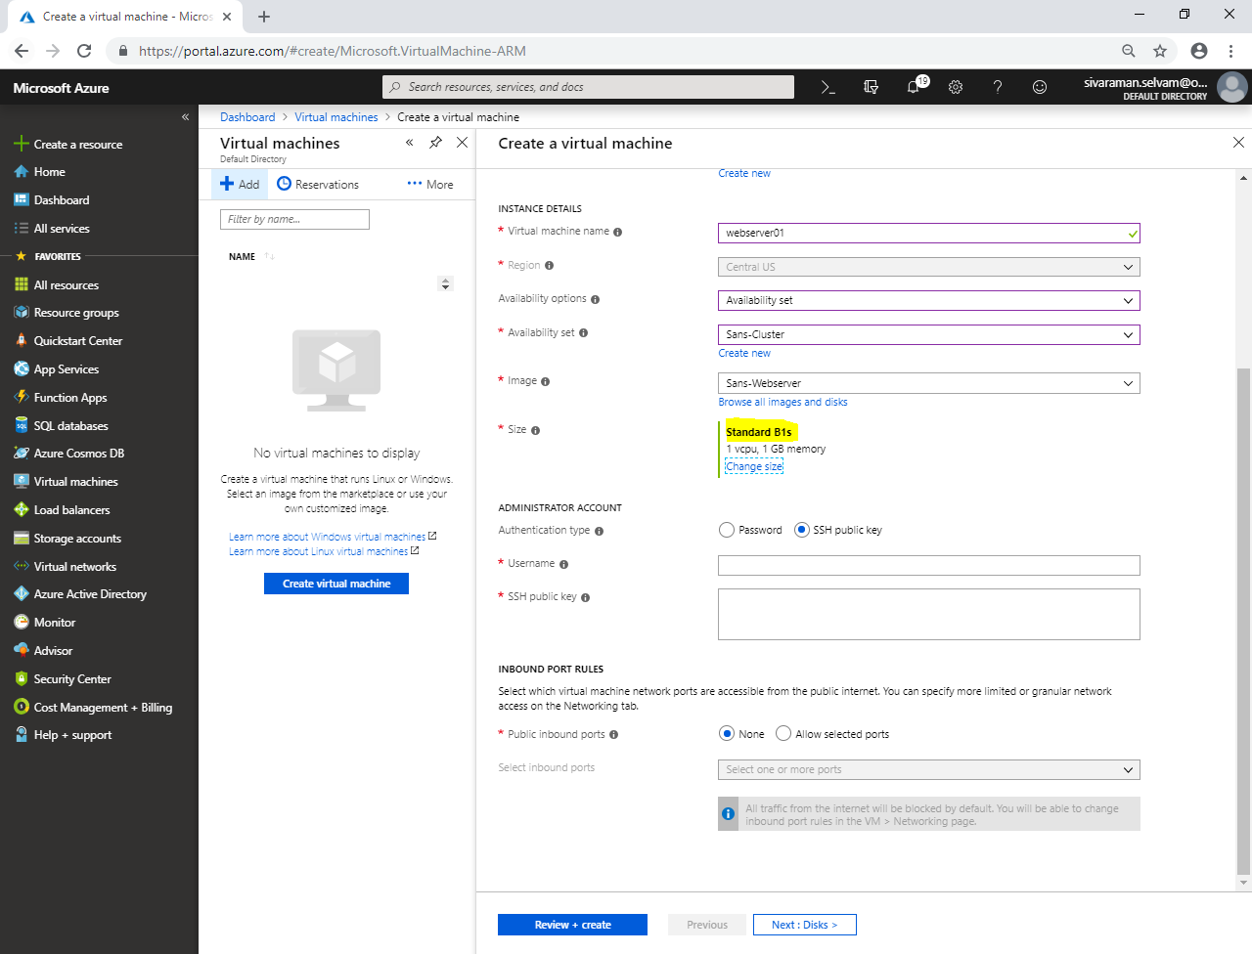

In **“Administrator account”**,

Click **“Authentication type”** as **“Password”**.

Type **“Username”** as **“sansbound”**.

Type **“Password”** for the Ubuntu server.

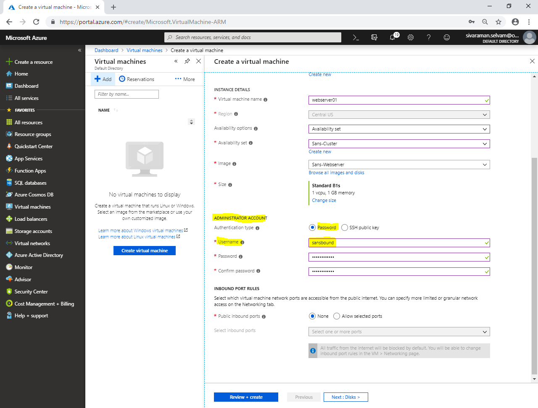

Ensure **“Inbound port rules”** as **“None”**.

Because associated subnet for **“Front-EndNSG”.**

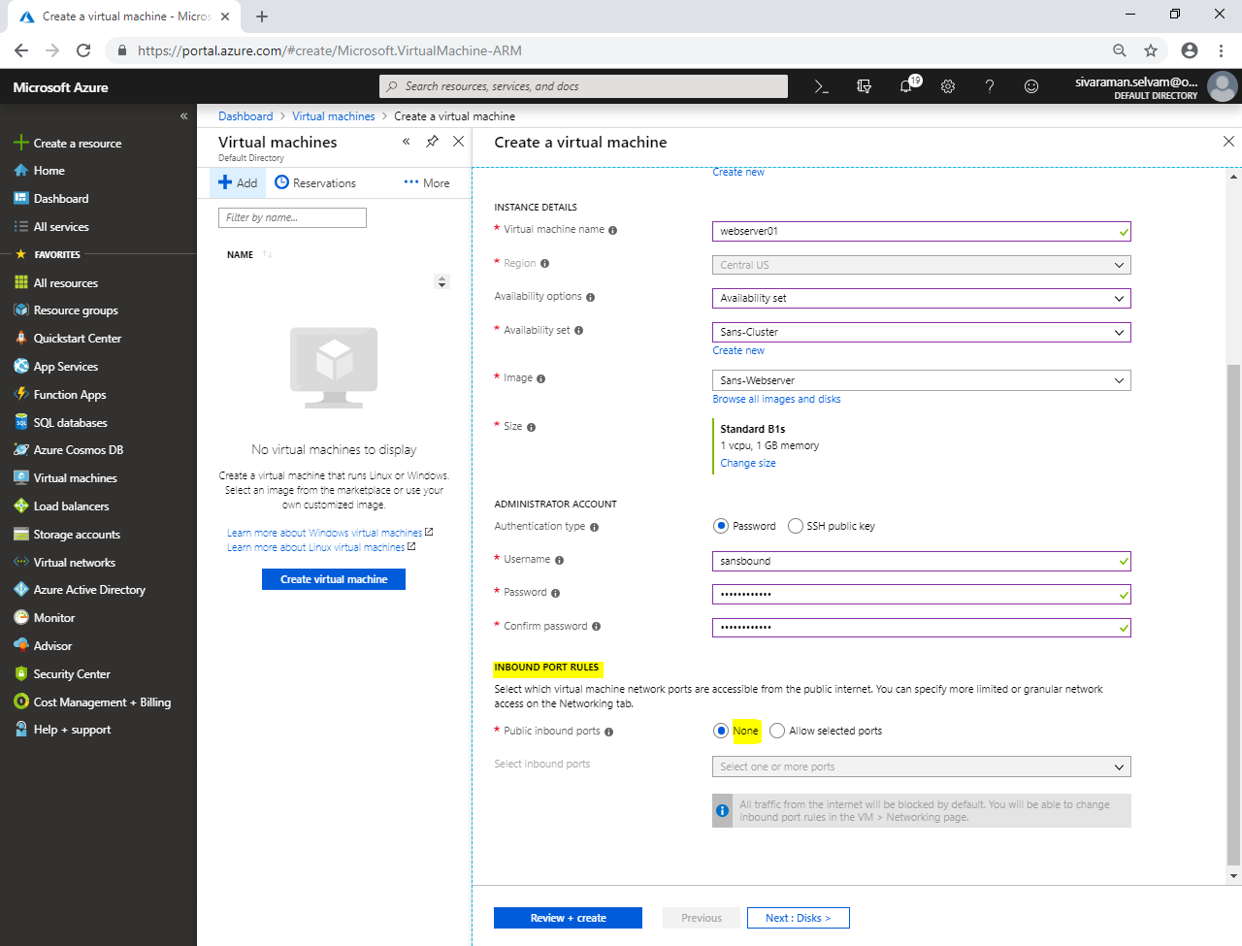

Click **“Next : Disks >”**.

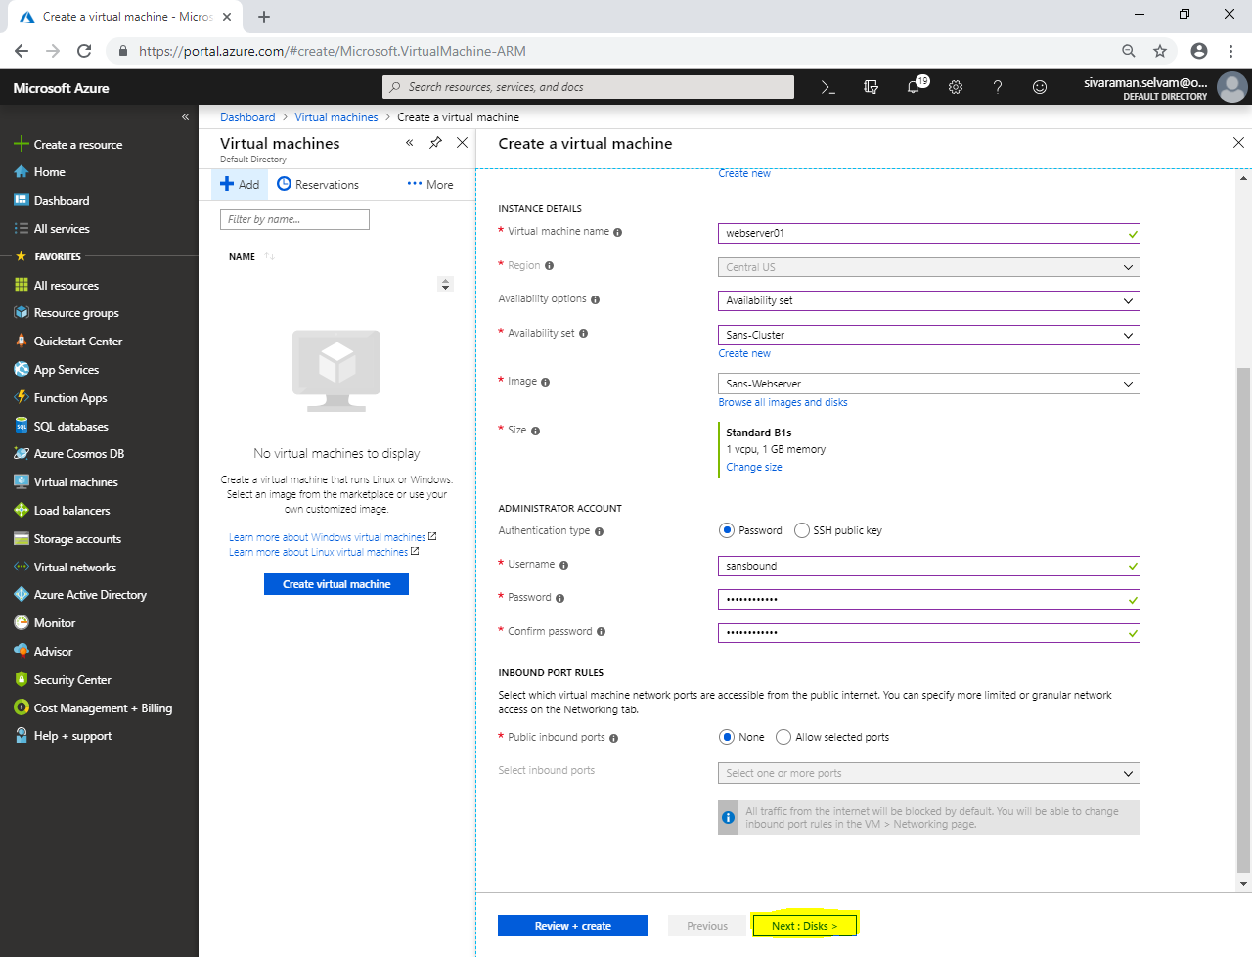

In **“Disks”**,

Click **“Next : Networking >”**.

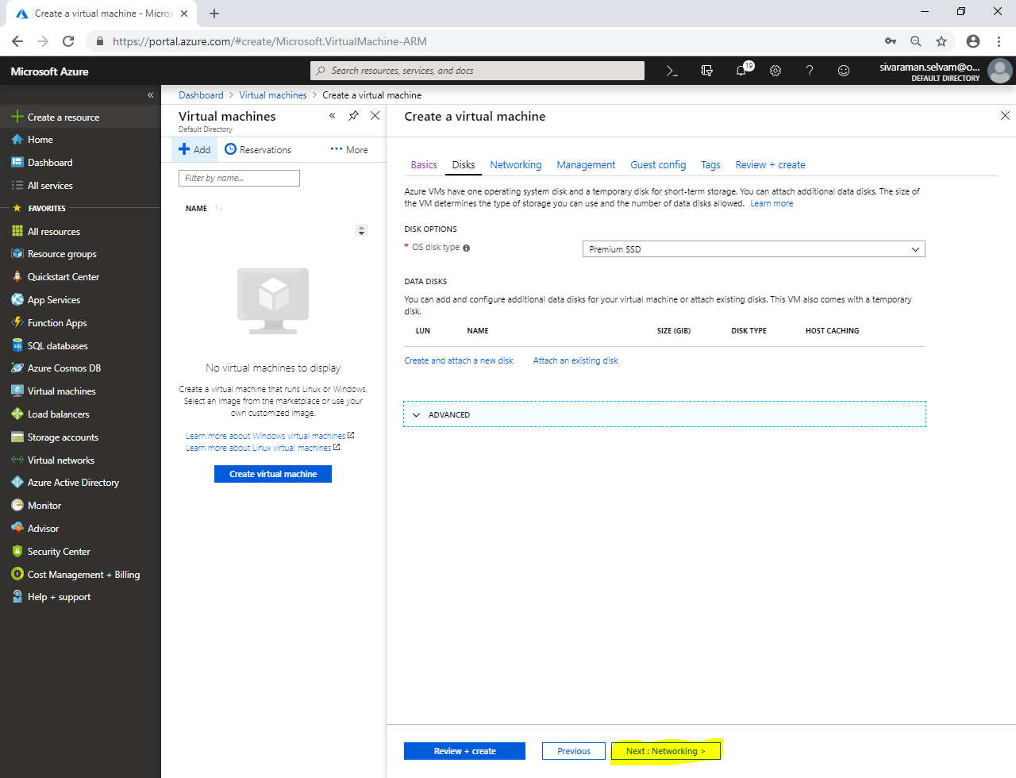

In **“Networking”**,

Ensure **“Virtual network”** as **“SANS-VNET”**.

Ensure **“Subnet”** as **“SANS-PubSubnet”**.

Ensure **“Pubic IP”** is selected.

Ensure **“NIC network security group”** as **“None”**.

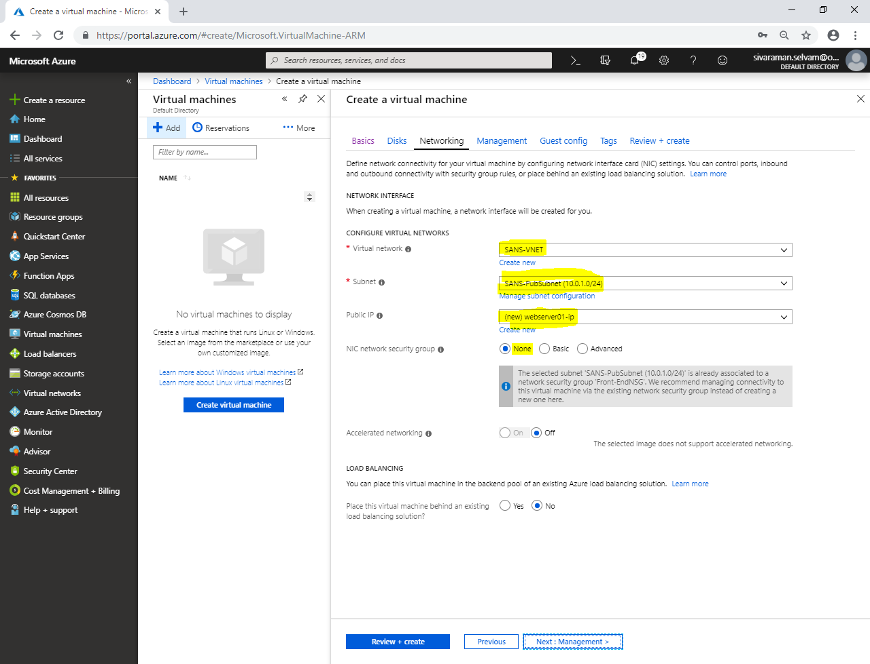

Click **“Next : Management >”**.

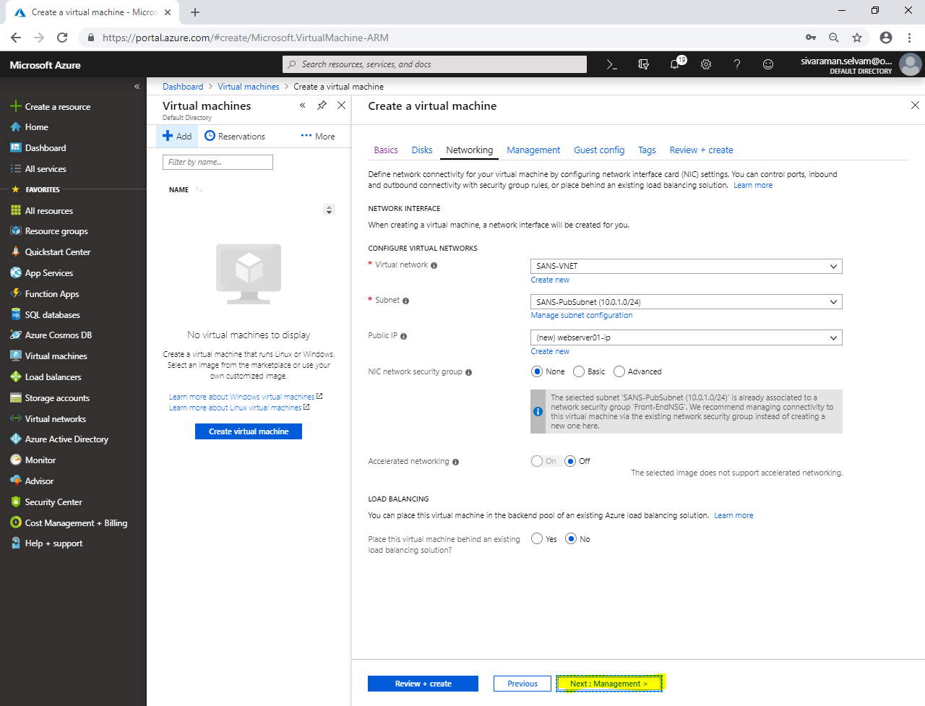

In **“Management”**,

Click **“Next : Guest config >”**.

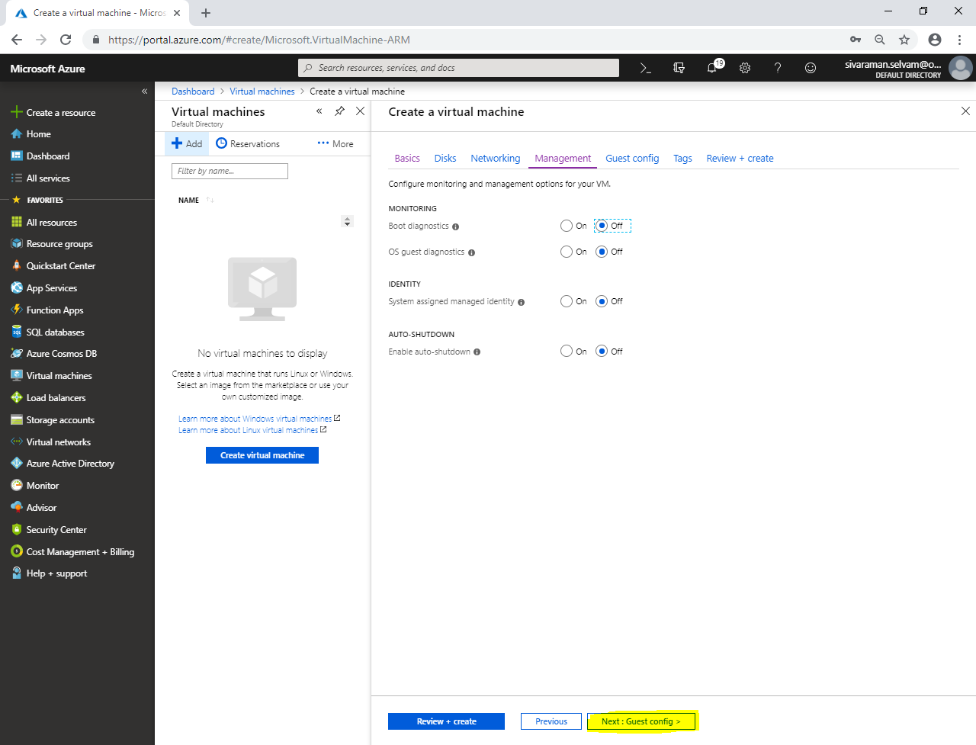

Click **“Next : Tags >”**.

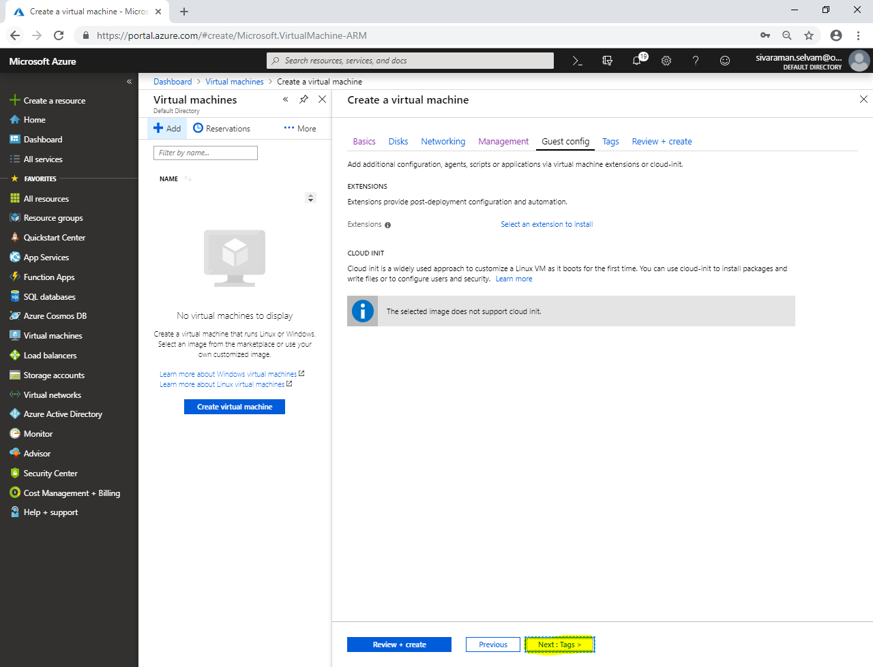

In **“Tags”**,

Click **“Next : Review + create”**.

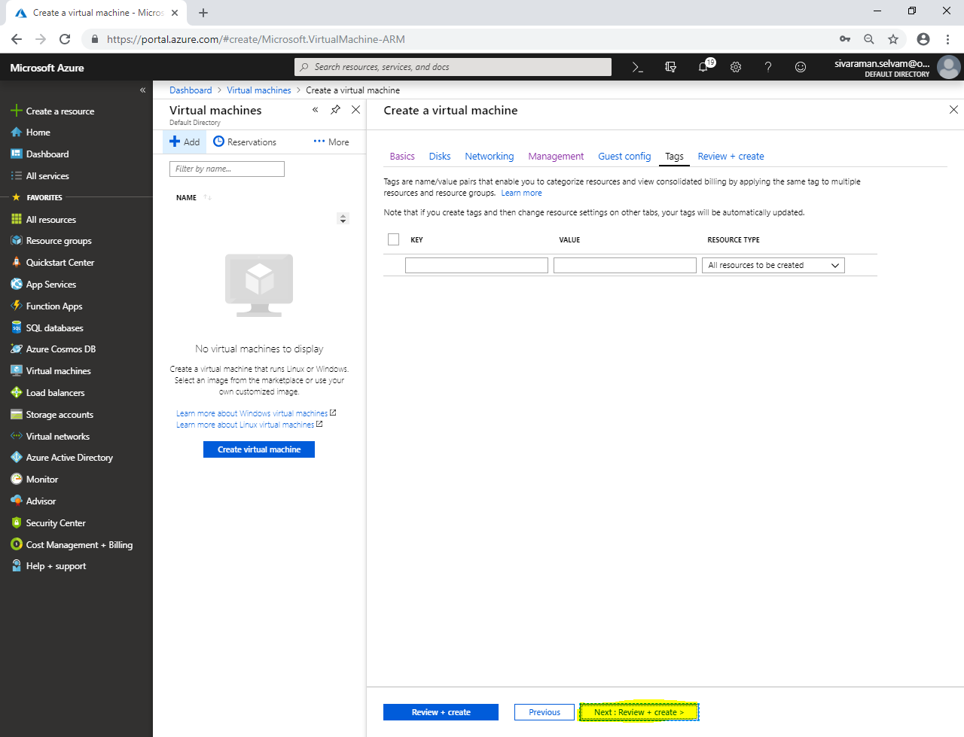

Click **“Create”**.

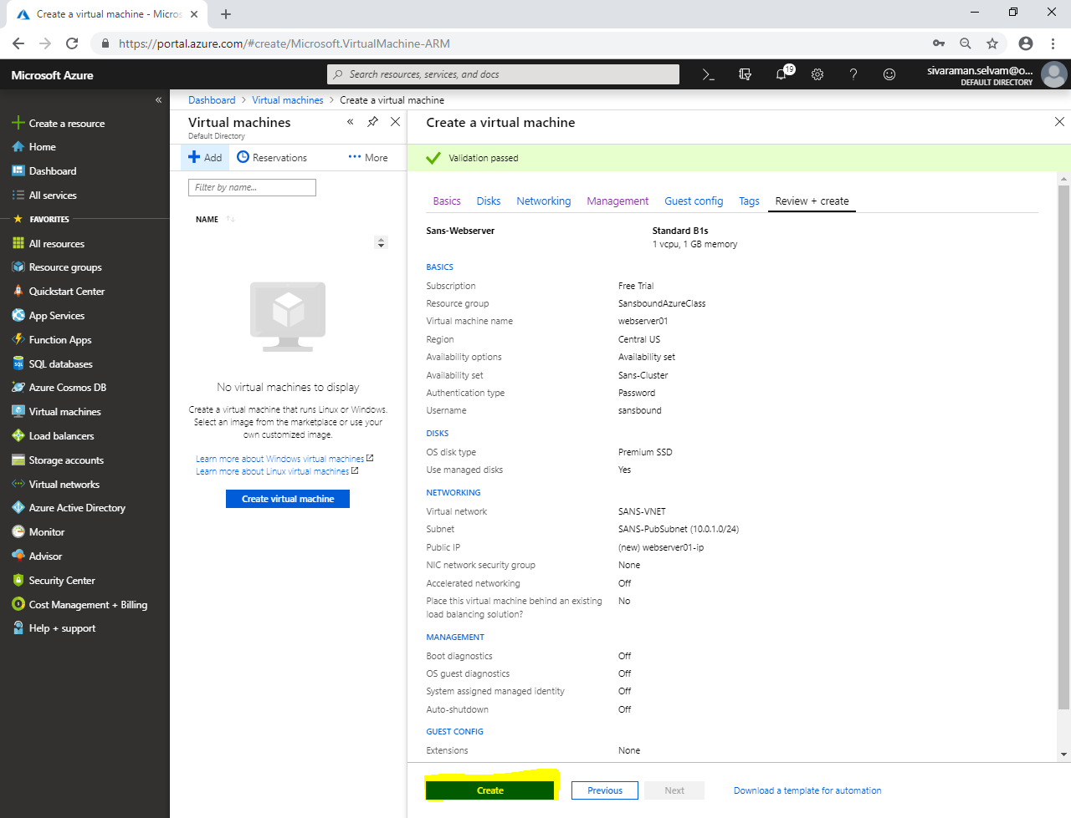

Click **“Virtual machines”** in left side panel.

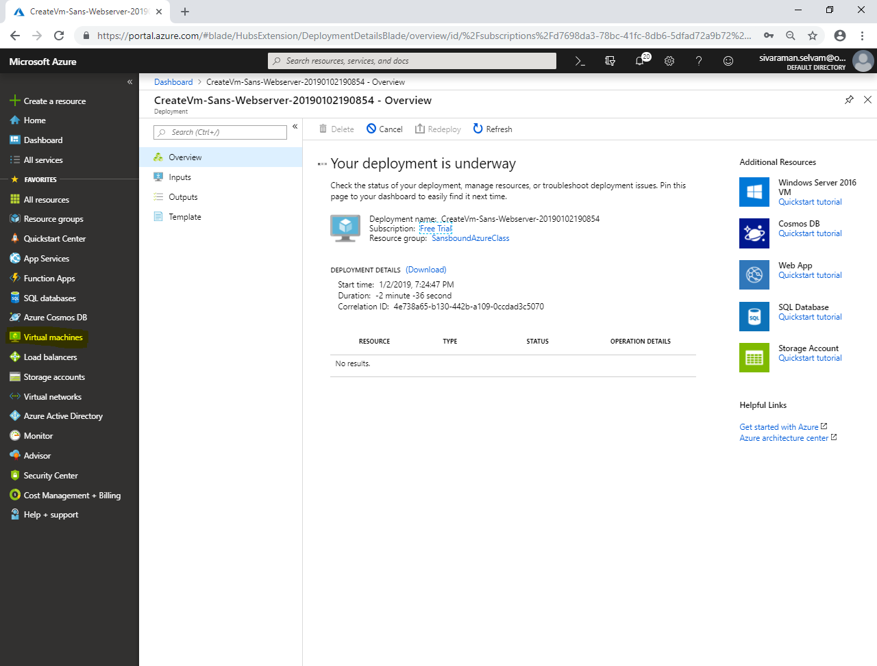

In **“Virtual machines”**,

Click **“Add”**.

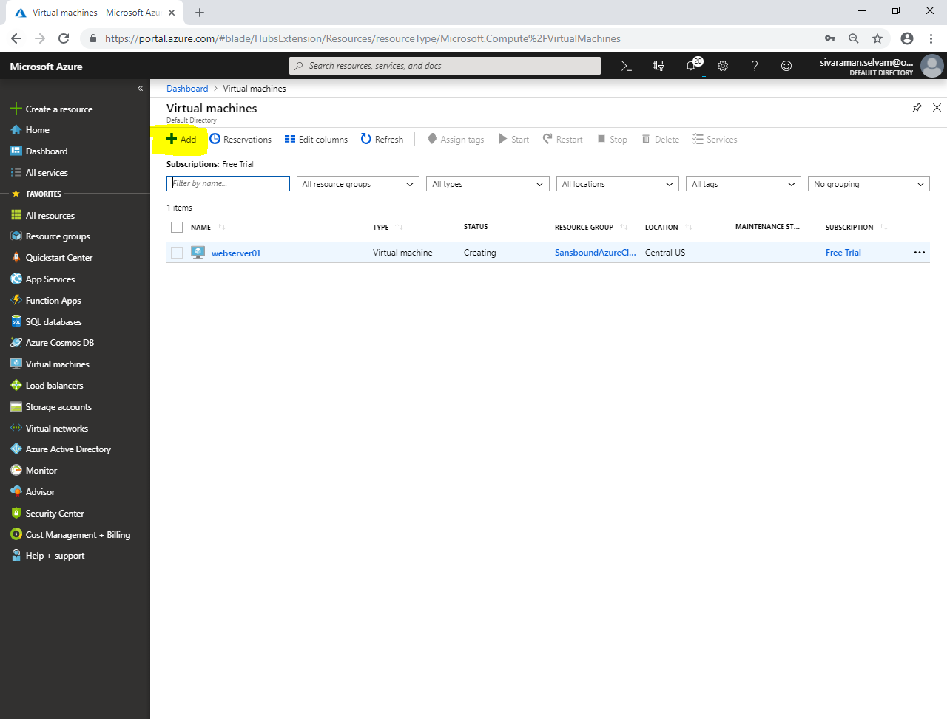

Select **“Subscription”** as **“Free Trial”**.

Select **“Resource group”** as **“SasboundAzureClass”**.

Type **“Virtual machine name”** as **“webserver02”**.

Select **“Region”** as **“Central US”**.

In **“Availability Options”** select **“Availability set”**.

In **“Availability set”** select **“Sans-Cluster”**.

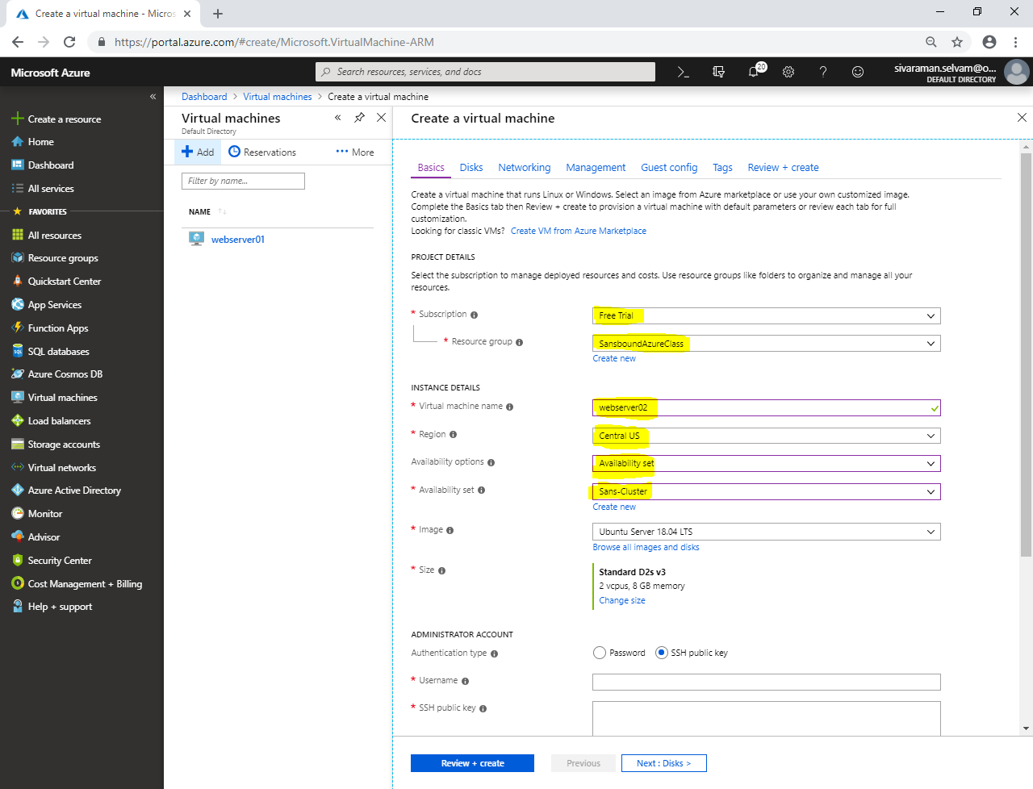

Click **“Browse all images and disks”**.

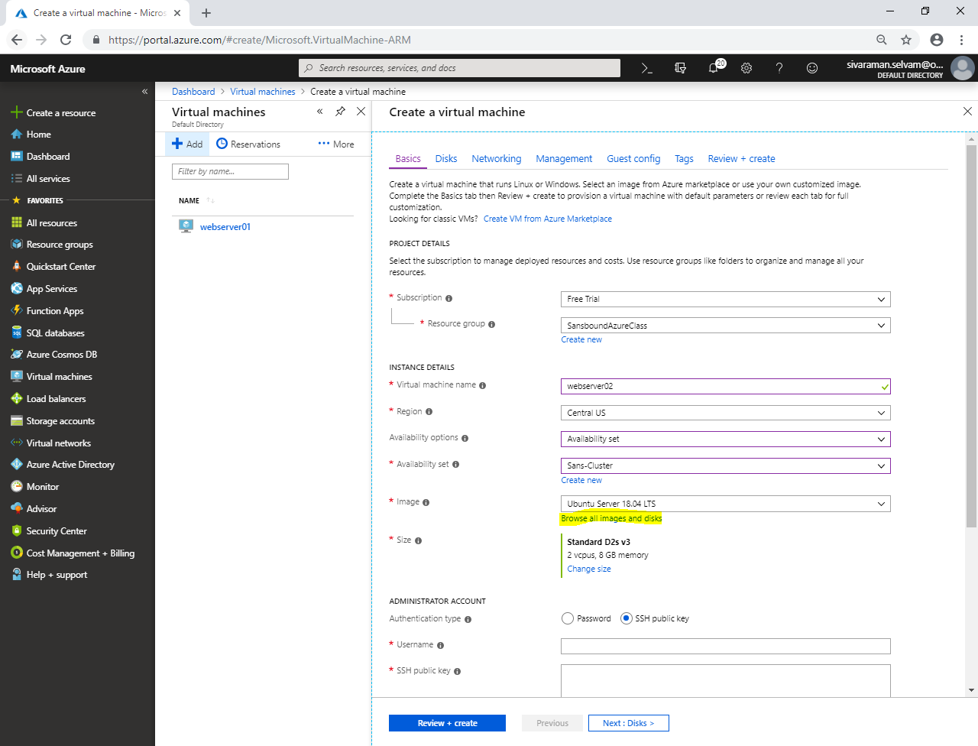

Click **“My Items”**.

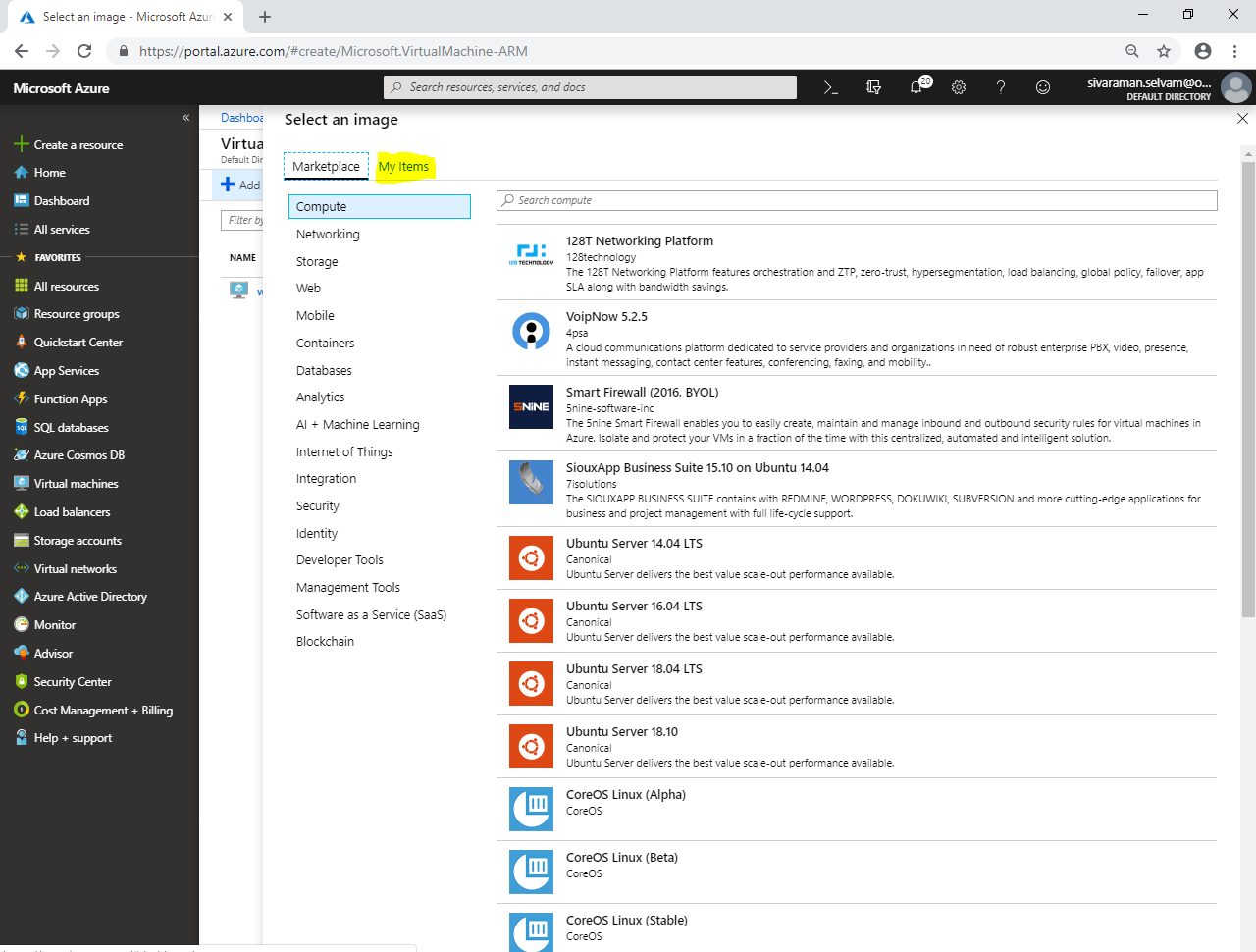

In “My Items”,

Click **“Sans-Webserver”** to select the captured image.

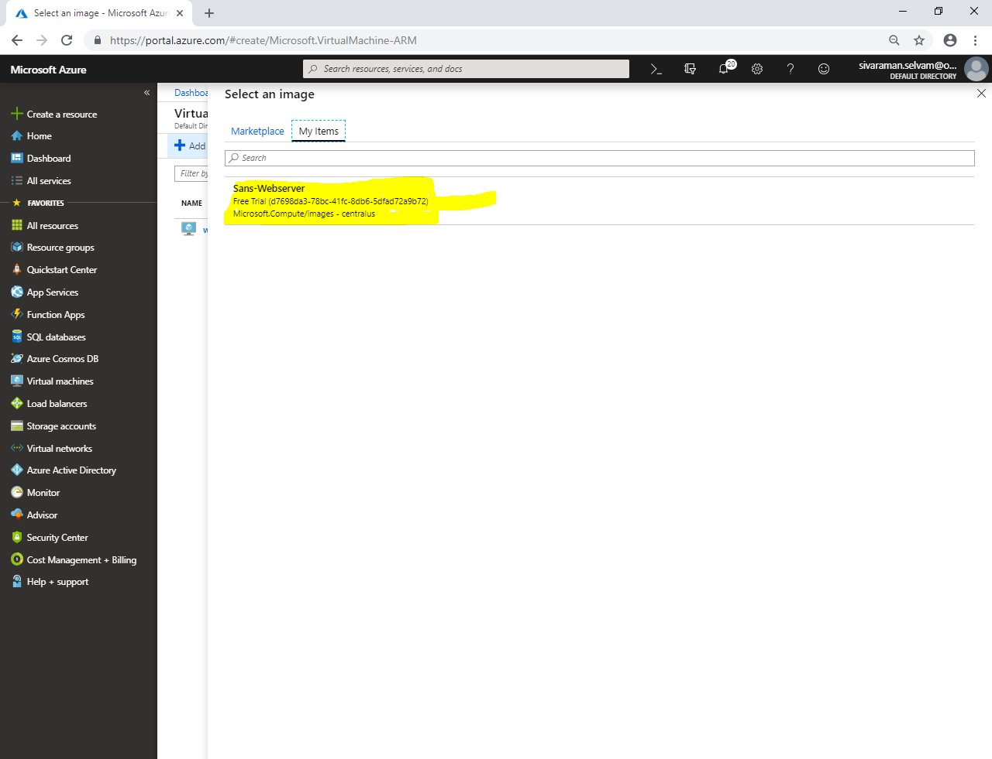

Ensure that you have selected captured image as **“Image”**.

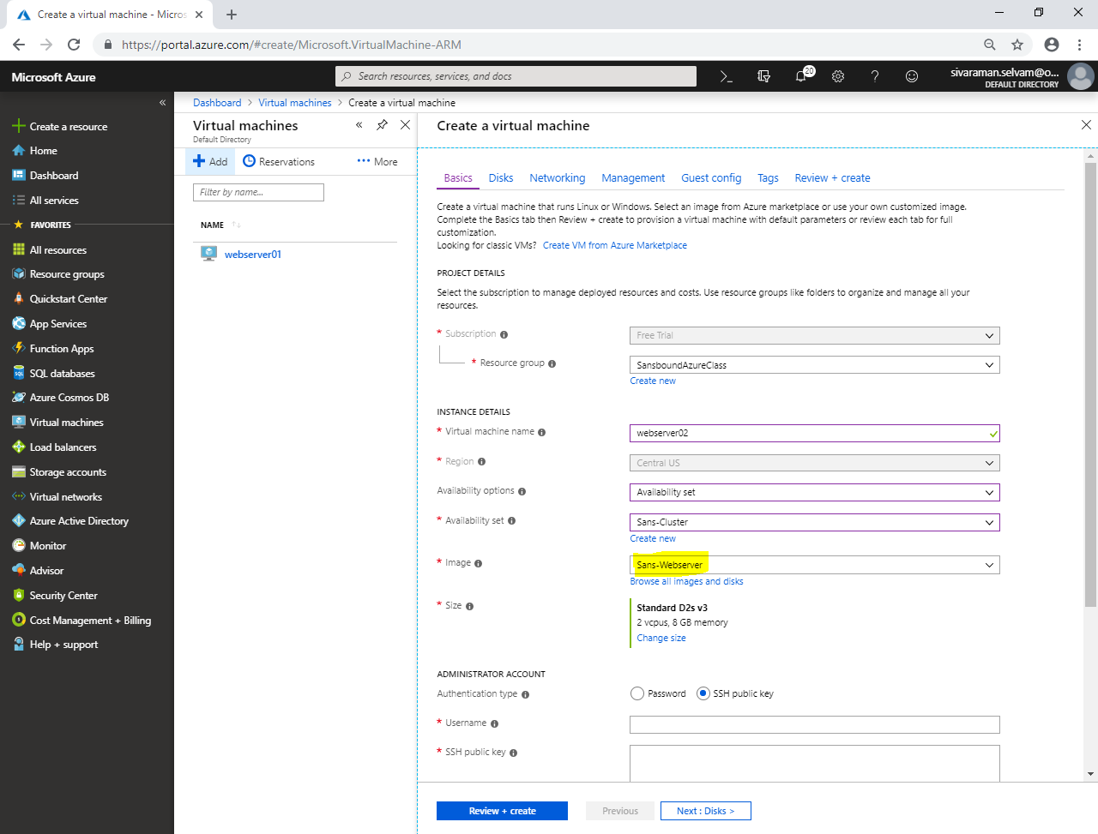

Change **“VM size”** as **“Standard B1s”**.

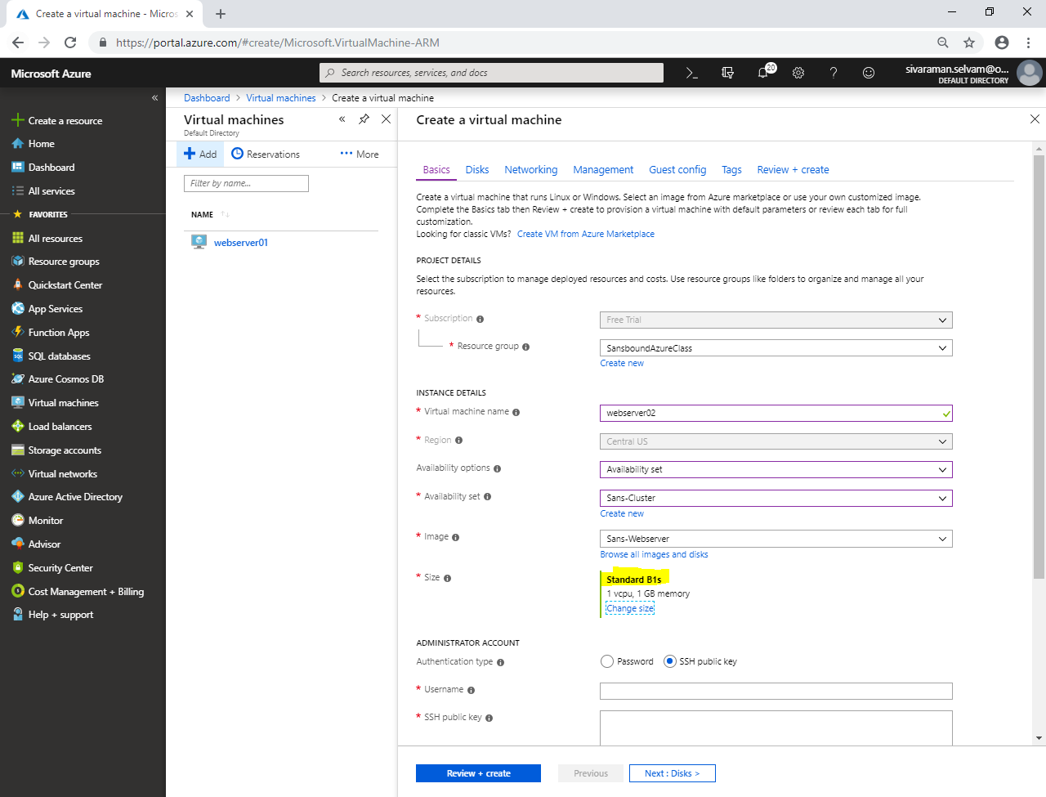

In **“Administrator Account”**,

Set **“Authentication type”** as **“Password”**.

Type **“Username”** as **“sansbound”**.

Type **“Password”** for Ubuntu.

Ensure that **“Inbound Port rules”** as **“None”**.

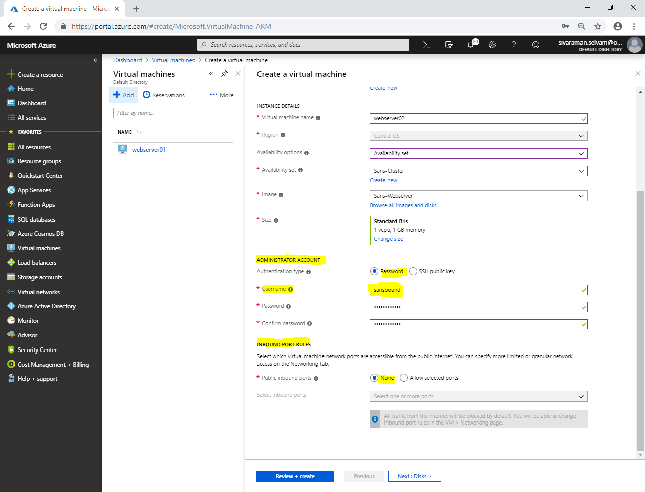

Click **“Next : Disks >”**.

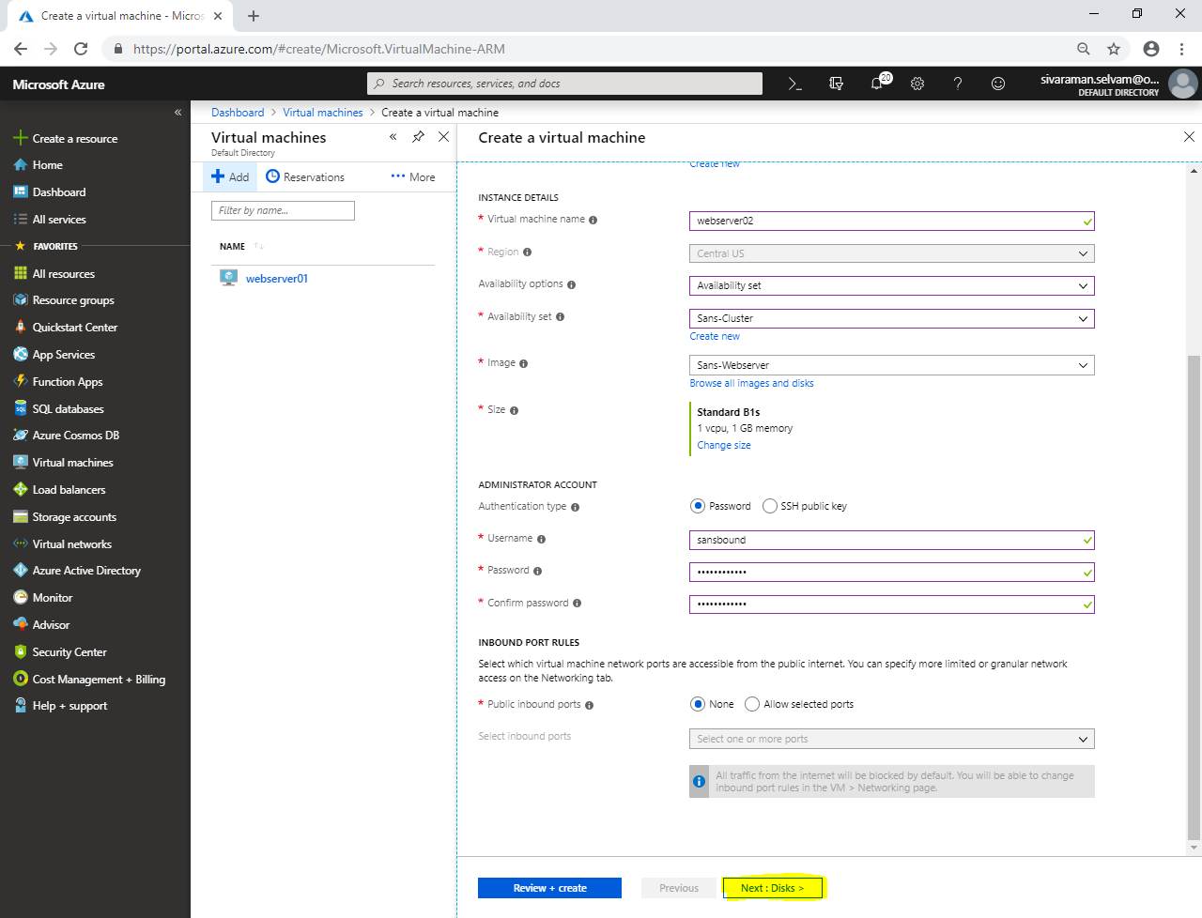

In **“Disks”**,

Click **“Next : Networking >”**.

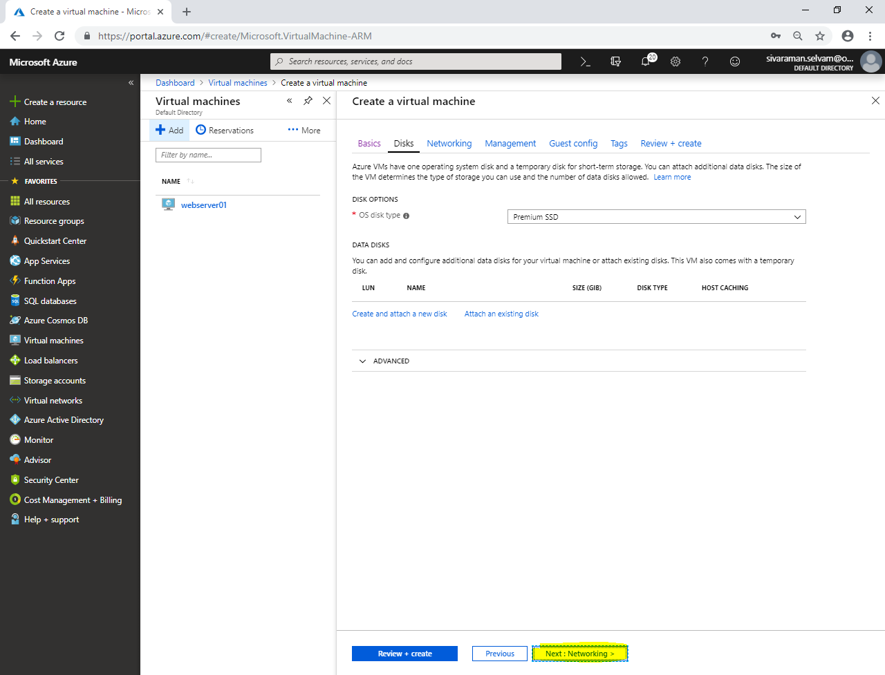

In **“Networking”**

Ensure **“Virtual network”** as **“Sans-VNET”**.

Ensure **“Subnet”** as **“SANS-PubSubnet”.**

Select **“Public IP”** is selected.

Ensure **“NIC network security group”** as **“None”**.

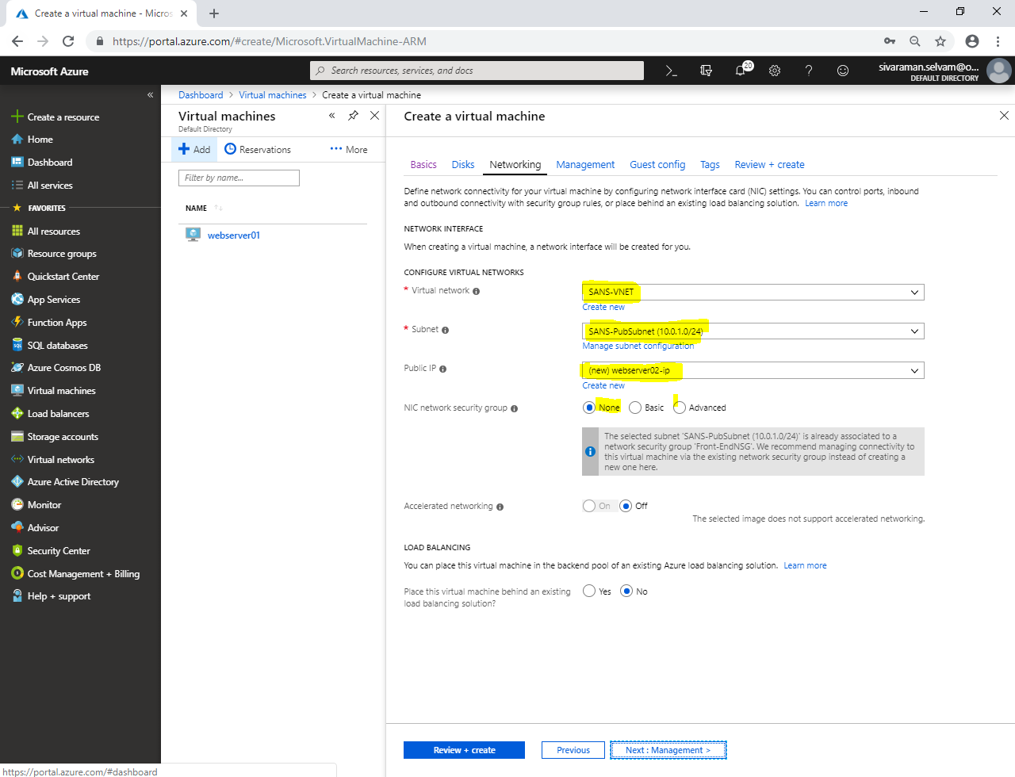

Click **“Next : Management >”**.

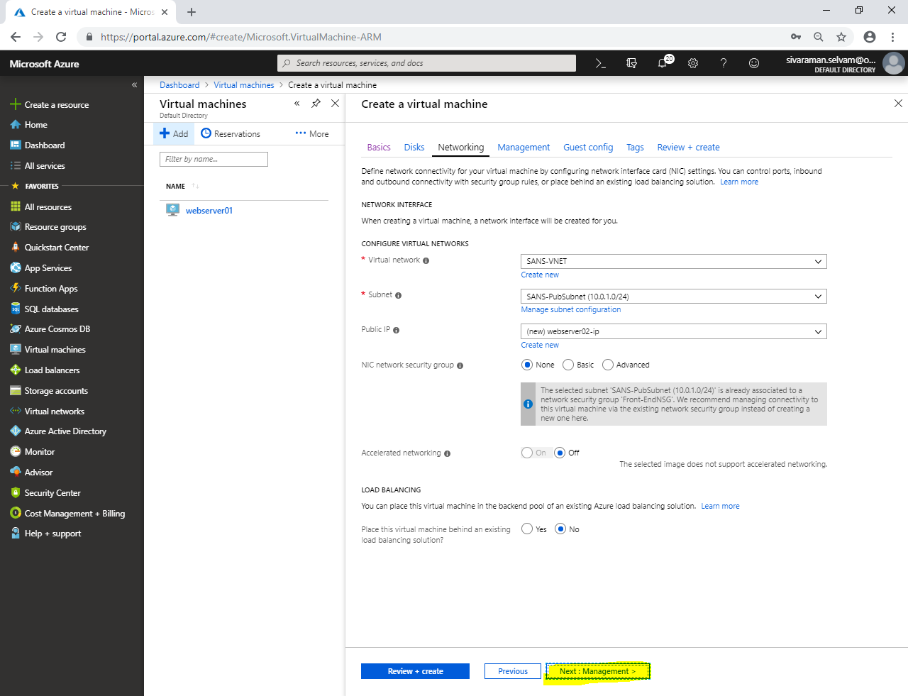

In **“Management”**,

Click **“Next : Guest config >”**.

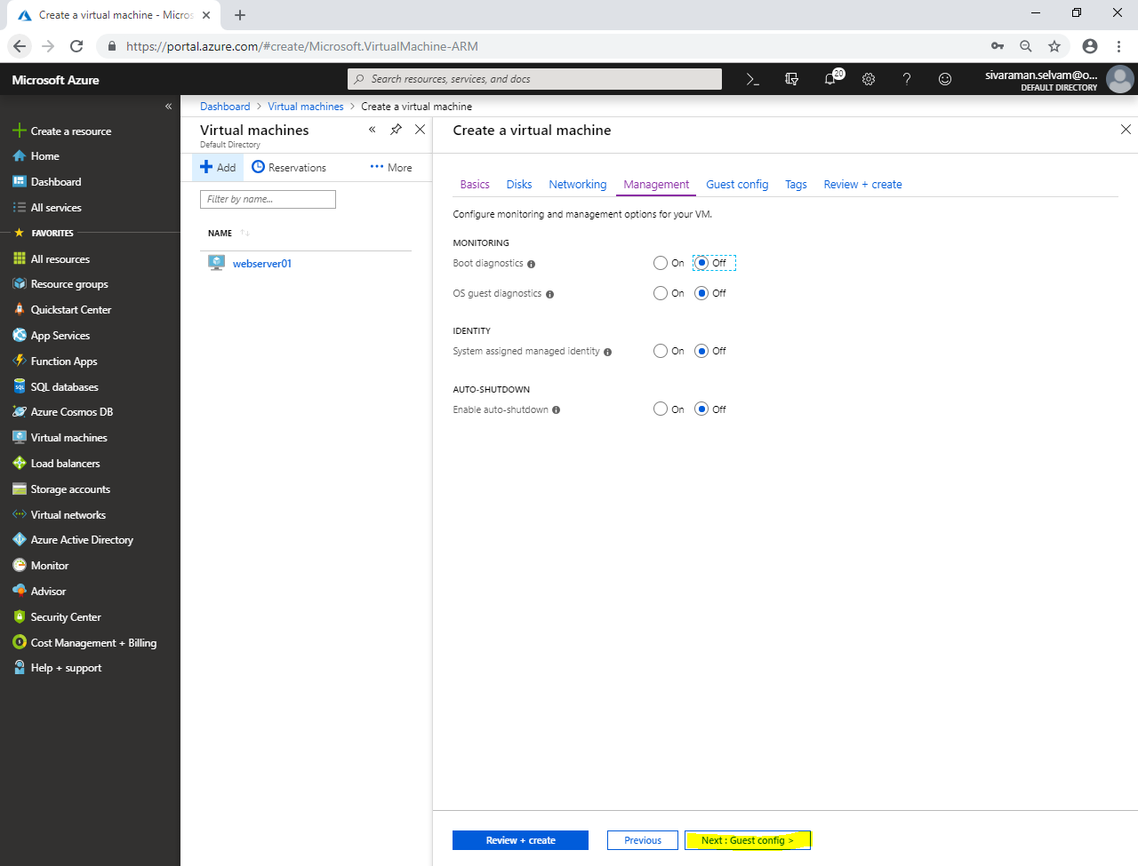

Click **“Next : Tags >”**.

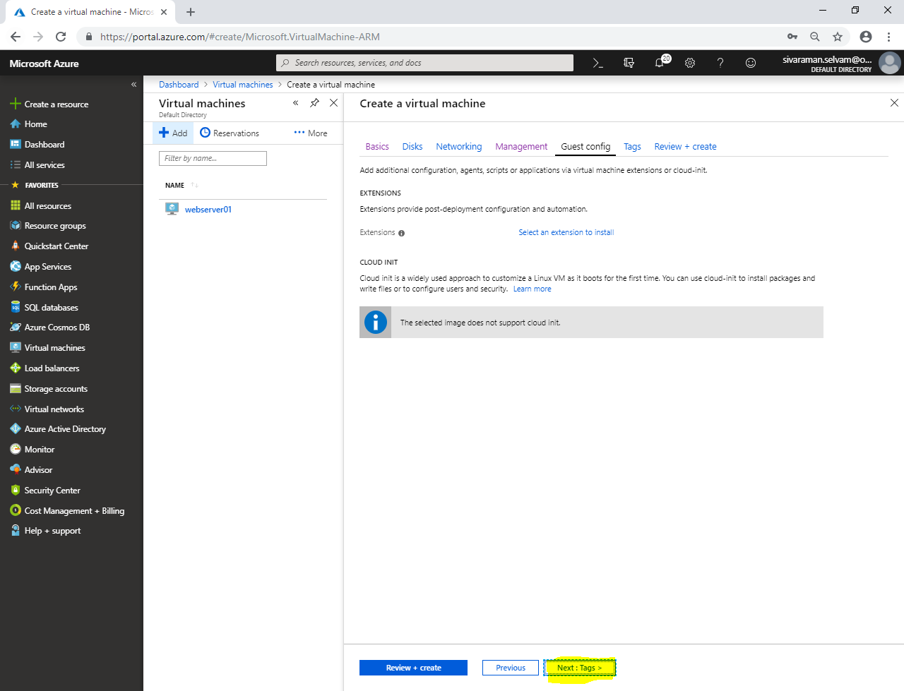

Click **“Next : Review + create >”**.

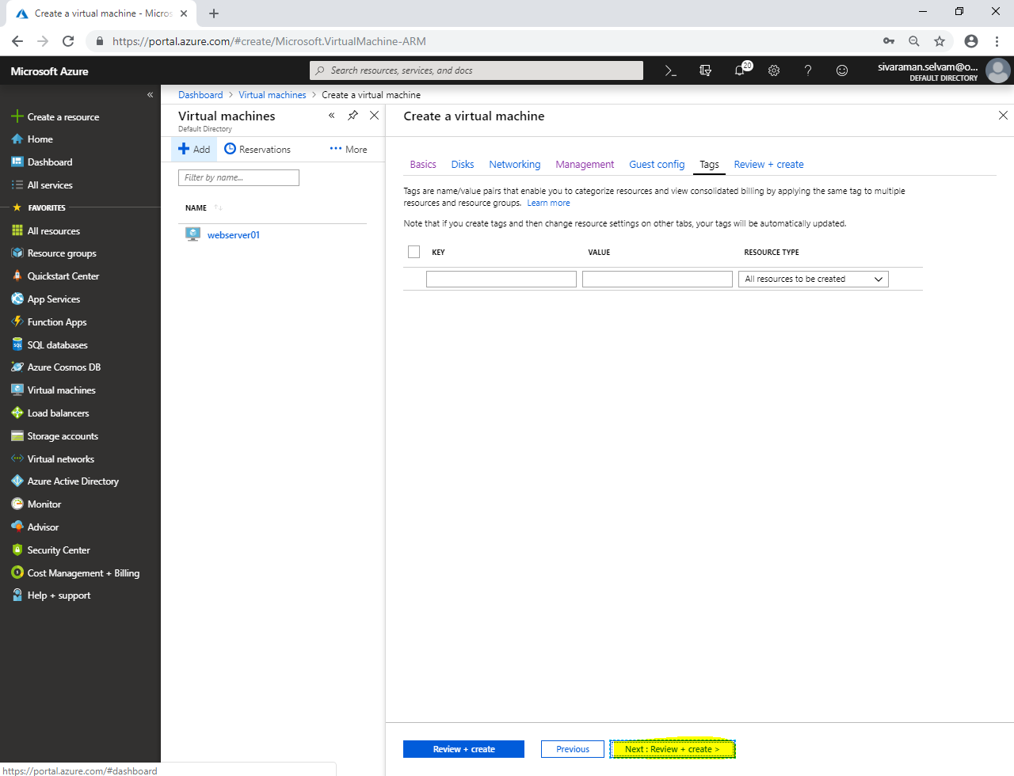

Click **“Create”**.

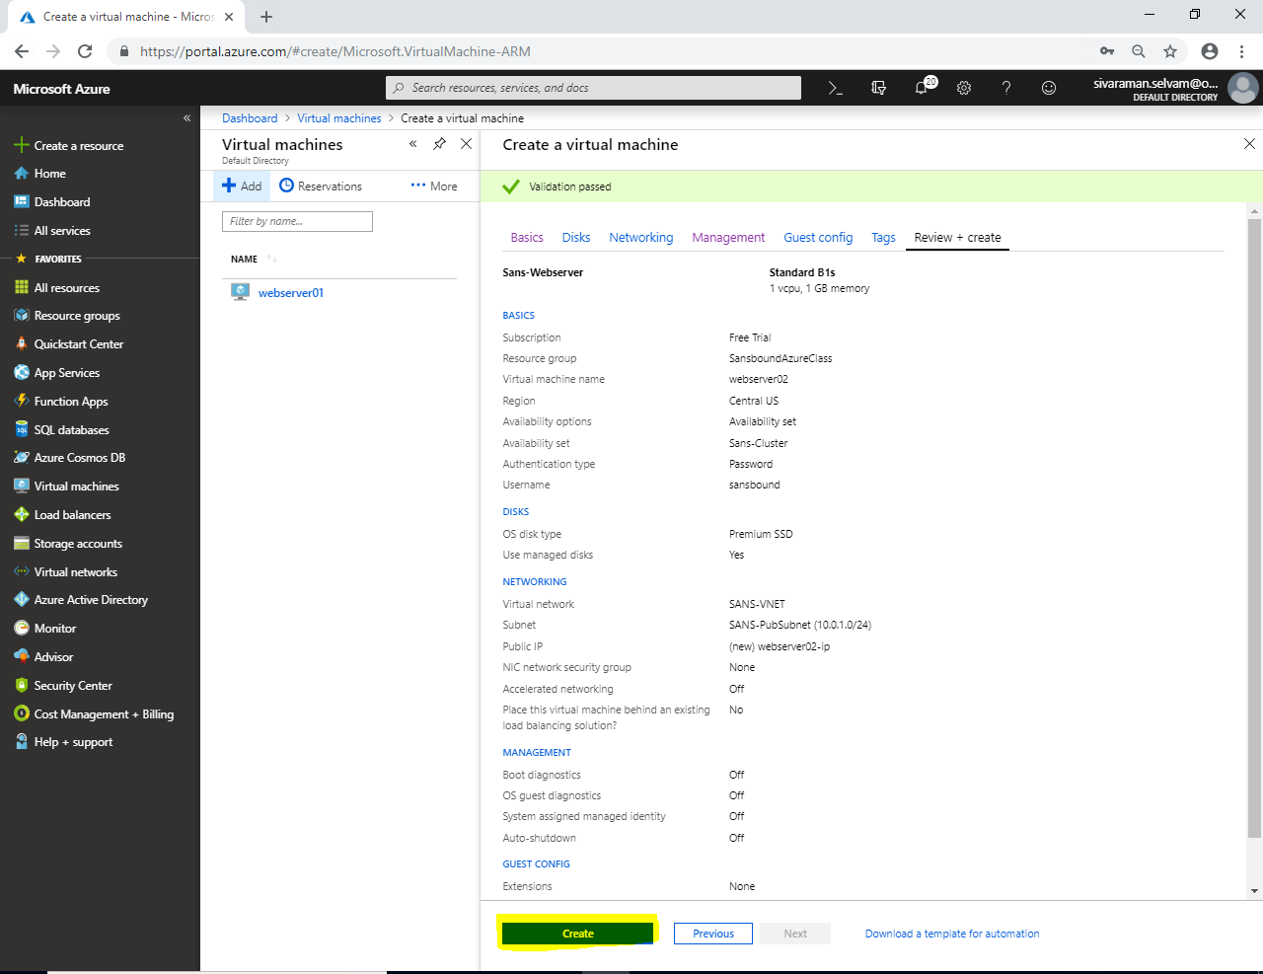

Click **“Virtual machines”** in left side panel.

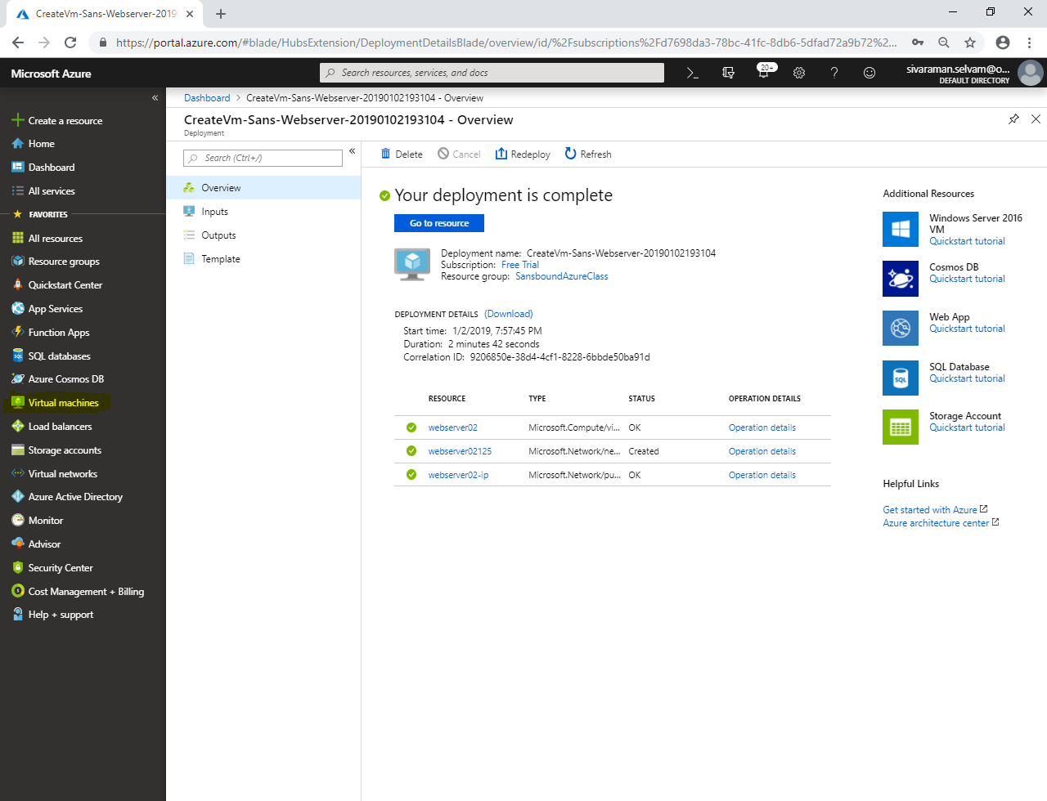

In **“Virtual machine”**,

Click **“webserver01”**.

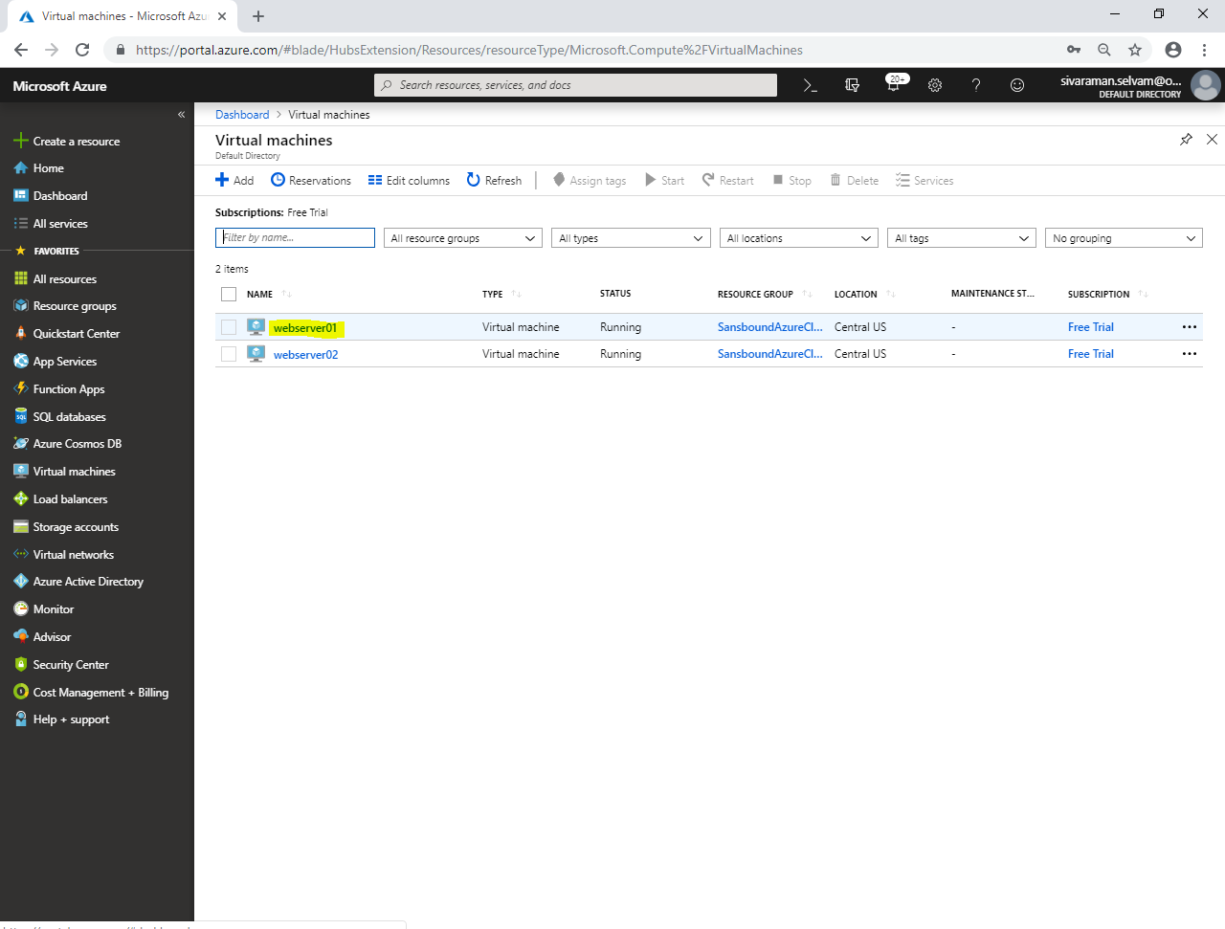

Kindly note IP address of **“webserver01”**.

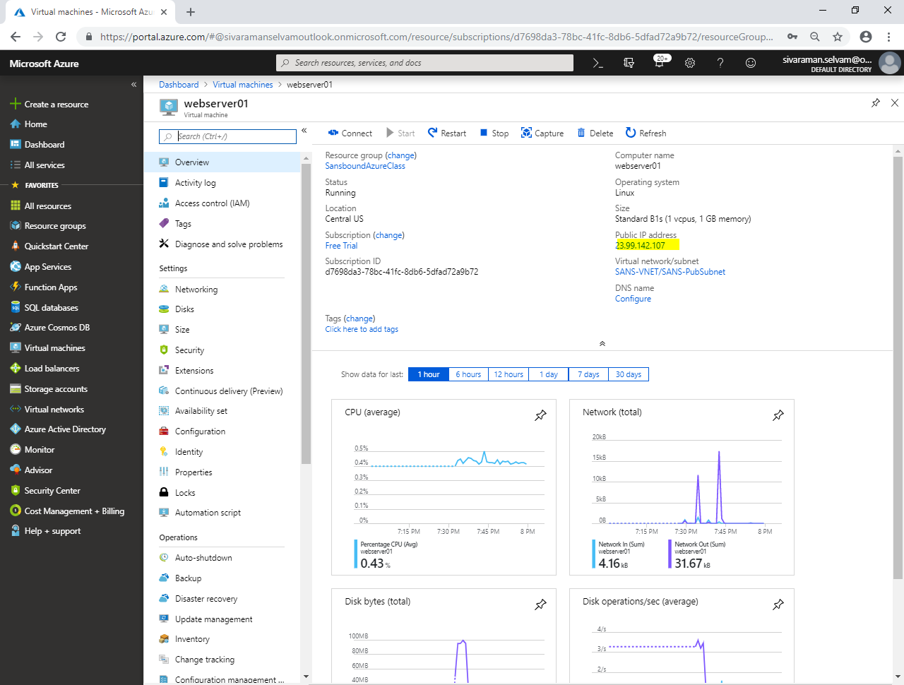

From your local machine, launch **“putty.exe”**.

Type Pubic IP address of **“webserver01”** and click **“Open”** to connect webserver01.

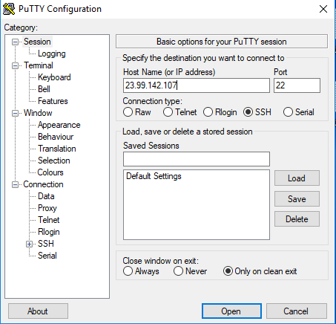

Click **“Yes”**.

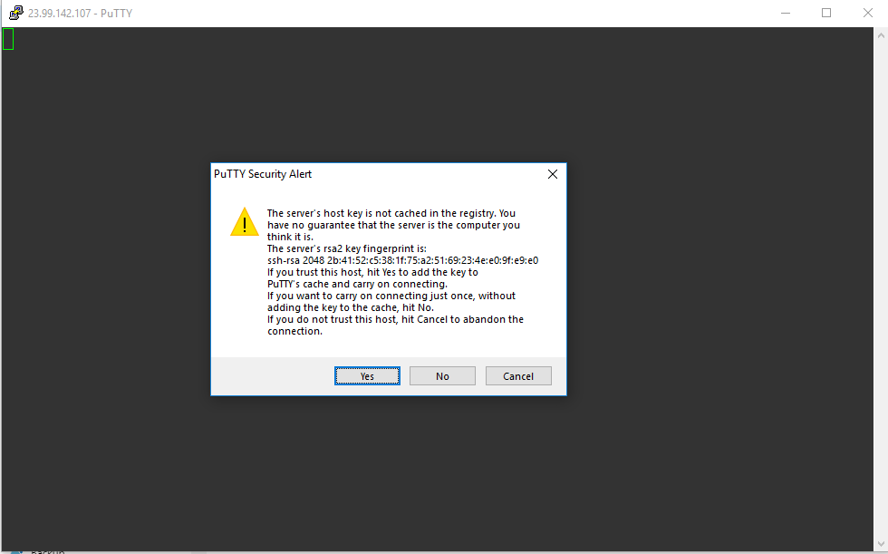

Type **“username”** as **“sivaraman”** and press **“Enter”**.

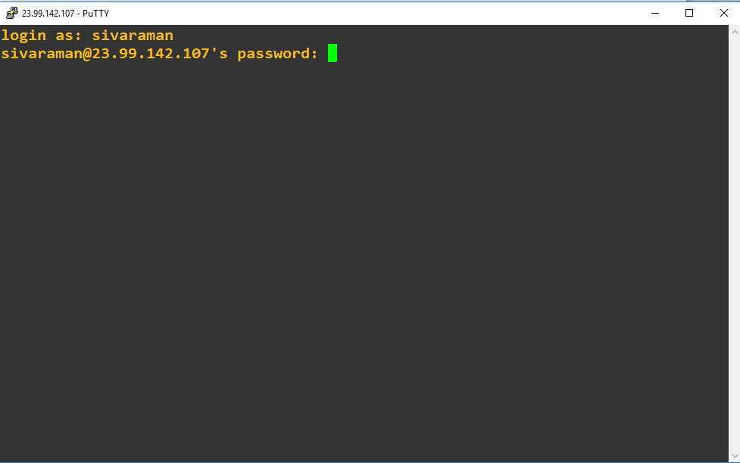

Type **“Password”** of Ubuntu and press **“Enter”**.



You have logged on to Ubuntu successfully.

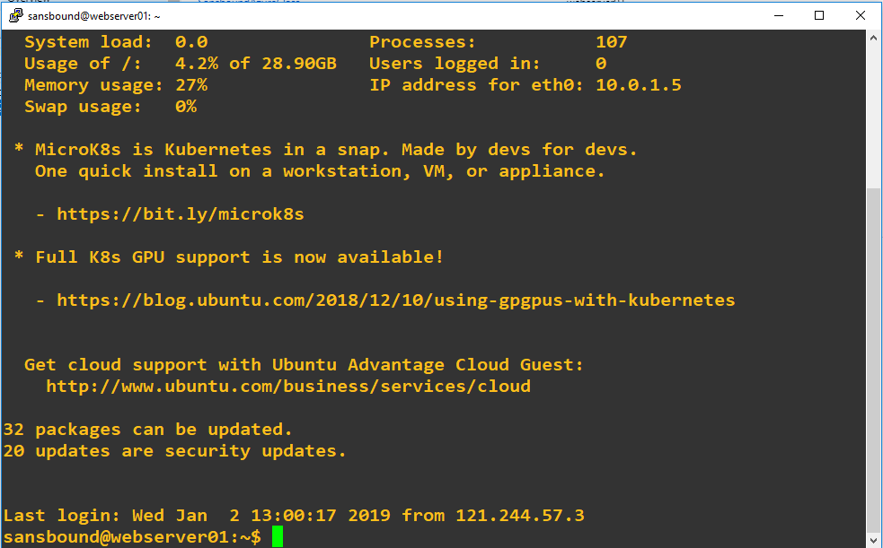

Type **“sudo –i”** and press **“Enter”**.

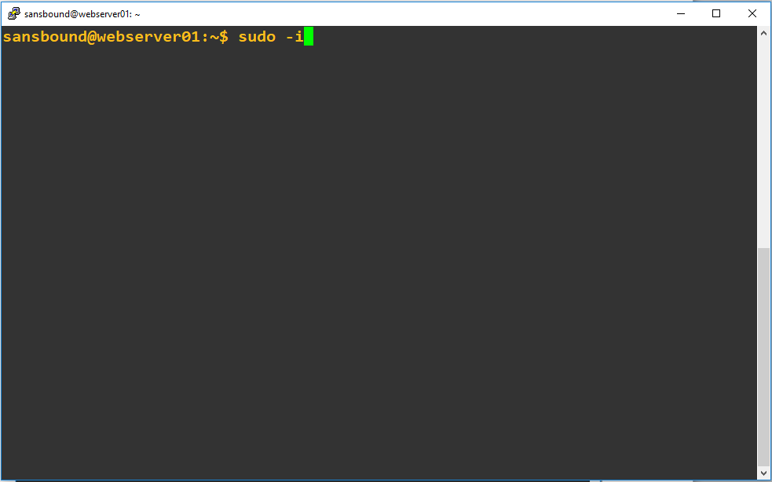

You have successfully logged in as root user.

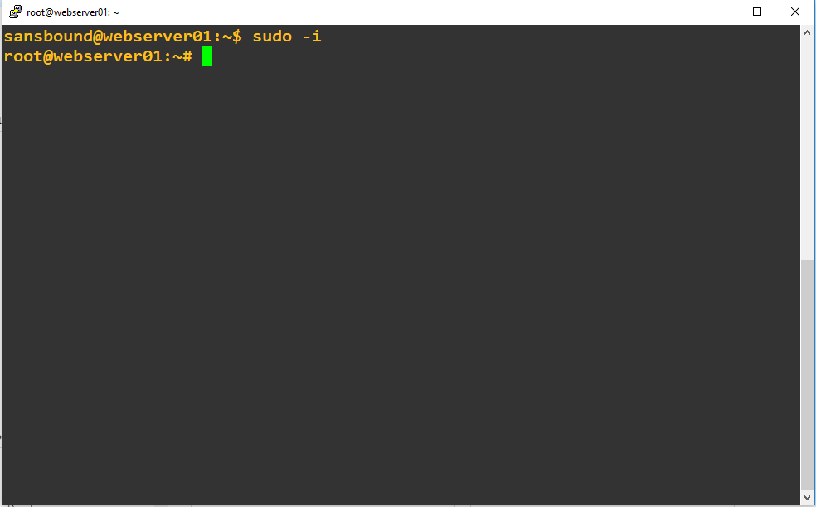

Type **“vi /var/www/html/index.html”** and press **“Enter”**.

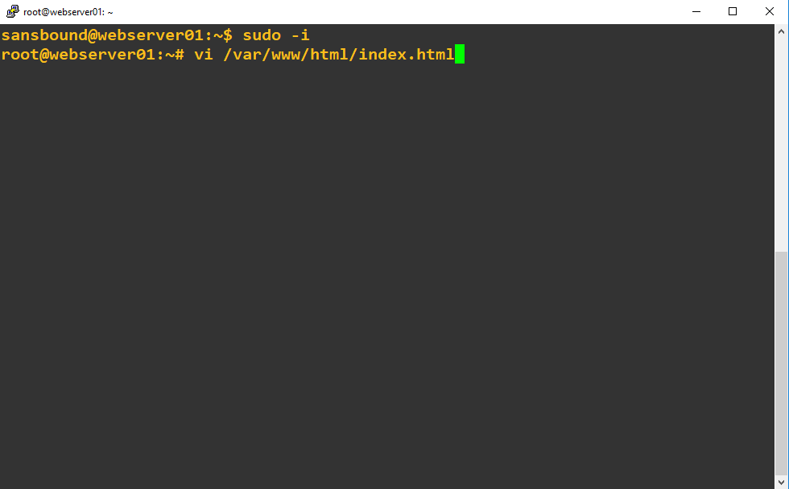

Go to line 198,

Press **“Insert”** key.

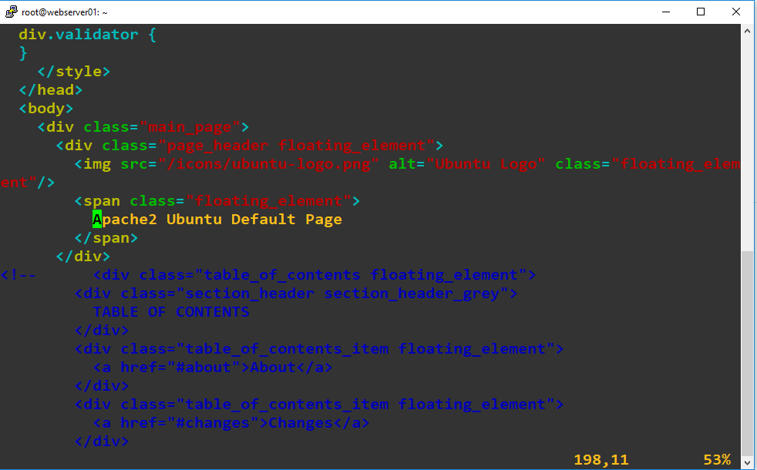

Ensure that **“Insert”** is pressed.

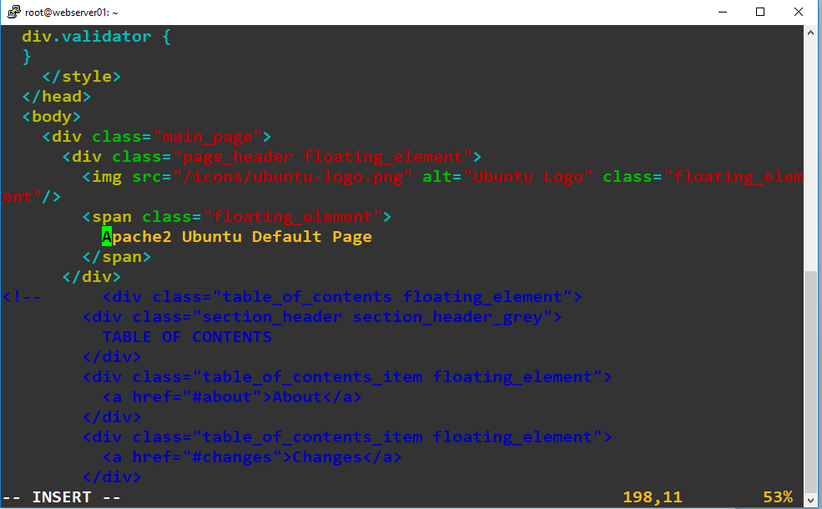

Delete the previous previous text and type **“Sansbound Azure Class Webserver01”**.

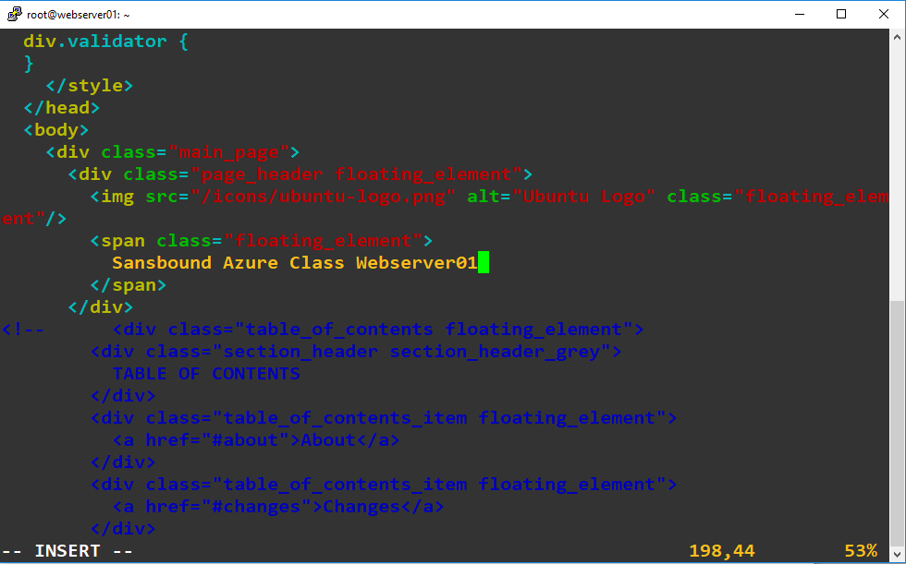

Press **“Escape”** key.

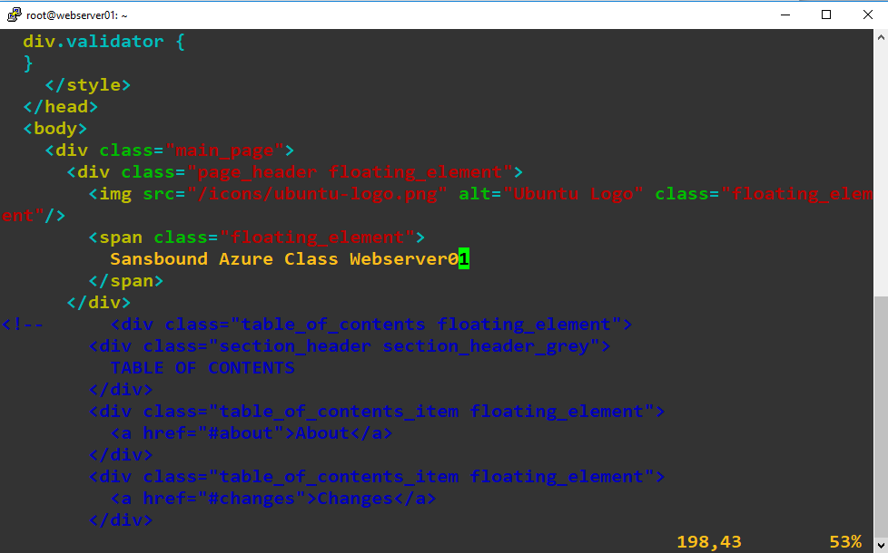

Type **“:wq”** and press **“Enter”**.

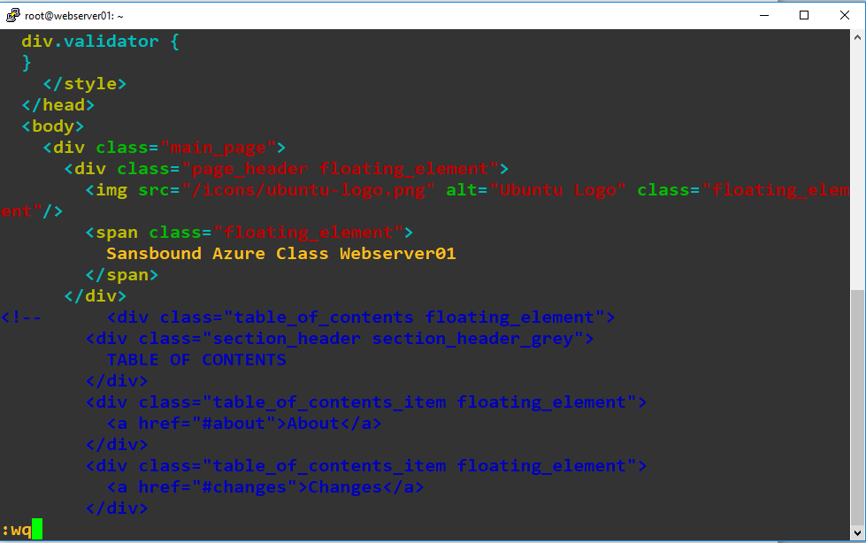

Type **“webserver01”** Public IP address in browser and press **“Enter”**.

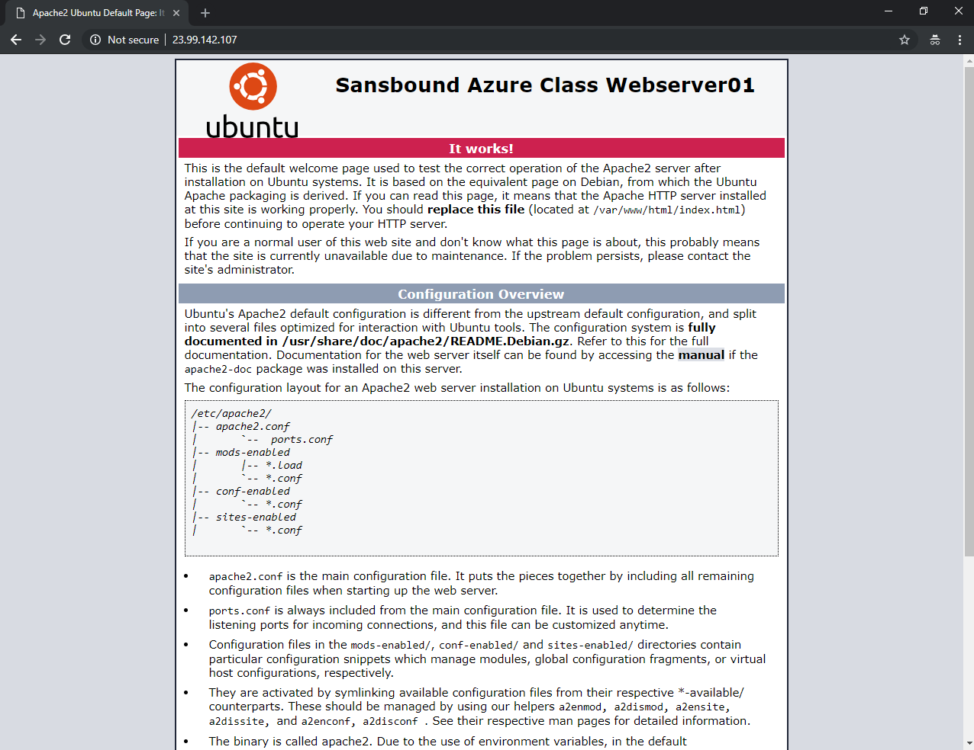

In **“virtual machines”** from left side panel.

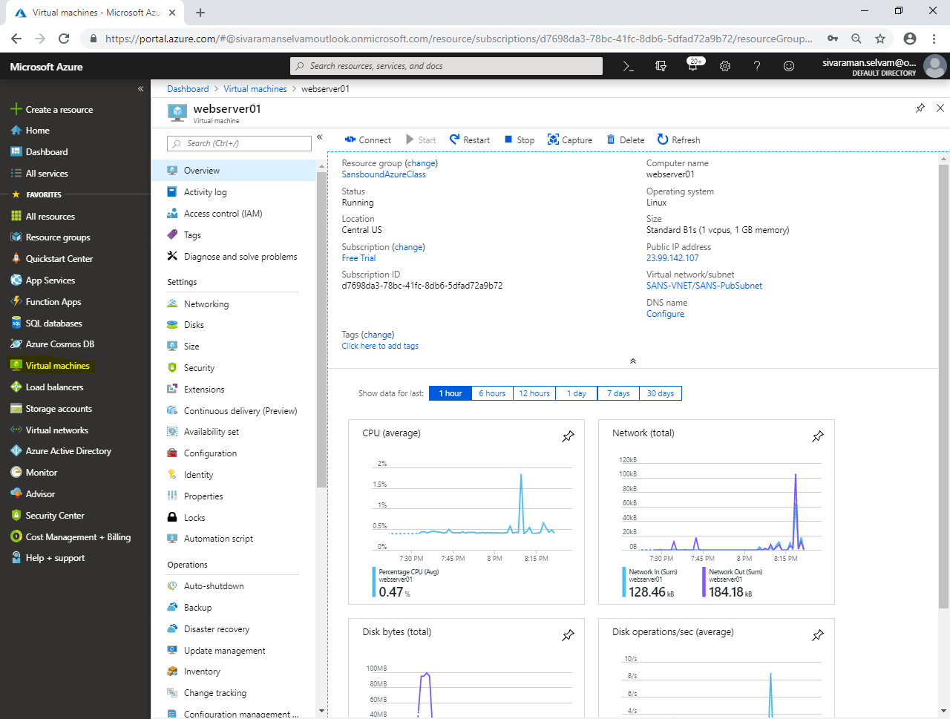

In **“Virtual machines”**,

Click **“webserver02”**.

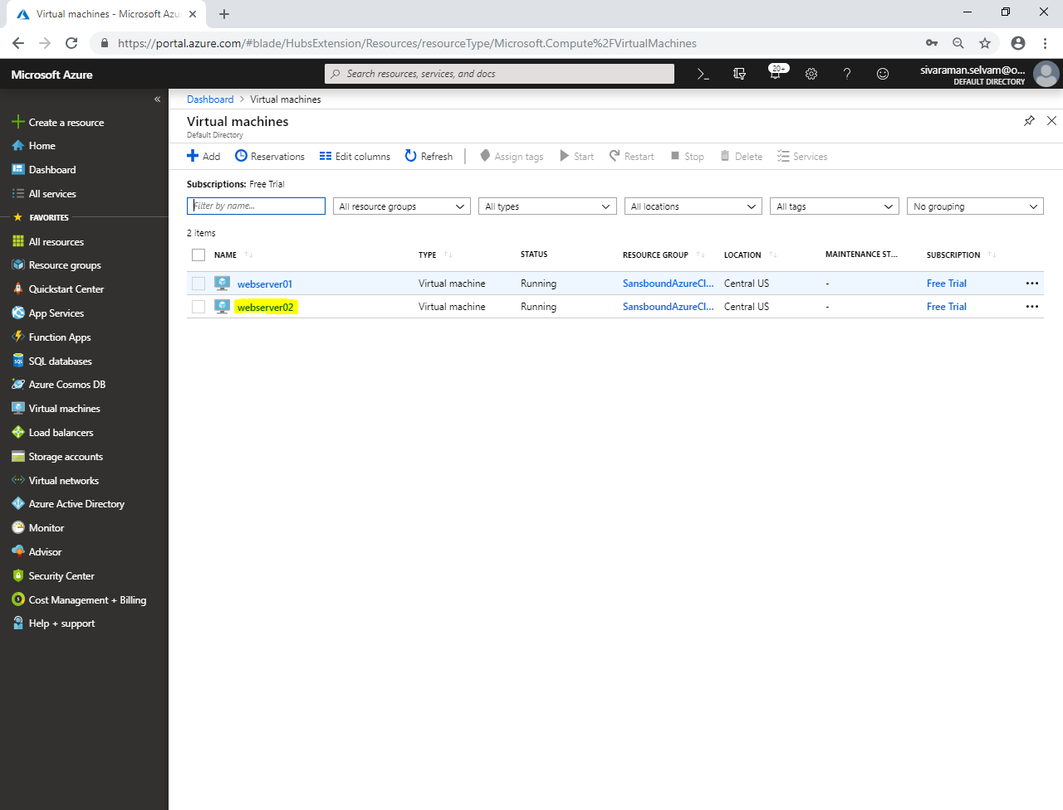

Kindly note public IP address of the **“webserver02”.**

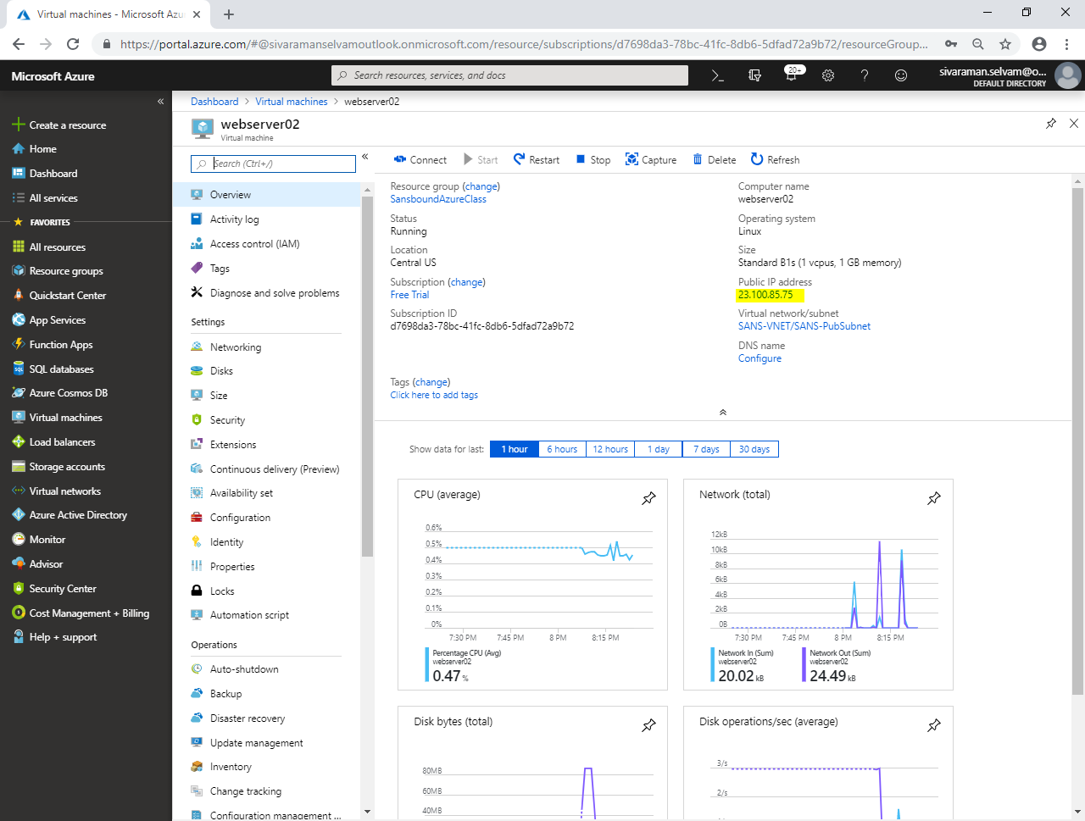

From your local machine, launch putty.exe.

In Putty, type Public IP address of **“Webserver02”** and click **“Open”** to connect.

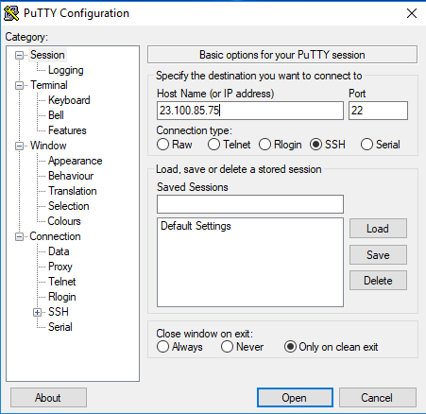

Click **“Yes”**.

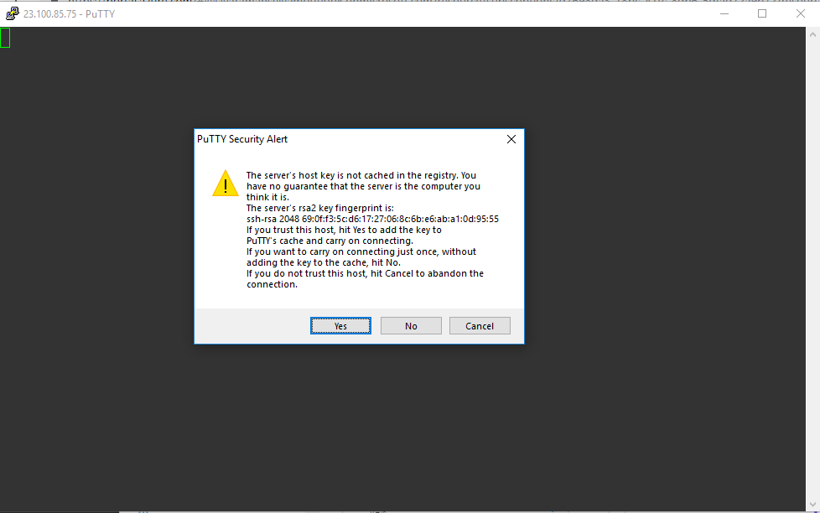

Type username of Webserver02 as “sansbound” and press **“Enter”**.

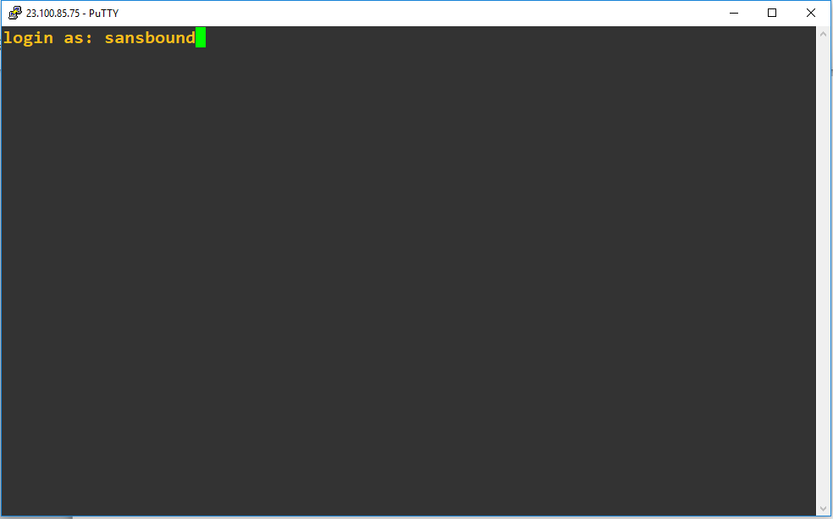

Type password of webserver02 and press **“Enter”**.

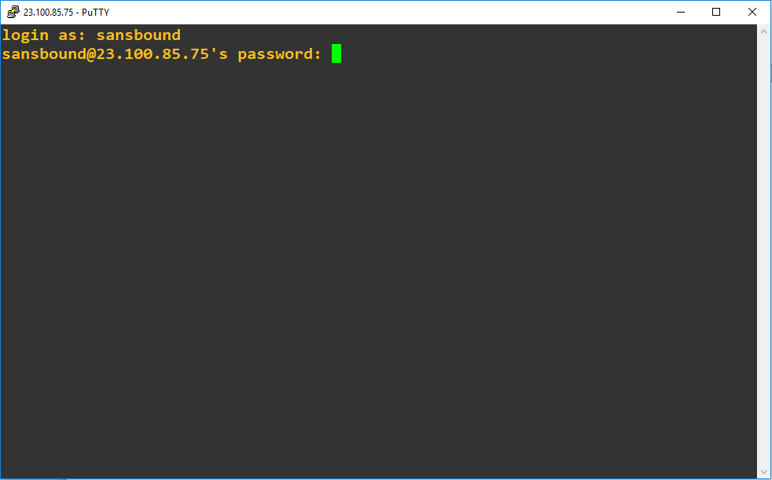

You have successfully logged into webserver02.

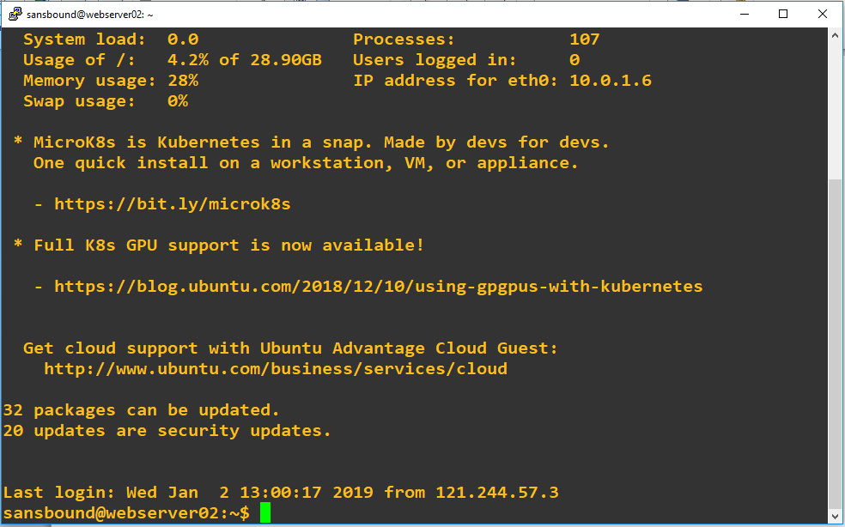

Type **“sudo –i”** and press **“Enter”** to login as root account.

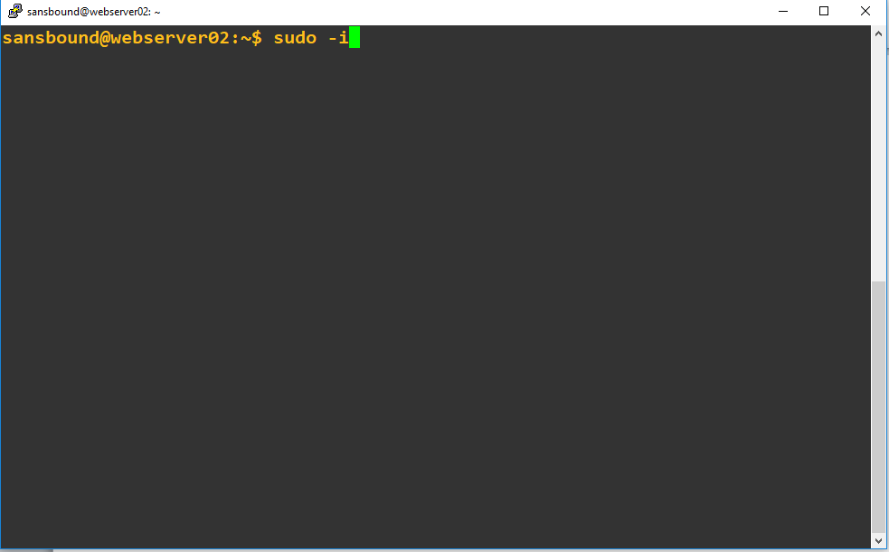

You have successfully logged in as a root account.

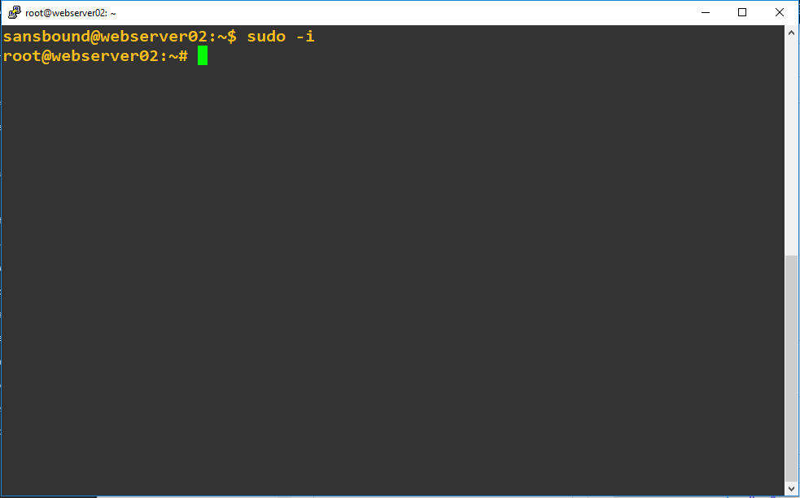

Type **“vi /var/www/html/index.html”** and press **“Enter”**.

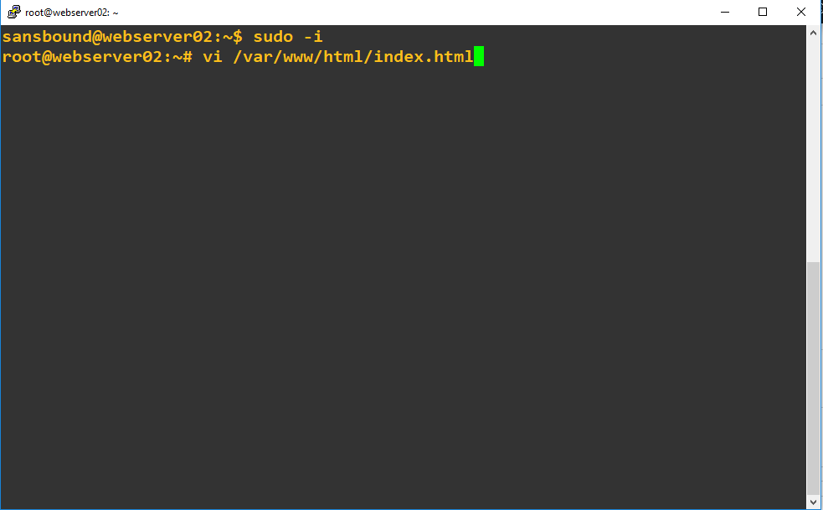

Go to Line “198” and press **“Insert”** key.

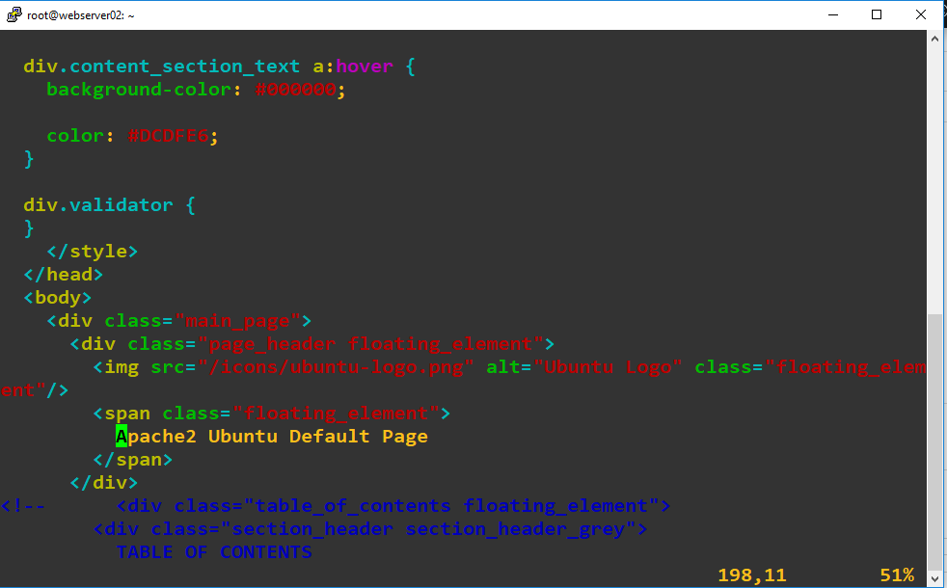

Ensure that **“Insert”** key is pressed.

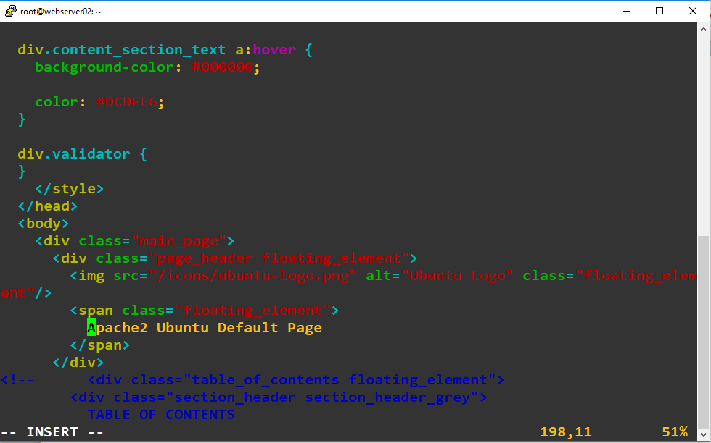

Delete previous values and type as **“Sansbound Azure Class Webserver02”**.

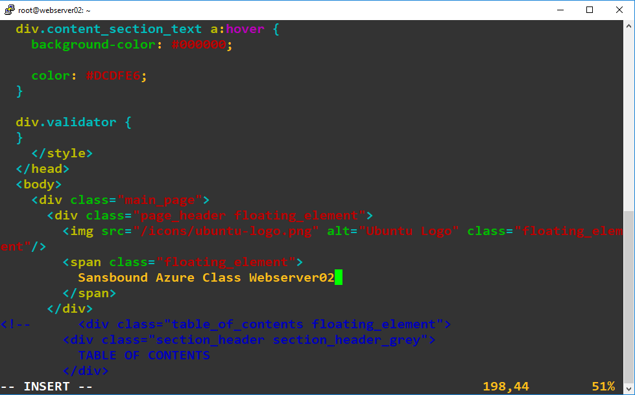

Press **“Escape”** key.

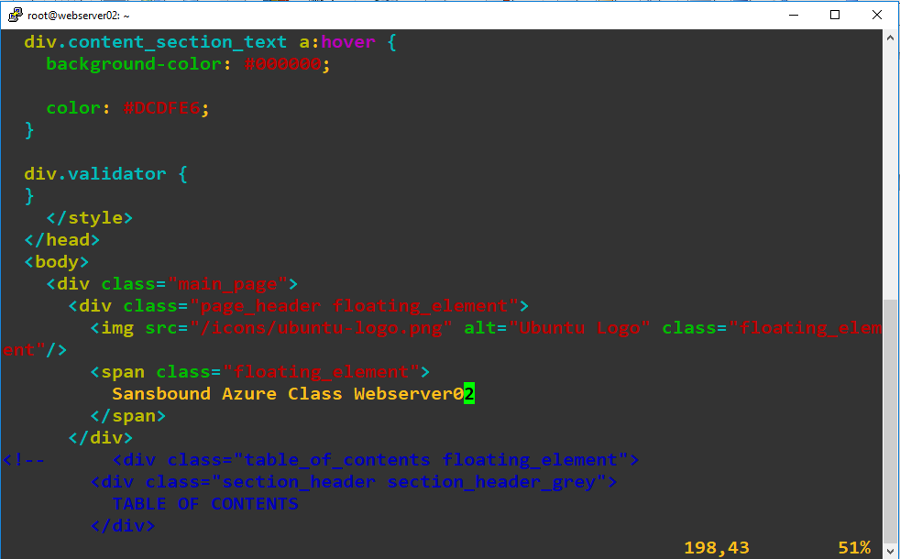

Type **“:wq”** and press **“Enter”**.

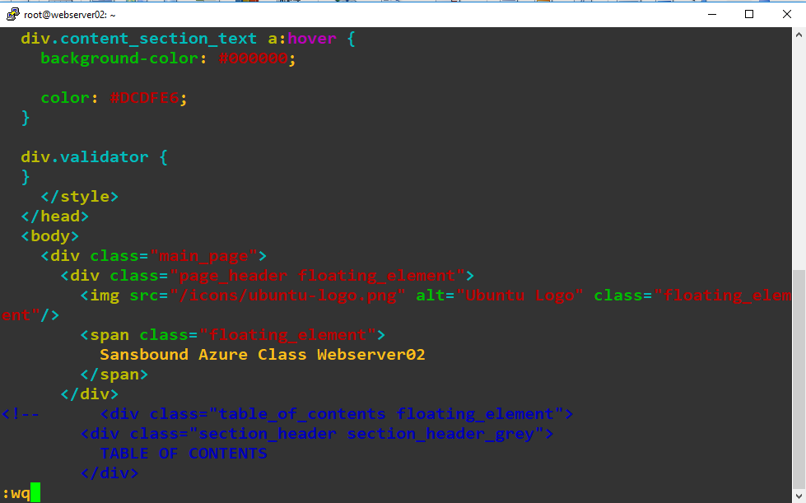

Type public IP address of Webserve02 in browser and press “Enter”.

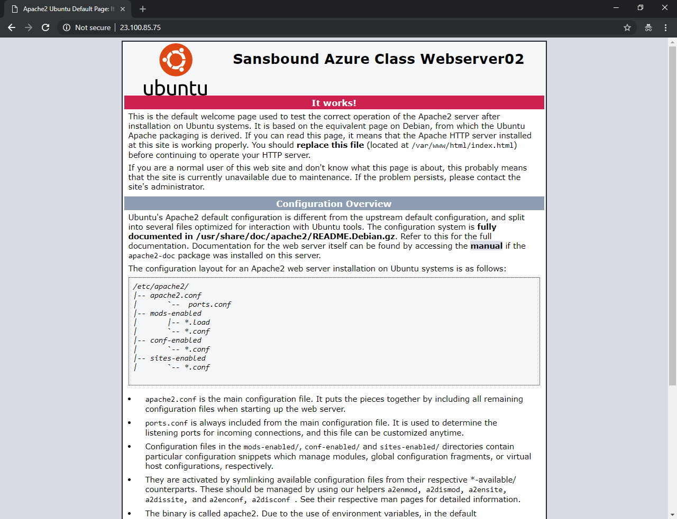

Click **“All services”**,

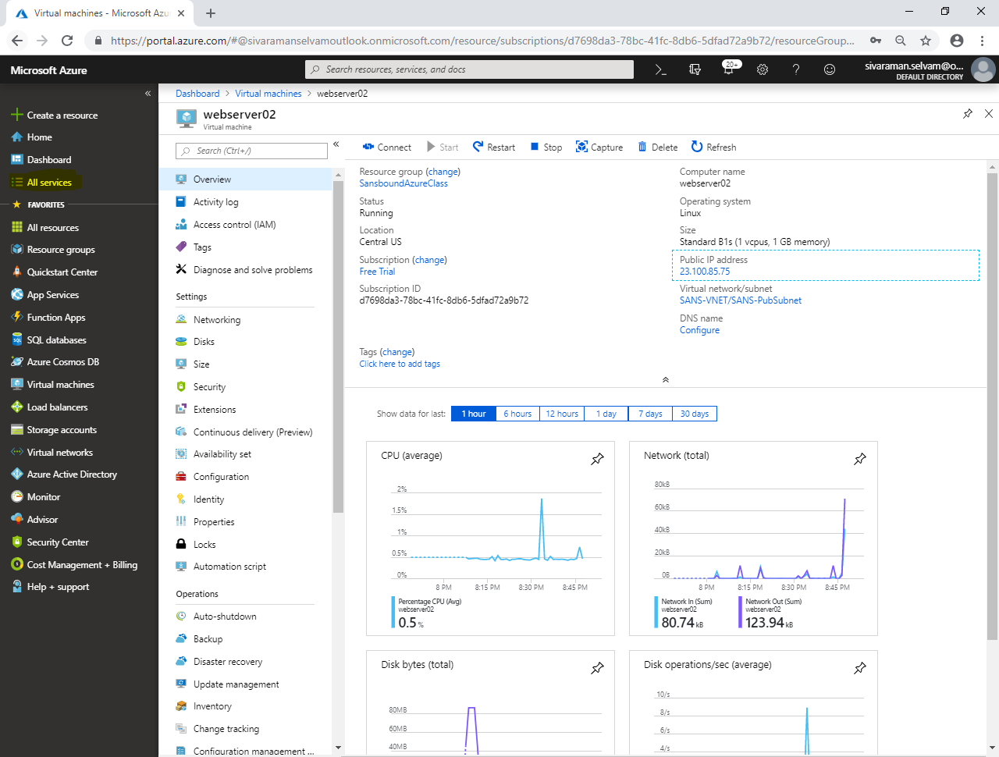

Click **“Load balancers”**,

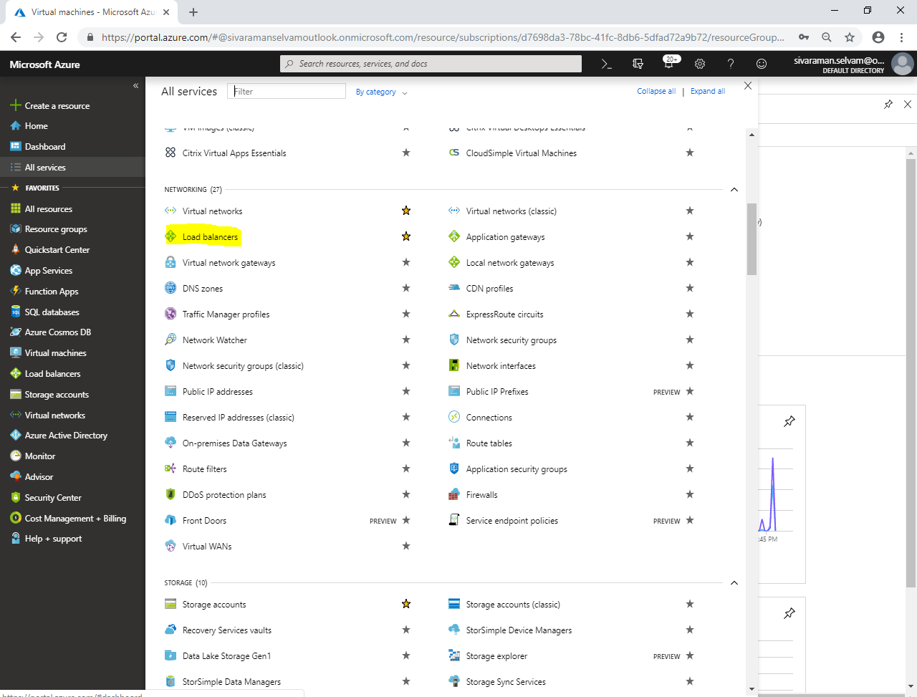

Click **“Add”**.

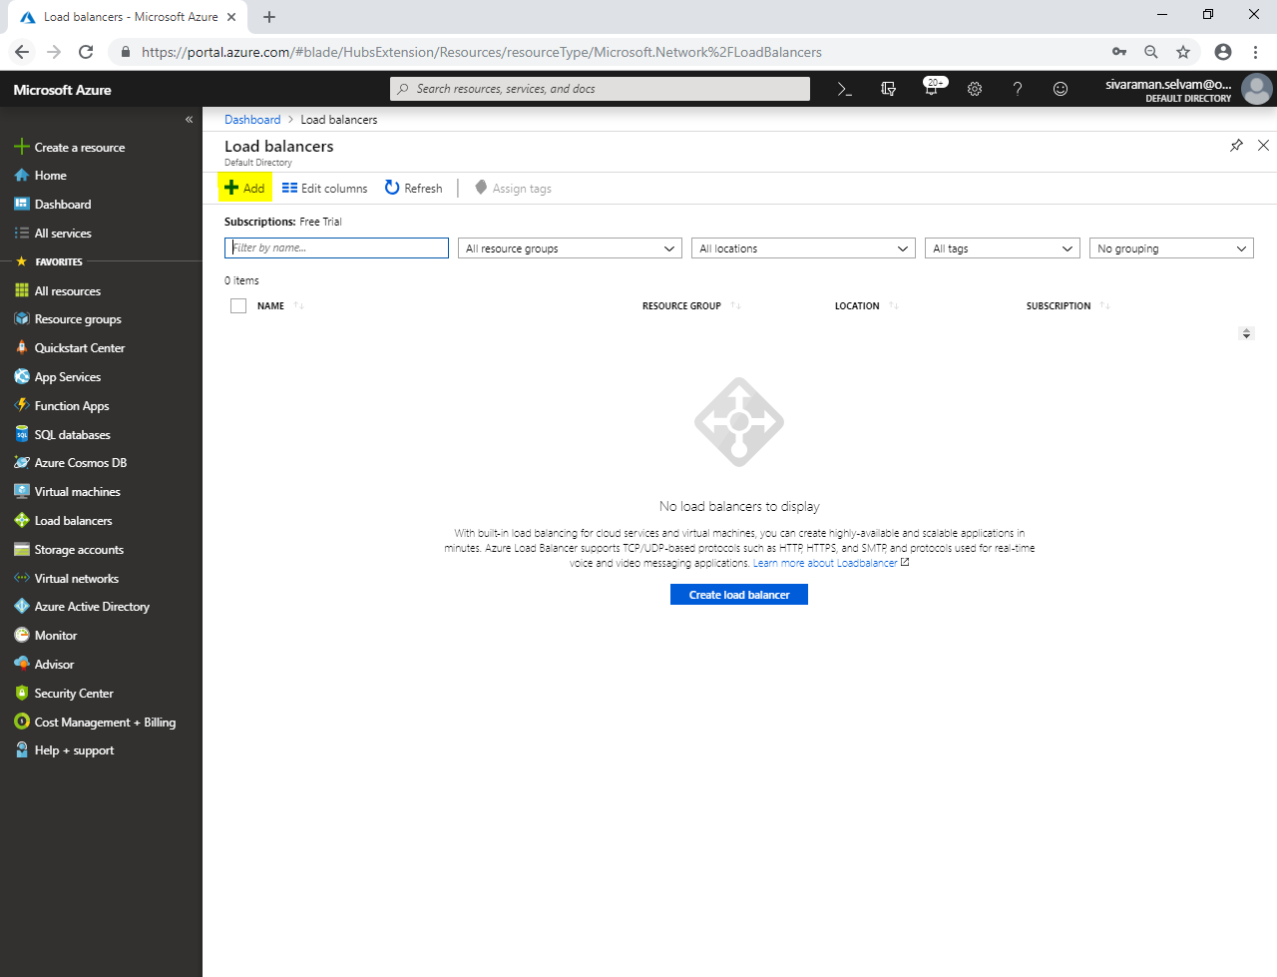

While create load balancer,

Type **“Name”** as **“Sans-WebLB”**.

Click **“Type”** as **“Public”**.

Click **“SKU”** as **“Basic”**.

Click **“Public IP address”** as **“Crete new”** type **“LB-IP”**.

Set **“Assignment”** as **“Static”**.

Select **“Subscription”** as **“Free Trial”**.

Select **“Resource group”** as **“SansboundAzureClass”**.

Select **“Location”** as **“Central US”**.

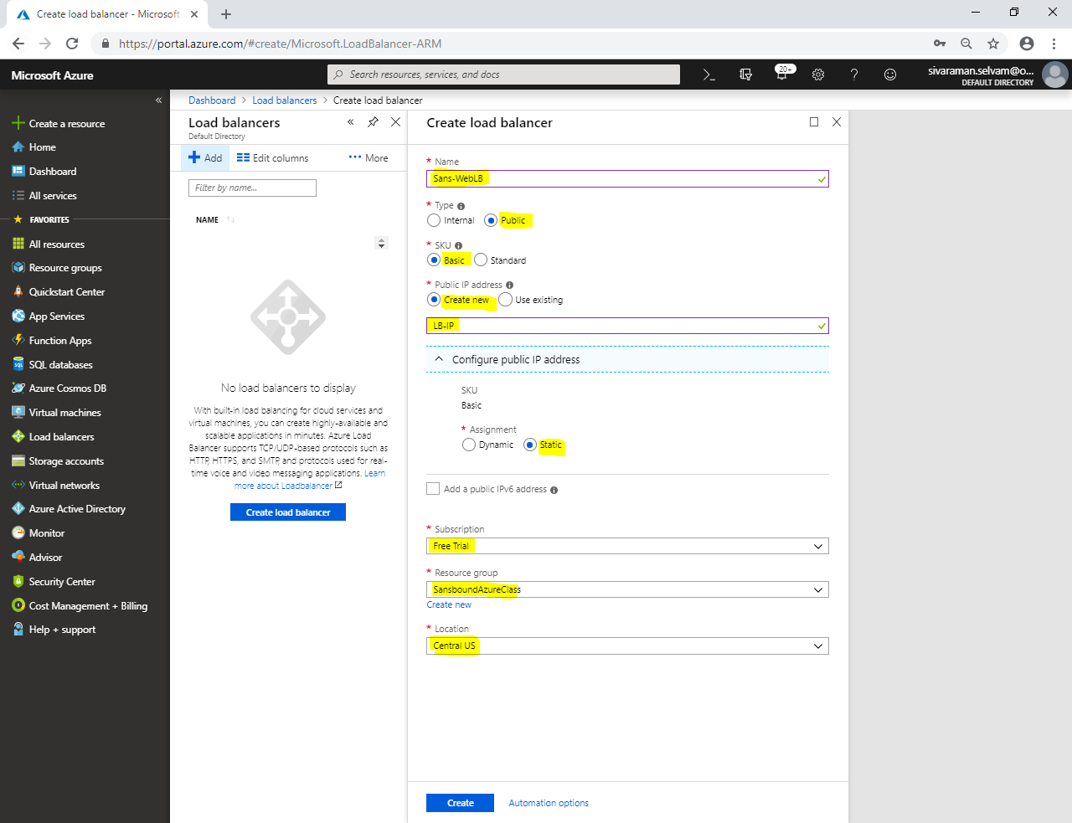

Click **“Create”**.

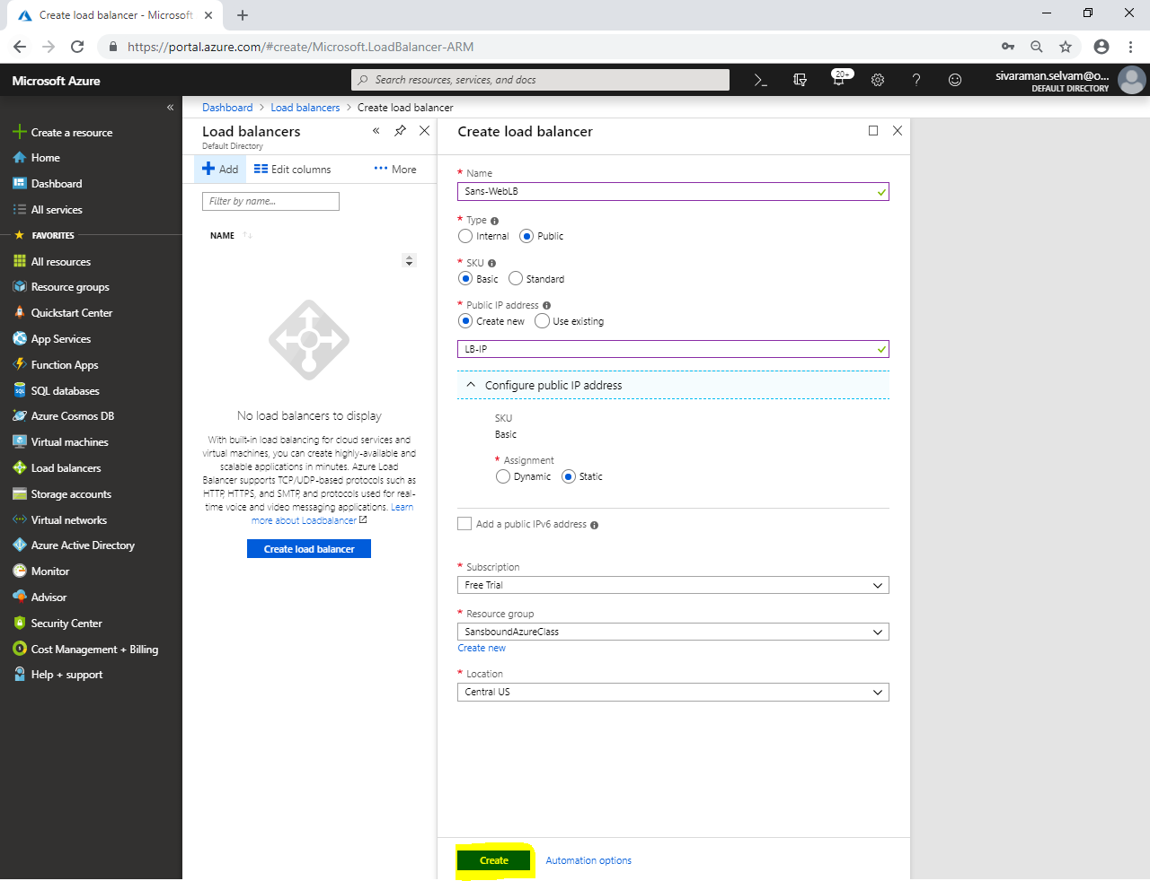

Click **“Sans-WebLB”**.

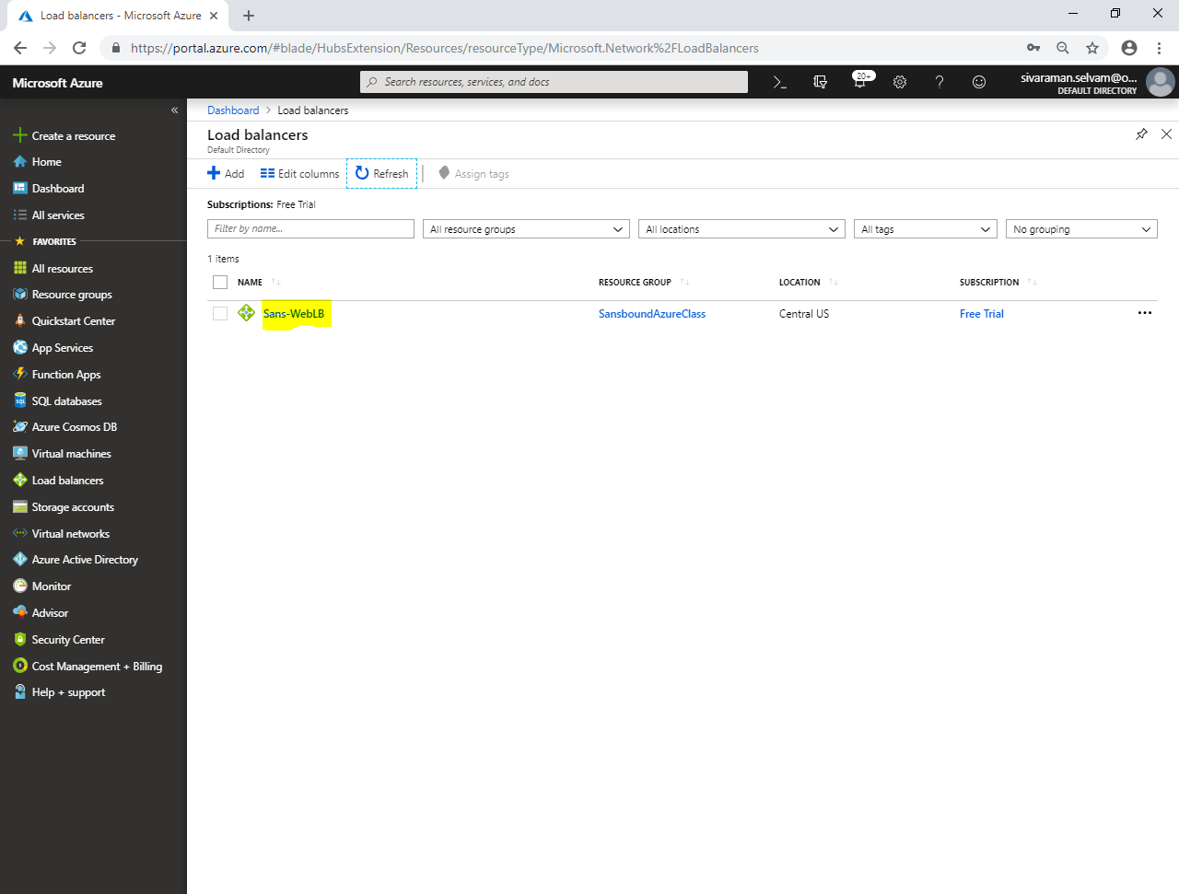

Click **“Backend pools”**.

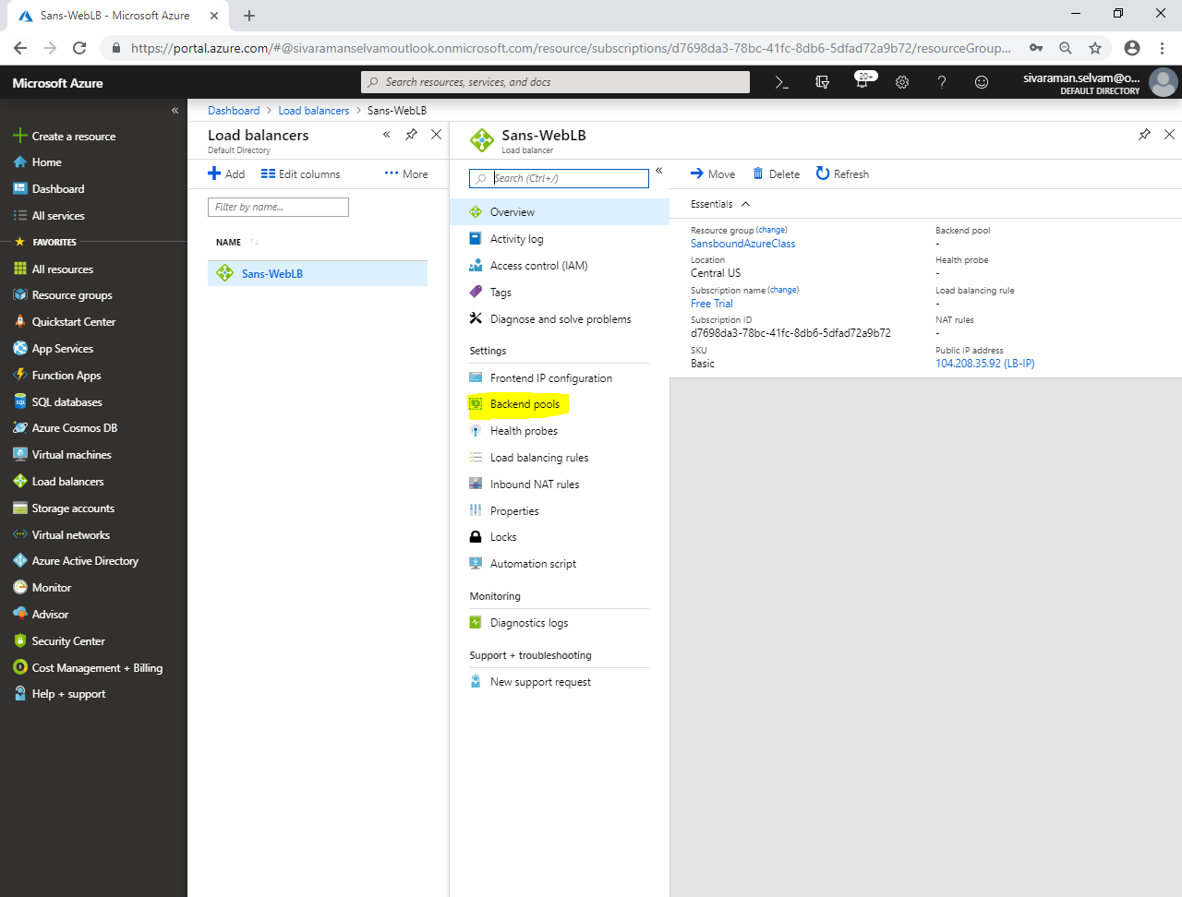

In **“Backend pools”**,

Click **“Add”**.

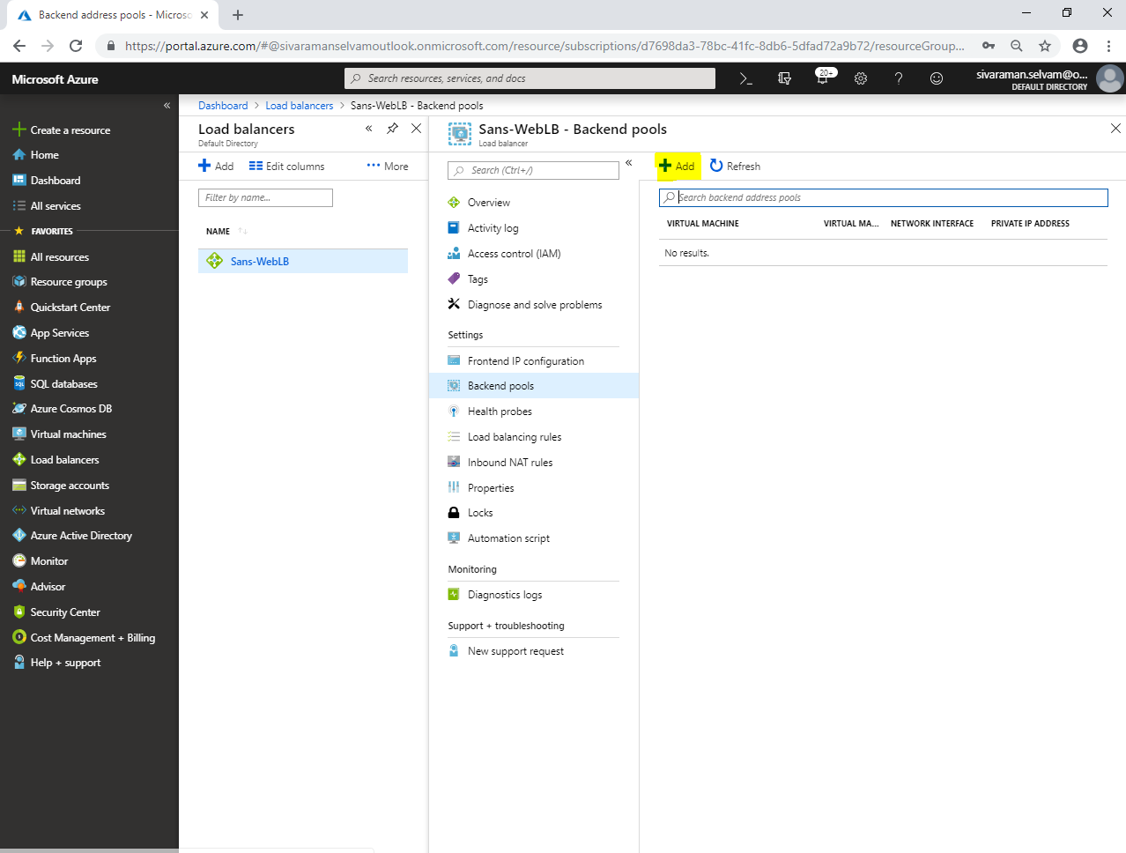

While **“Add backend pool”**,

Type **“Name”** as **“Webservers”**

In **“Associated to”** select **“Availability set”**.

Select **“Availability set”** as **“Sans-Cluster”**.

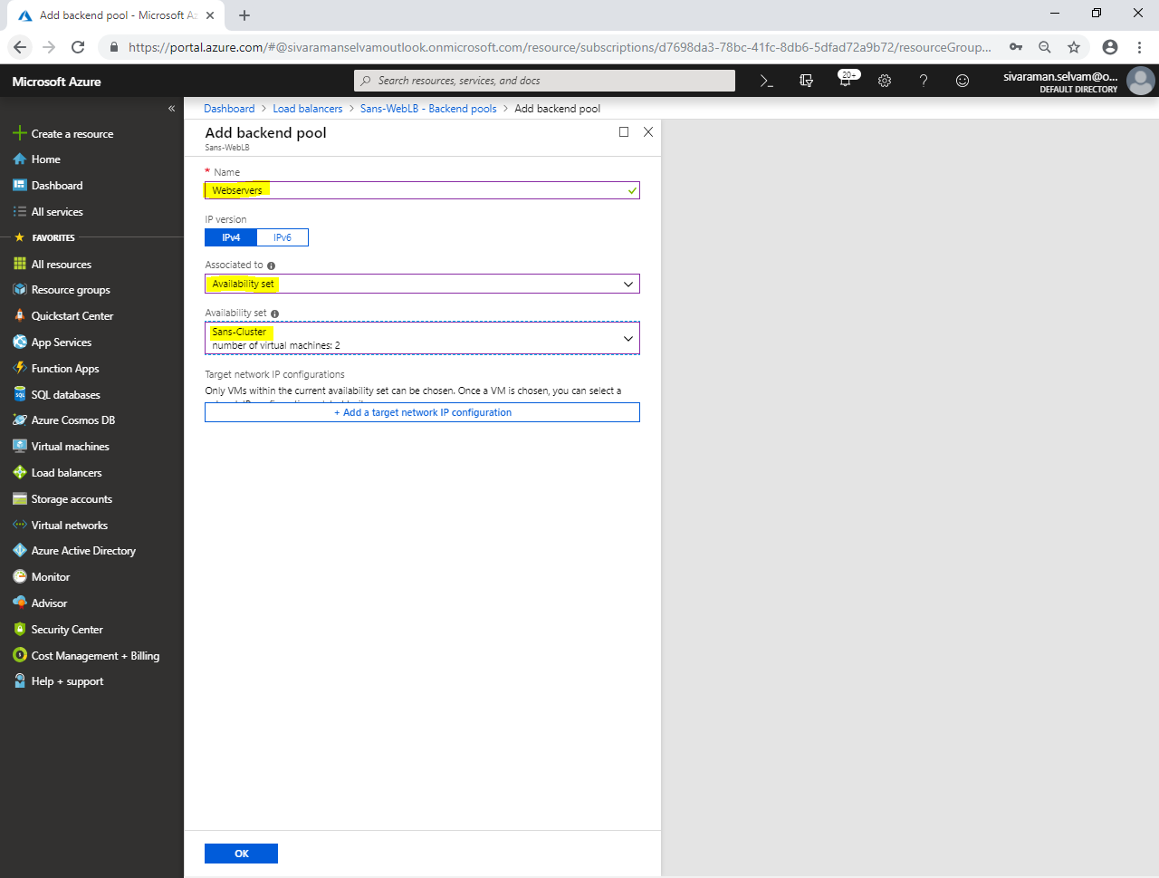

Click **“Add a target network IP configuration”**.

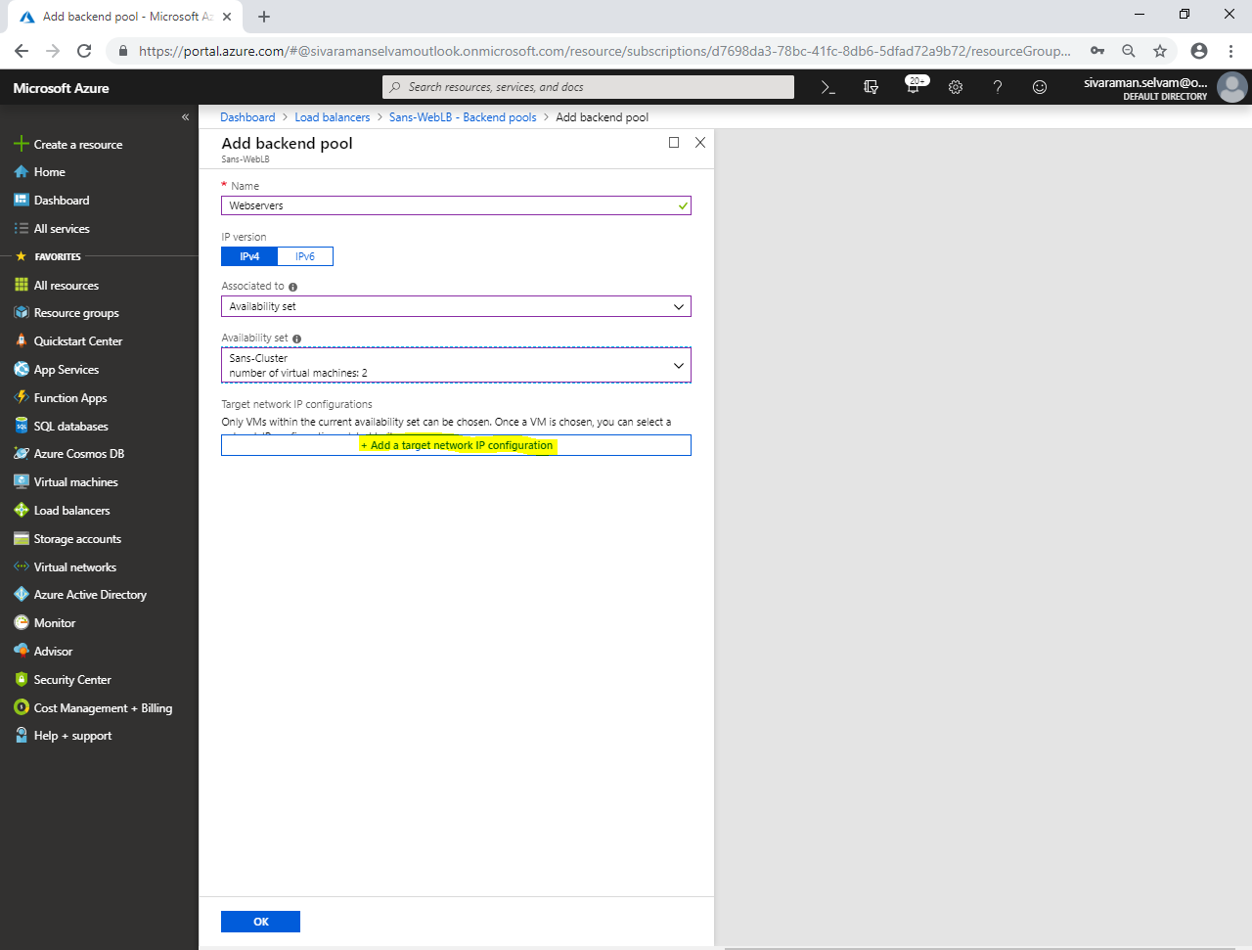

Select **“Target virtual machine”** as **“webserver01”**.

Select **“Network IP configuration”** as **“ipconfig1 (10.0.1.5)”**.

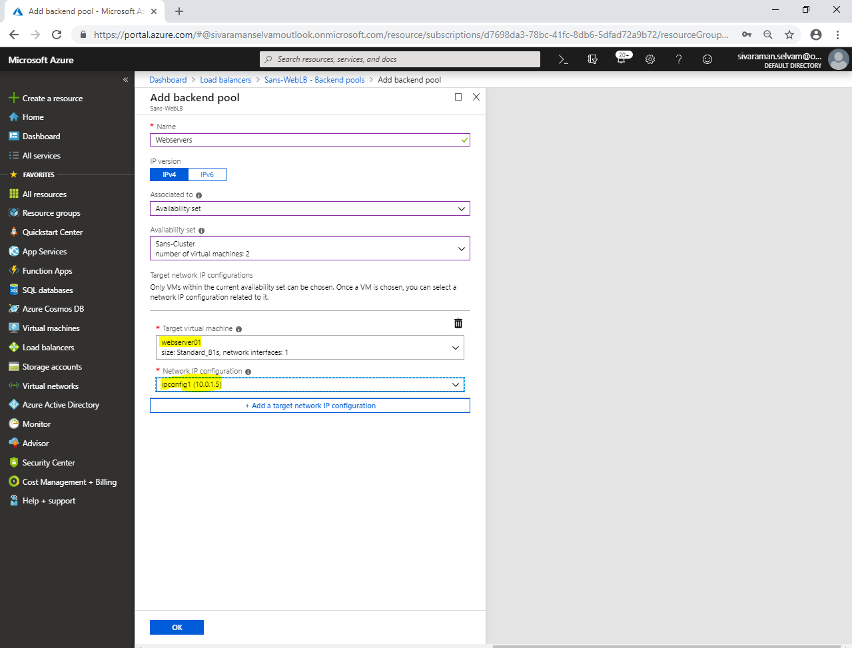

Click **“Add a target network IP configuration”**.

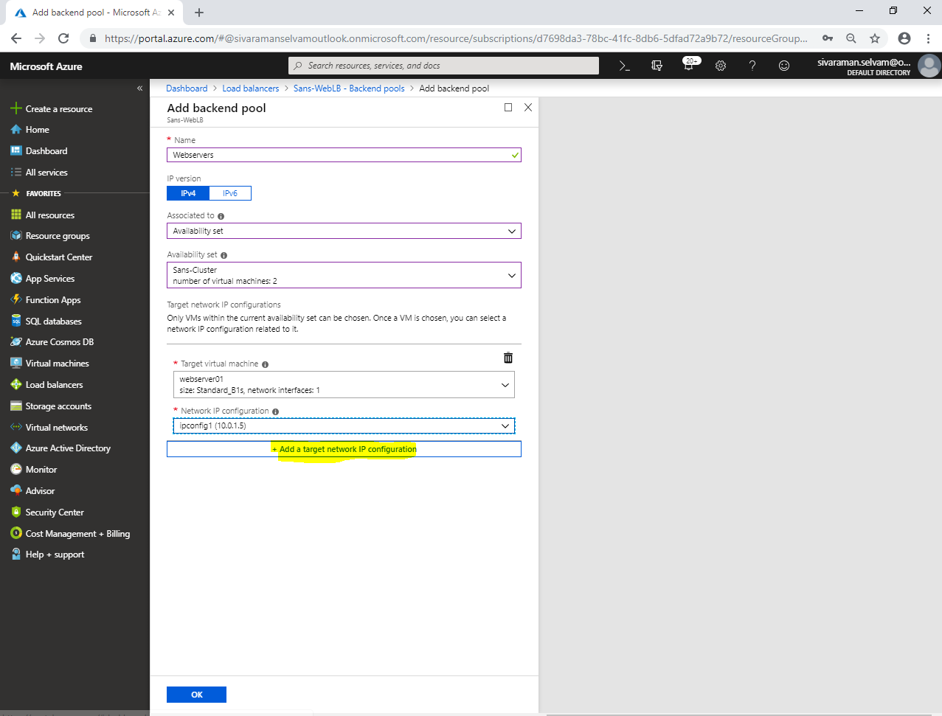

You are able to see that **“webserver01”** has been successfully added in target network IP configuration.

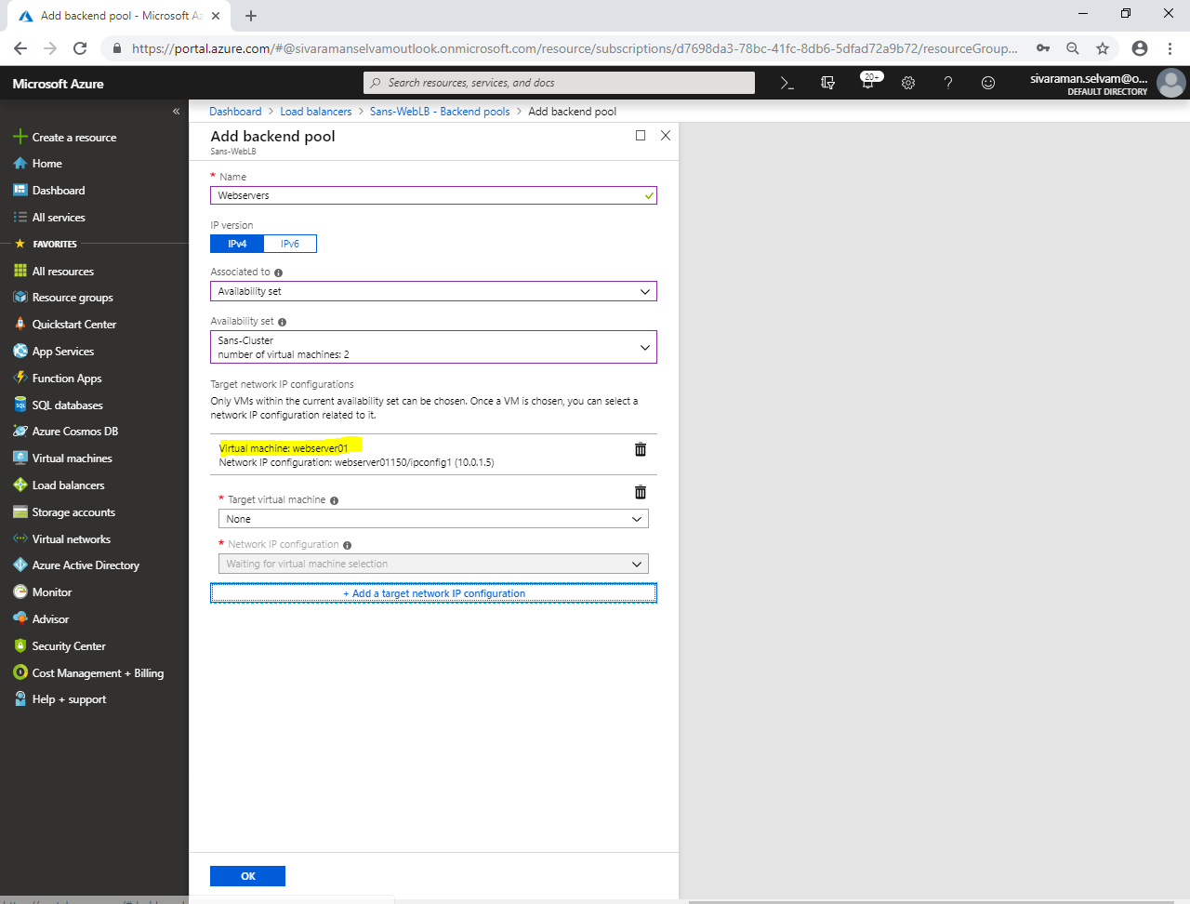

Select **“Target virtual machine”** as **“webserver02”**.

Select **“Network IP configuration”** as **“ipconfig1 (10.0.1.6)”**.

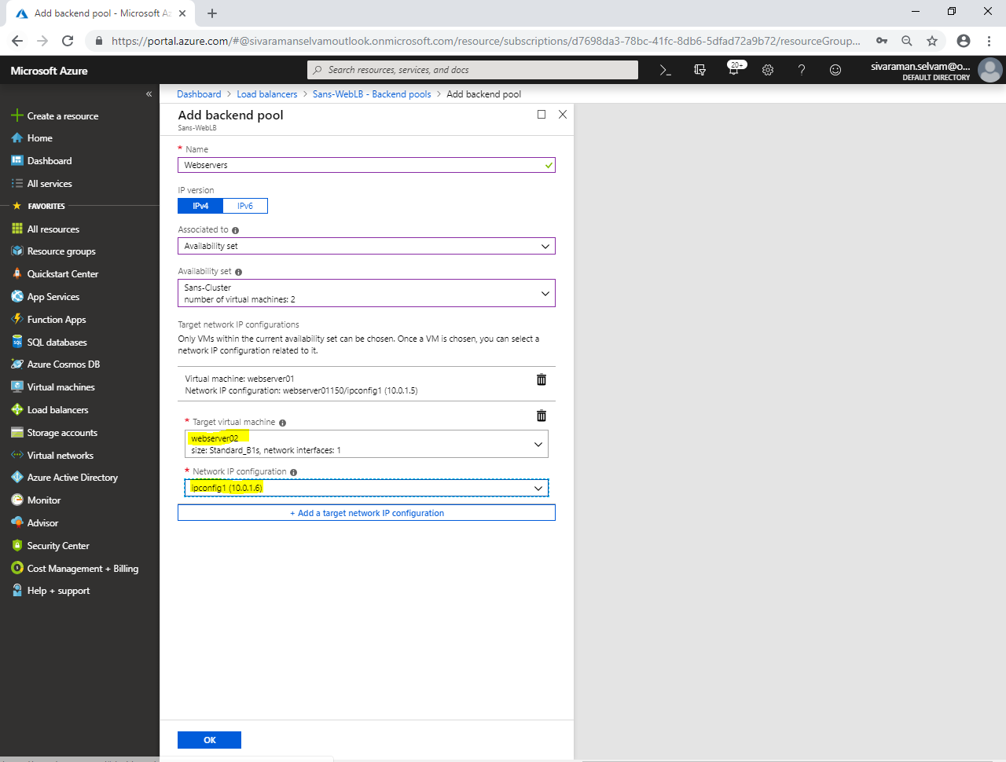

Click **“Ok”**.

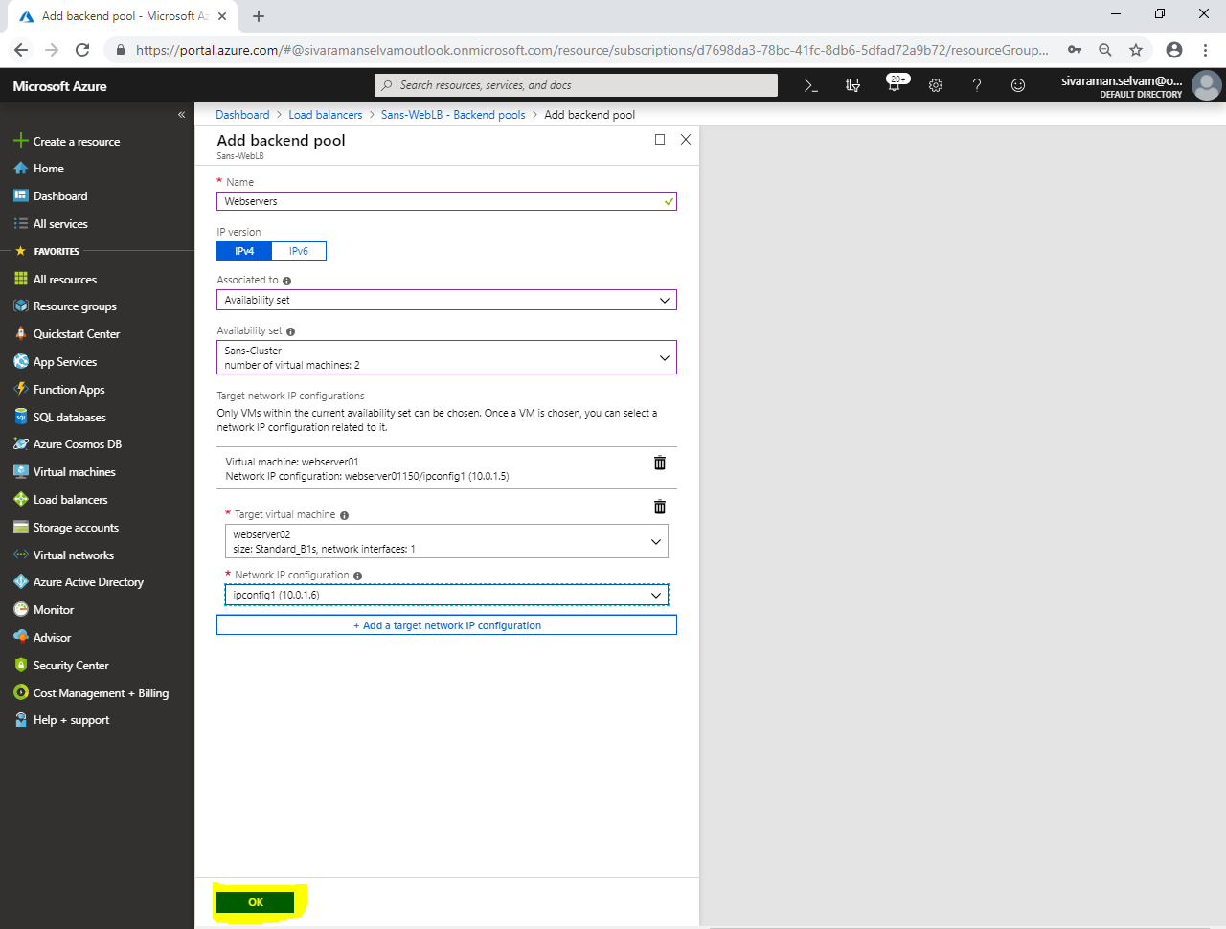

You are able to see that **webserver01** and **webserver02** servers are added successfully in Backend pools of **“Sans-WebLB”**.

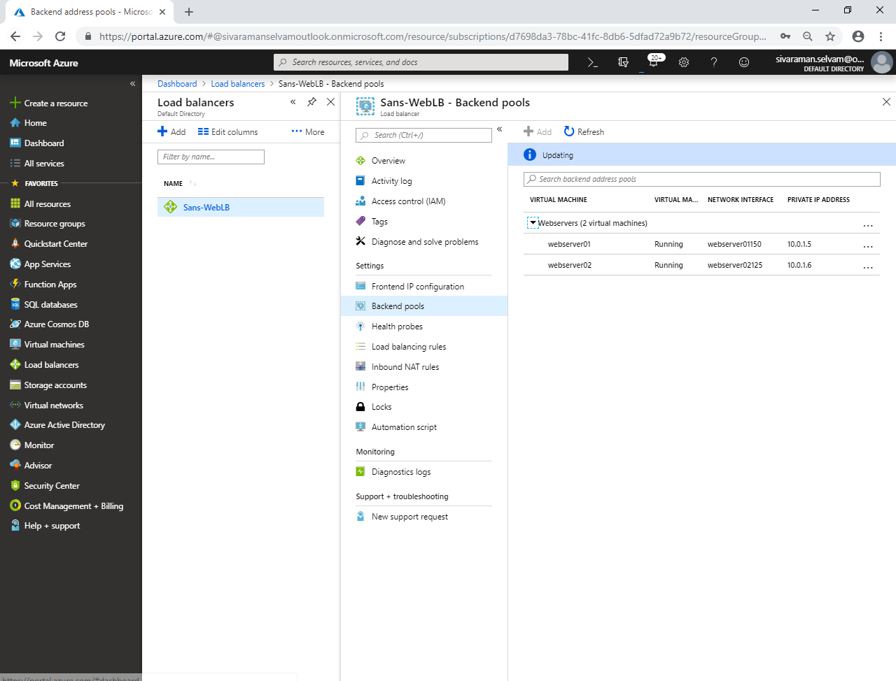

Click **“Health probes”**.

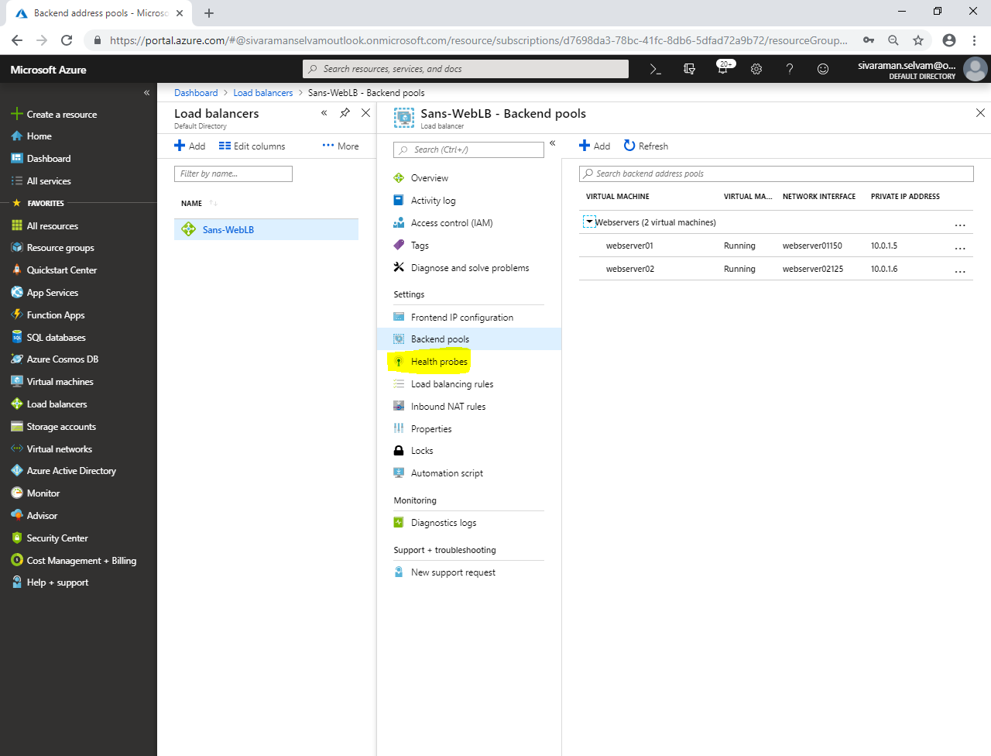

Click **“Add”**.

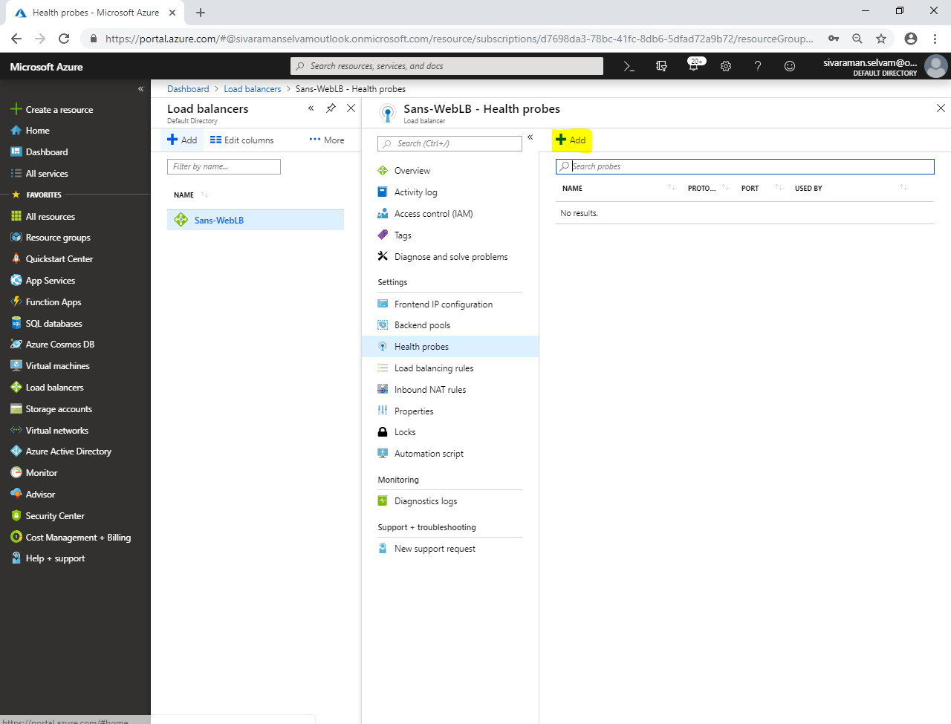

While **“Add health probe”**,

Type **“Name”** as **“WEB-HP”**.

Select **“Protocol”** as **“TCP”**.

Select **“Port”** as **“80”**.

Type **“Interval”** as **“5”** seconds (for check status of virtual machine and 80 port).

Type **“Unhealthy threshold”** as **“2”**.

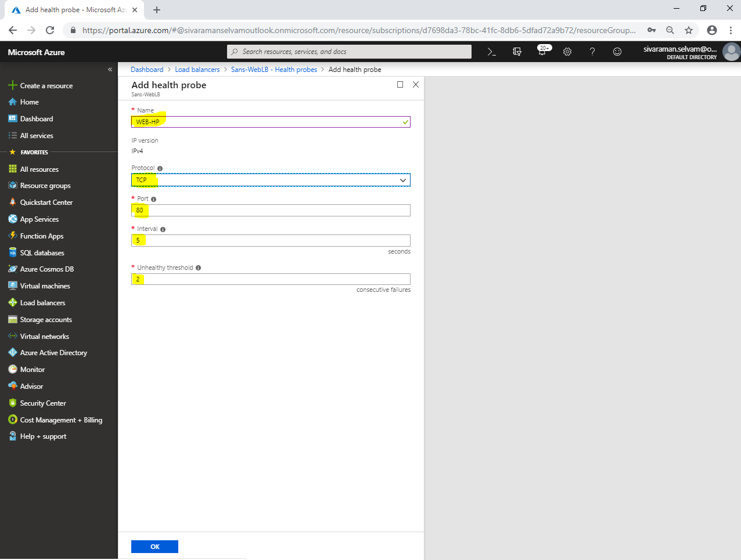

Click **“Ok”**.

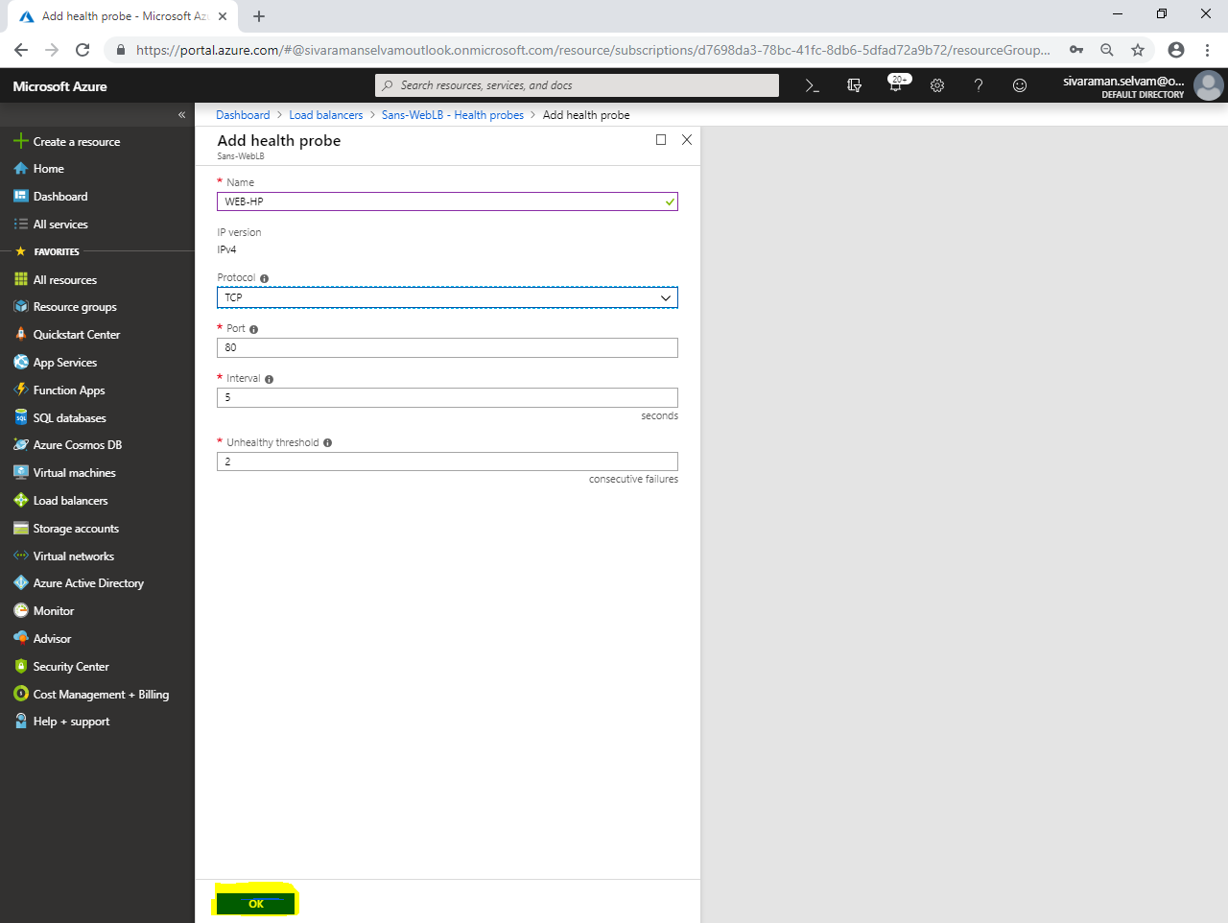

You have successfully created **“WEB-HP”** health probe.

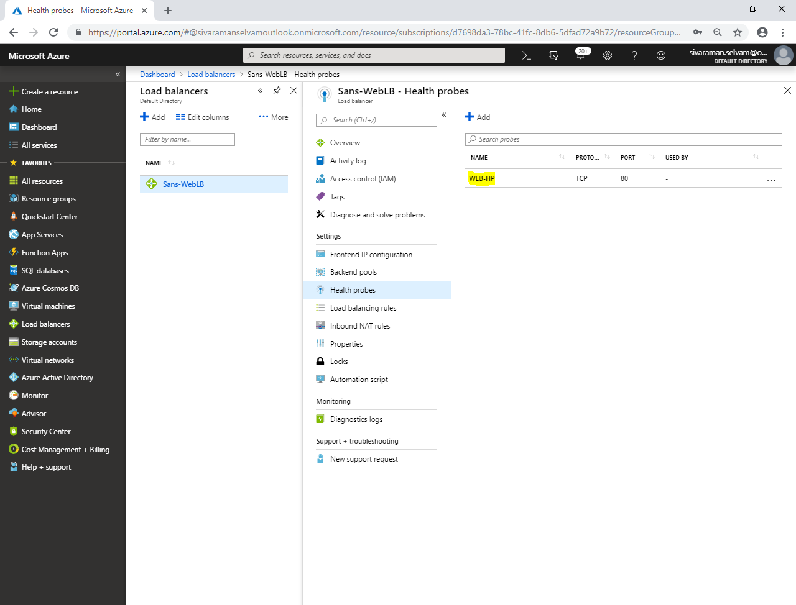

Click **“Load balancing rules”.**

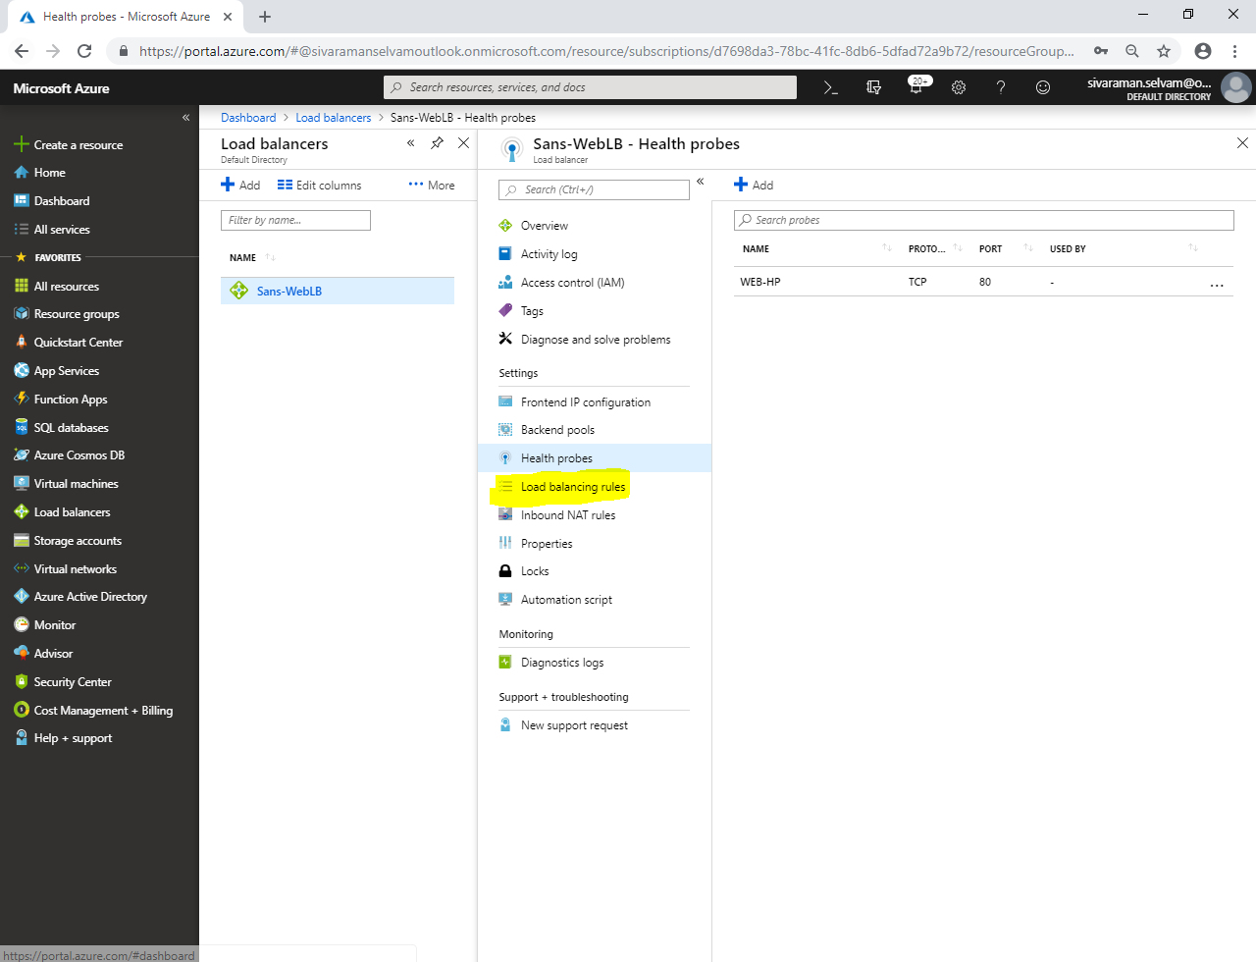

In **“Load balancing rules”**,

Click **“Add”**.

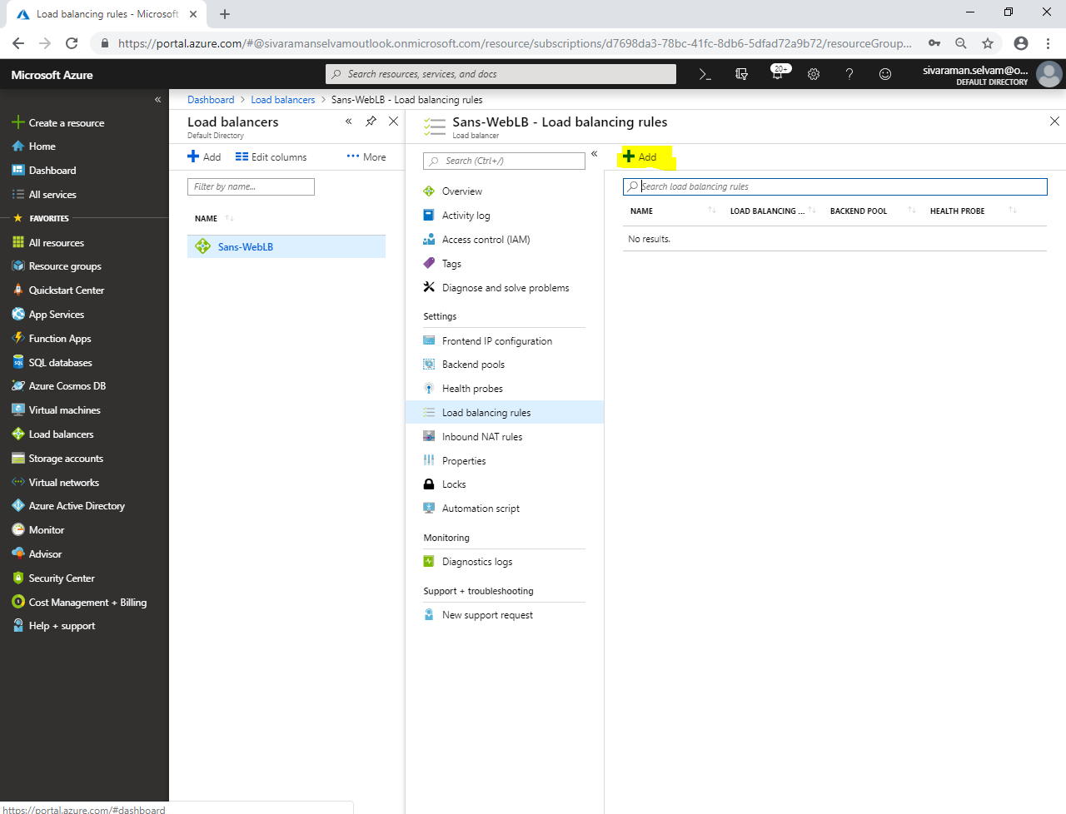

While **“Add load balancing rule”**,

Type **“Name”** as **“LB-Rule”**.

Ensure IP version as **“IPV4”**.

Ensure **“FrontEnd IP address”** is selected with IP address.

Set **“Protocol”** as **“TCP”**.

Ensure **“Port”** as **“80”** and **“Backend port”** as **“80”**.

Ensure **“Backendpool”** as **“Webservers”**.

Ensure **“Health probe”** as **“WEB-HP”**.

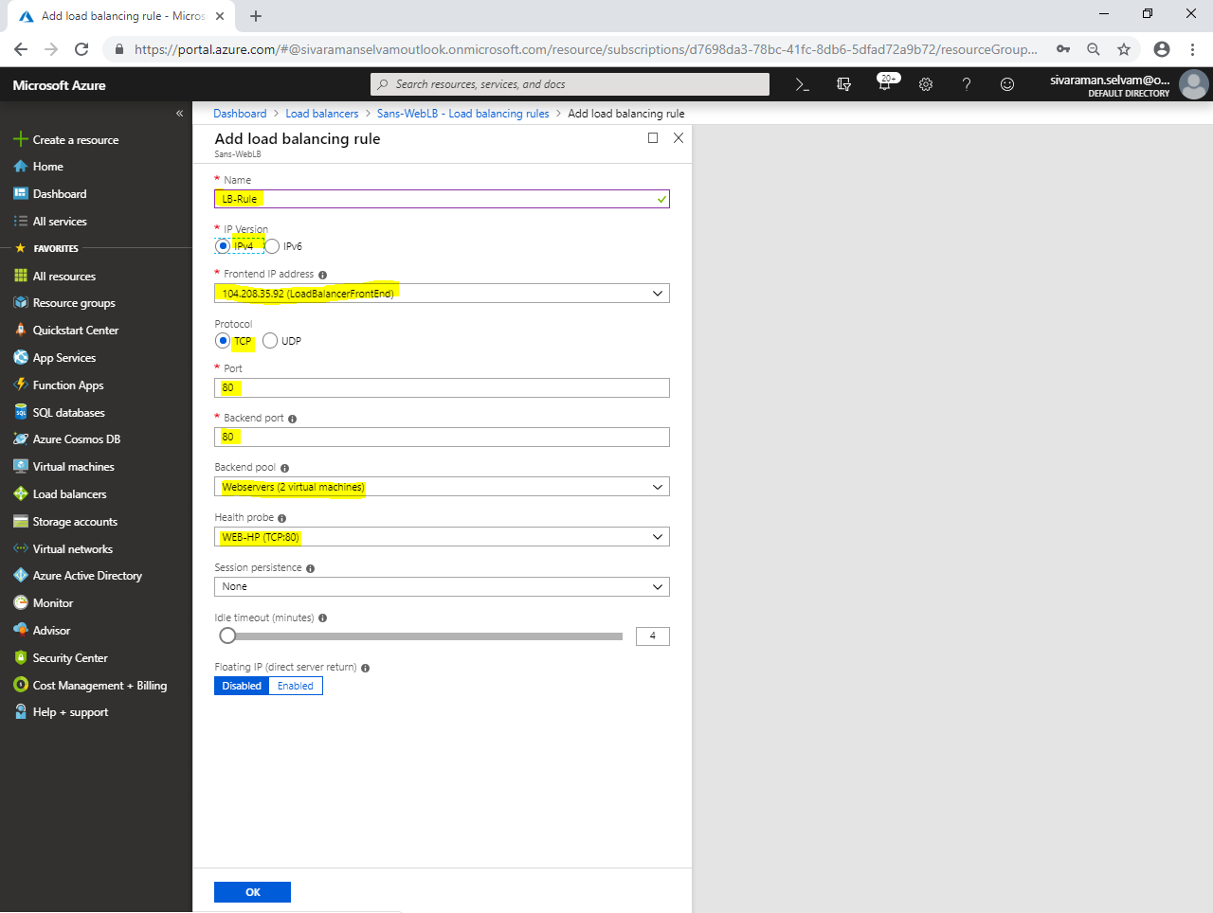

Click **“Ok”**.

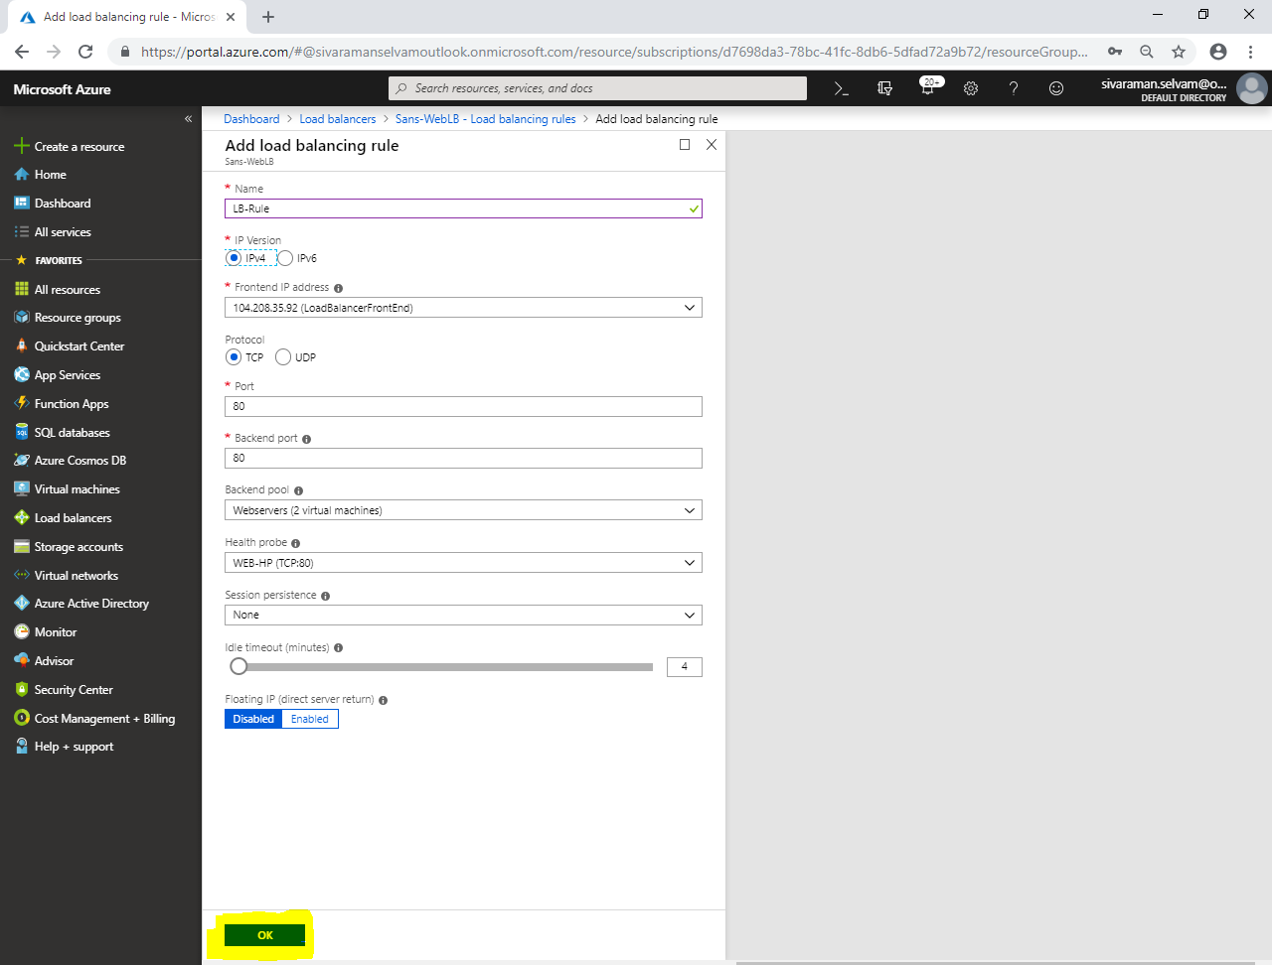

You are able to see the **“LBRule”**.

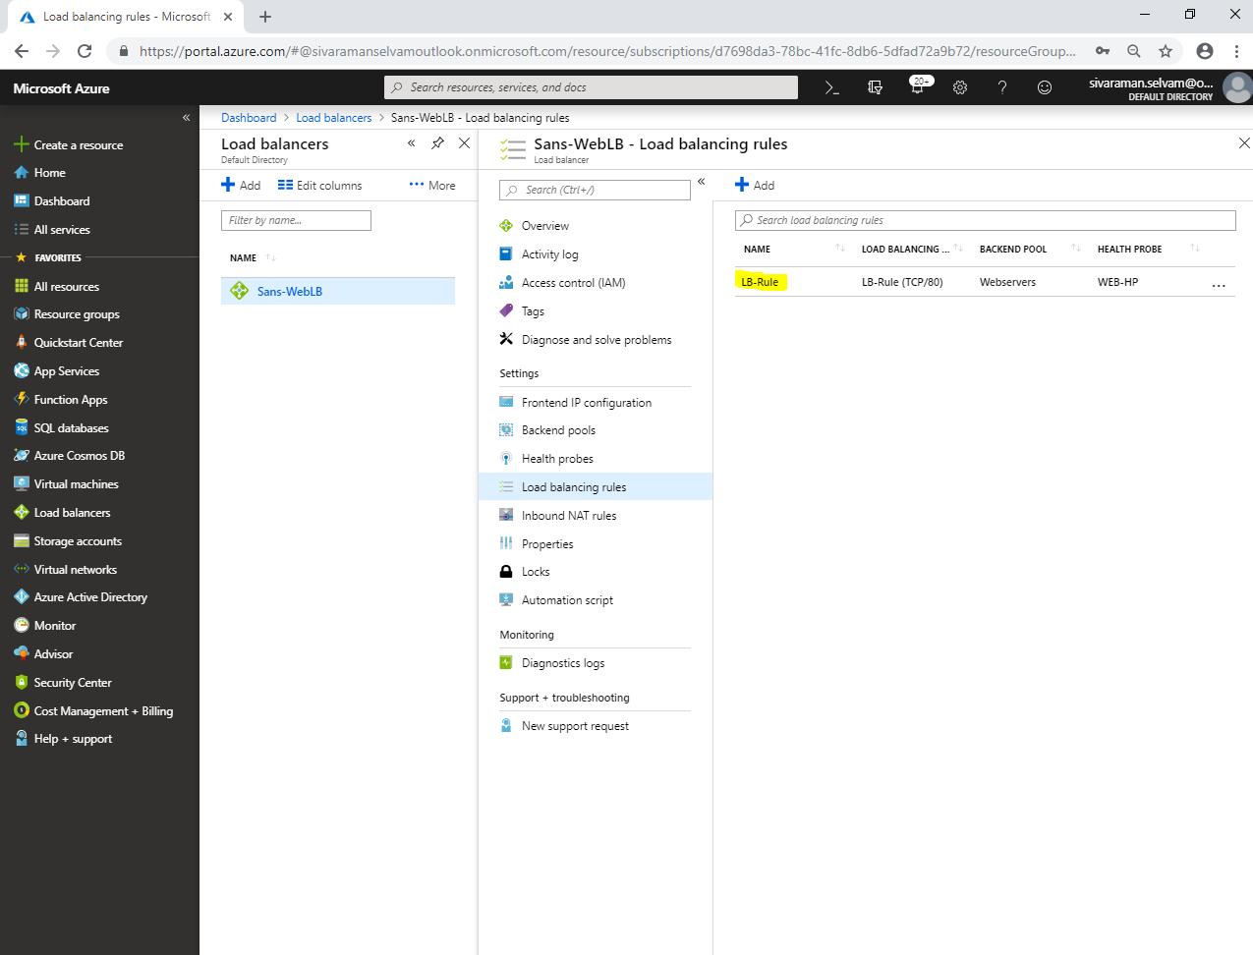

In **“Sans-WebLB”**, kindly note the Public IP address.

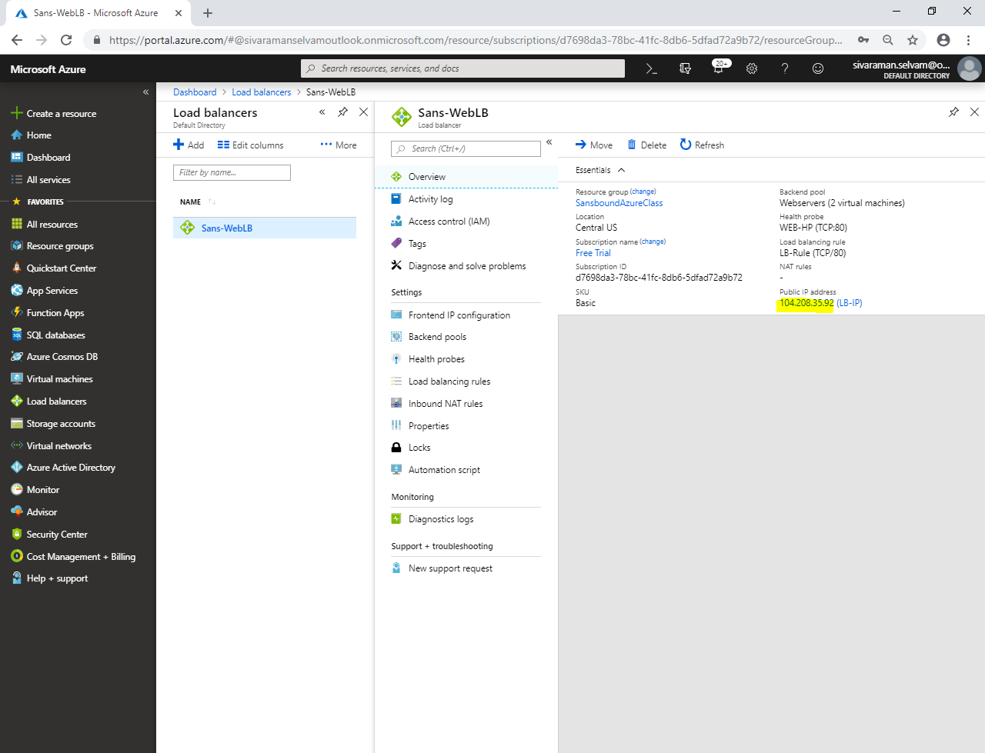

From your local machine, paste the public IP in browser and press **“Enter”**.

I have got the webserver02 page successfully.

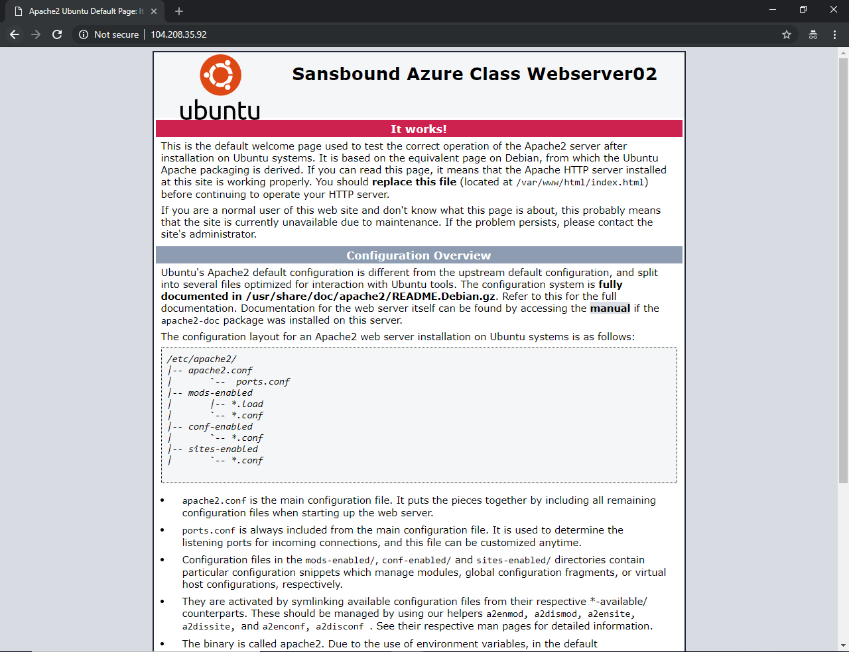

In Command prompt,

Type **“arp –d”** and press **“Enter”**.

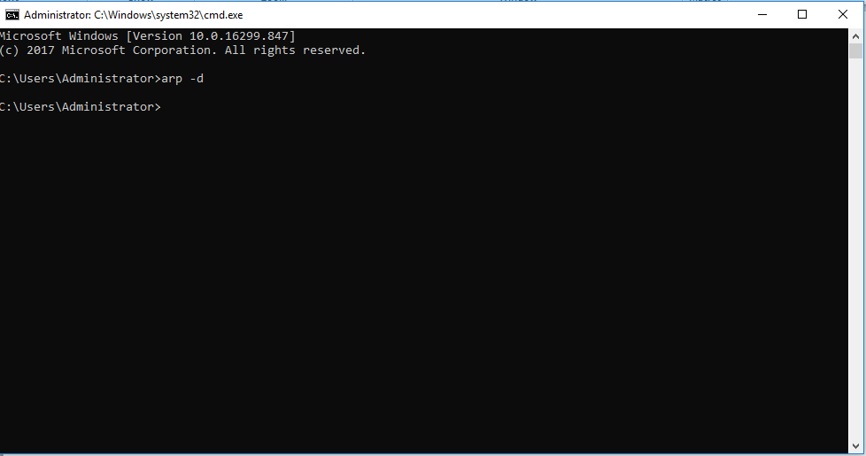

Type **“ipconfig /flushdns”**.

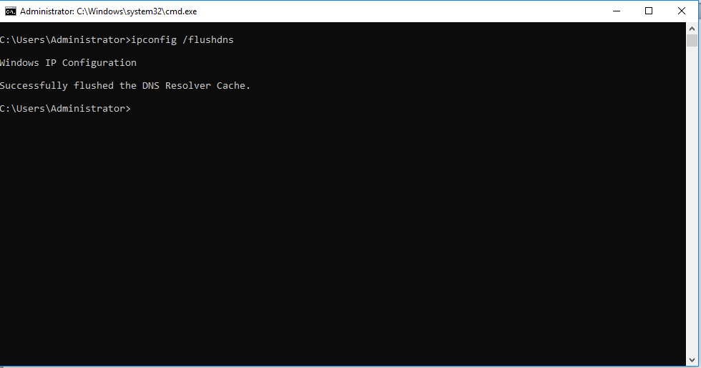

Click **“Refresh”** button in **“web browser”**.

After some try you will get webserver01 page.

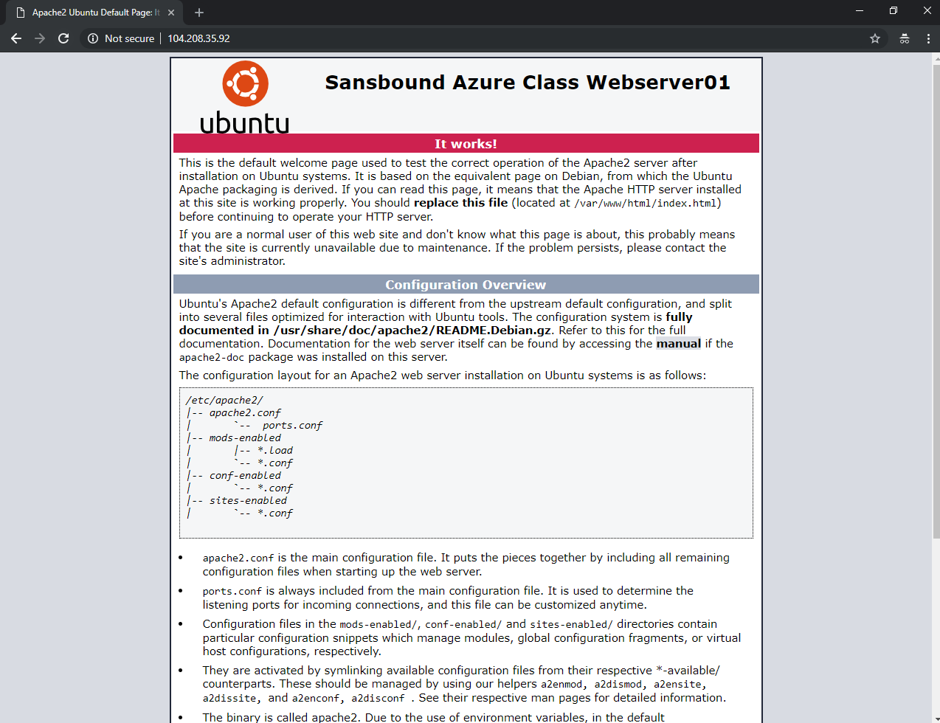

**Note: You have successfully configured availability set with Load balancer and web traffic has been load balanced successfully.**